PLACEMENT CELL REPORT
(2022-23)

The GPGCW Rohtak placement cell serves as the foremost platform between various stake holders for interactions that governs the career aspirations of the college girls. The cell plays the key role in locating the job-oriented career opportunities for the final year Under Graduate and Post Graduate students by encouraging them to participate in several Placement-cum-Training Programs. College placement cell conducts various workshops and seminars for students to learn and improve their interpersonal skills, communication skills, listening skills, time management, professional resume and bio-data writing etc.
For the students inclined towards higher education the placement cell organizes various Extension lectures by eminent persons from various institutes like MDU, Rohtak, BMU, Rohtak, NIIT, and TIMES groups to name a few. Placement cell has an aim of being transparent, technologically driven, and dynamic with students throughout courses and years.

Our team consists of the following members
1. Dr. Nisha Malik (convener)
2. Dr. Puspdeep Dagar (member)
3. Mrs. Meenu (member)
4. Mrs. Savita Malik (member)
5. Mrs. Nirmala Soni (member)
6. Dr. Bhupender singh (member)
7. Mrs. Manju (member)
8. Mr. Jogender Singh (member)
9. Ms. Sonika (member)
10. Mrs. Sanket (member)

Vision
Equipping the students with relevant and conceptualized professional skills
and to guide them for embarking on a successful career journey.

Mission
- To groom the students and make them aware of current scenarios of various
- industries.
- To ensure 100% placement assistance.
- To maintain good liaison with the recruiters.
- To inculcate the quality of taking on industry challenges and emerging out as
- young leaders.
- To develop strong analytical and competitive skills.

Placement cell organized various activities for the welfare of the students during the whole year.

Detail of activities session (2022-23)

Sr. No. | Name of Program | Date | No. of Students | Name of Agencies/Consultant
1 | Training cum lecture | 03-11-2022 | 120 | Upskilling yourself using Saylor Academy Courses
2 | Workshop on soft skills | 10-02-2023 | 301 | Career institute of education, Rohtak
3 | Rohtak division Job fair | 14—02-2023 | 225 | Pt. NRS Govt. College, Rohtak
4 | Lecture on Administrative services | 01-03-2023 | 137 | Bhavishya Academy, Rohtak
5 | Campus Placement Drive | 31-03-2023 | 87 | Quotient Software Company
6 | Workshop on “Career Development” | 06-04-2023 | 60 | Sunstone LEAP

ACTIVITY 1:
To implement the MOU signed in the end of last session, A training cum lecture on “Upskilling yourself using Saylor Academy Courses” was conducted on 03-11-22. Saylor Academy consultant explained various steps of registration and joining various courses offered in it in online mode. This lecture attended by 120 students of our college.

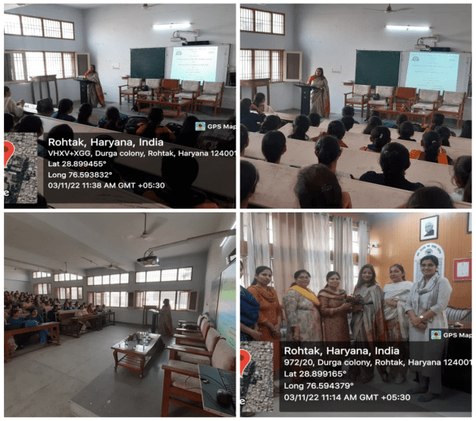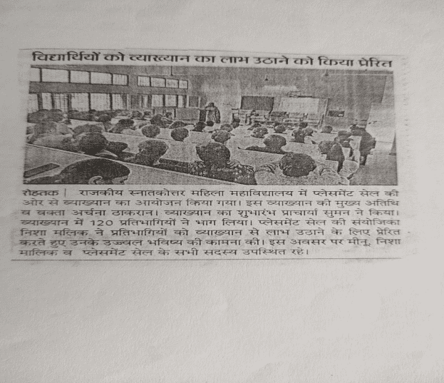

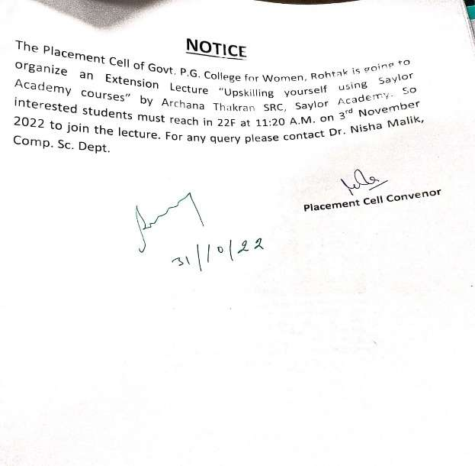

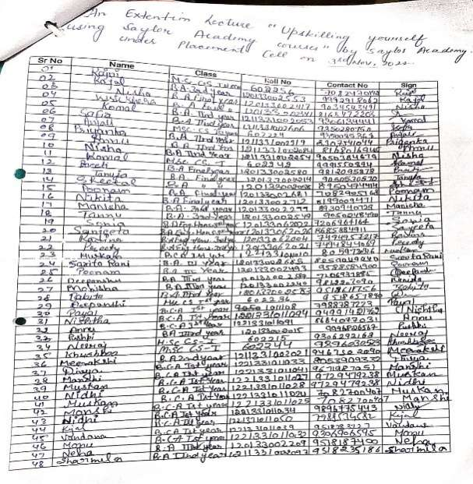

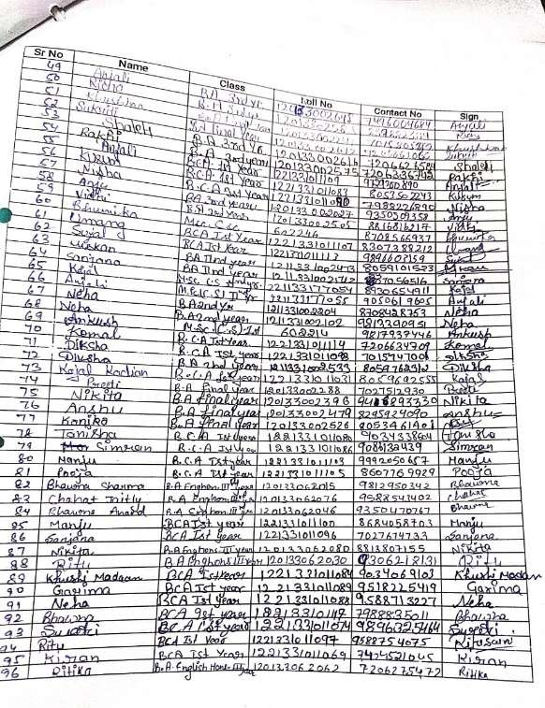

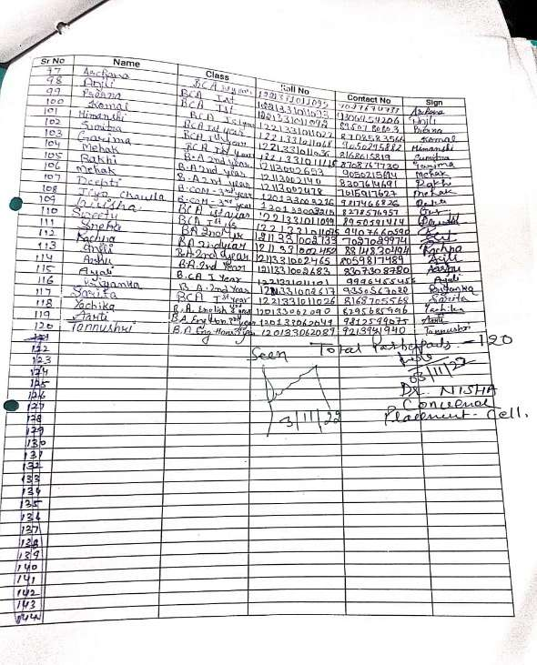

ACTIVITY 2:

One day workshop on “Soft-Skills” was organised in our college for final year students of UG/PG on10-02-2023. Career institute of Education faculty provide training to the students regarding communication skills, resume writing and other personality traits. Two groups of total 301 students attended this workshop and that help them for upcoming Divisional Job Fair.
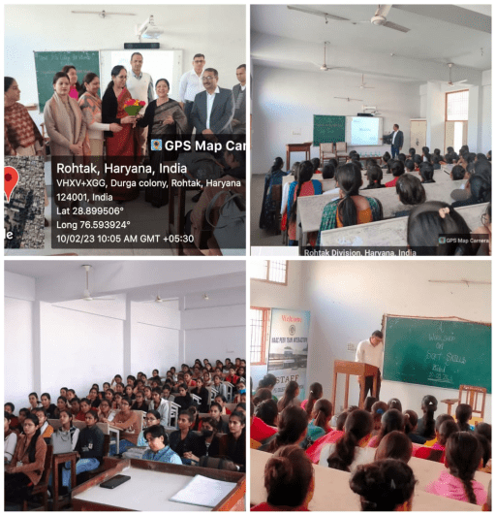
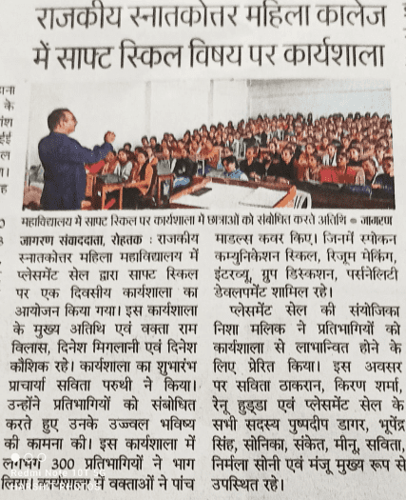

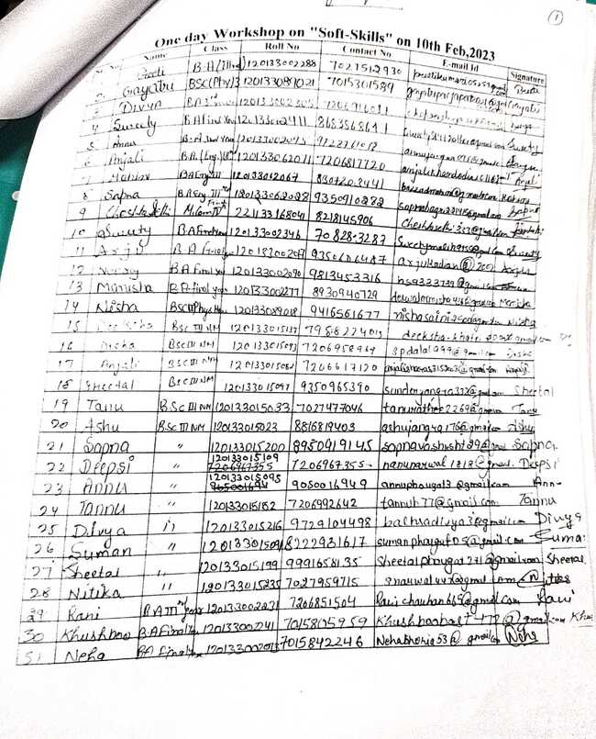

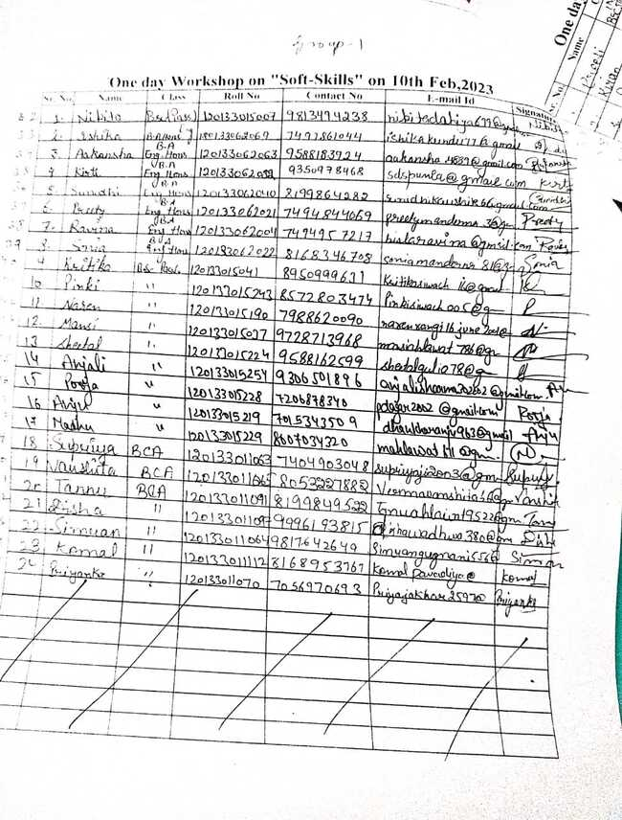

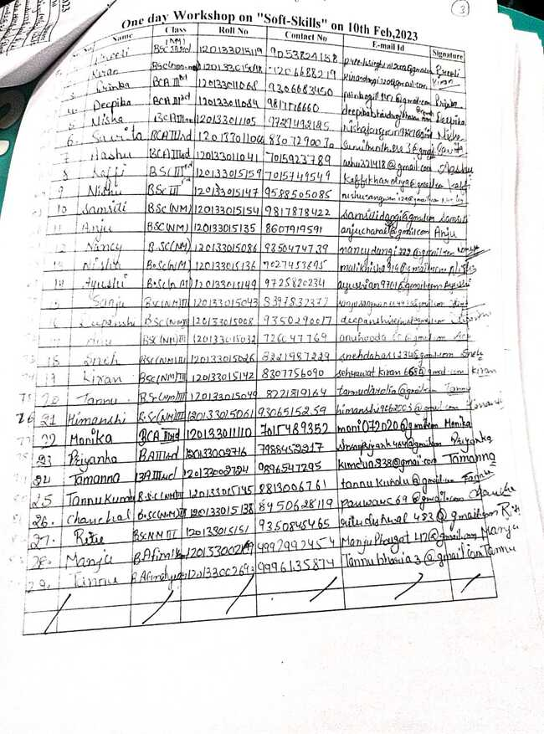
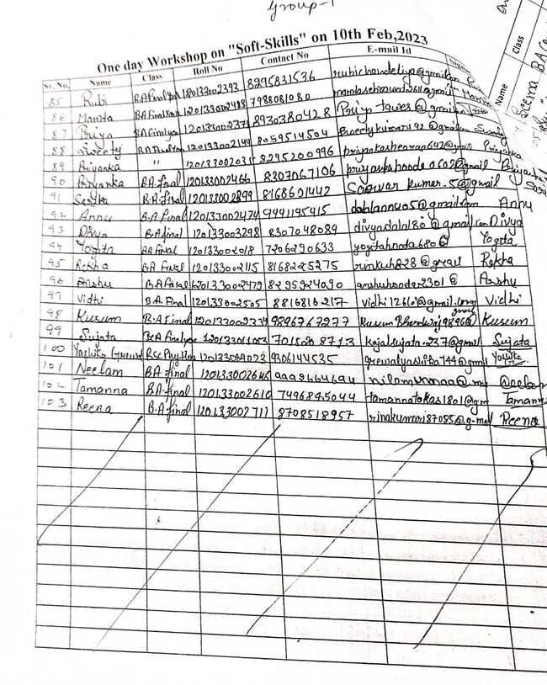

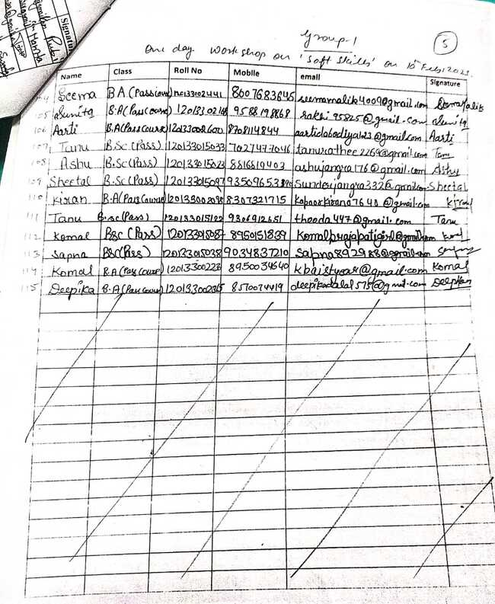

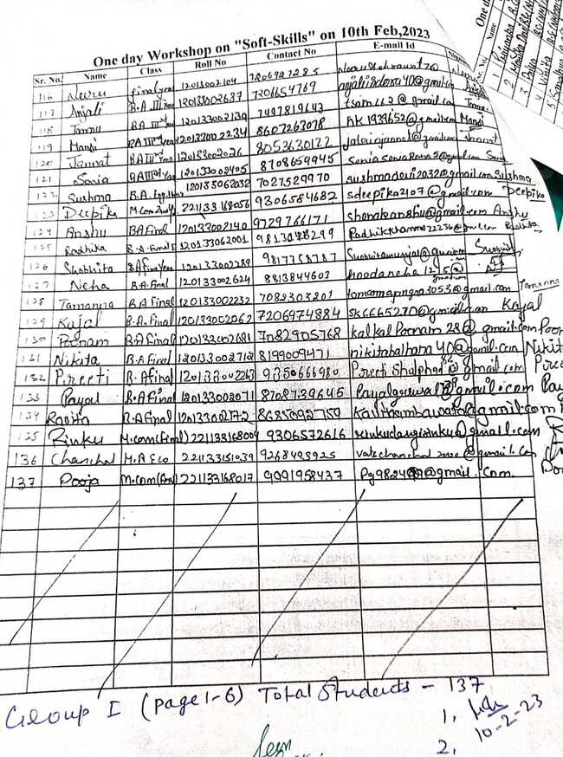
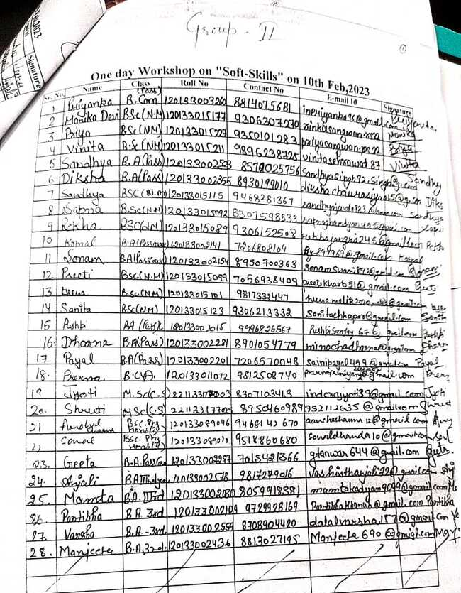
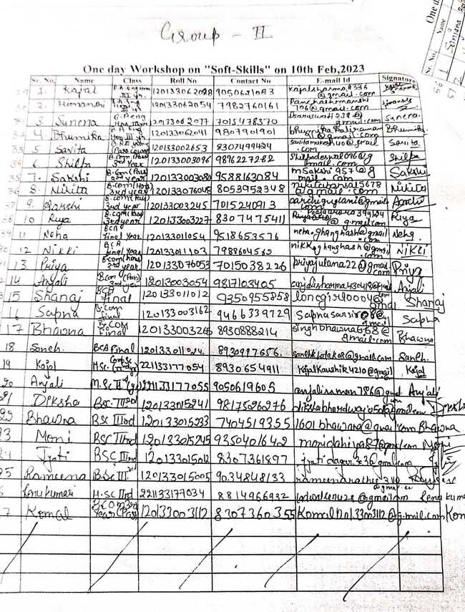

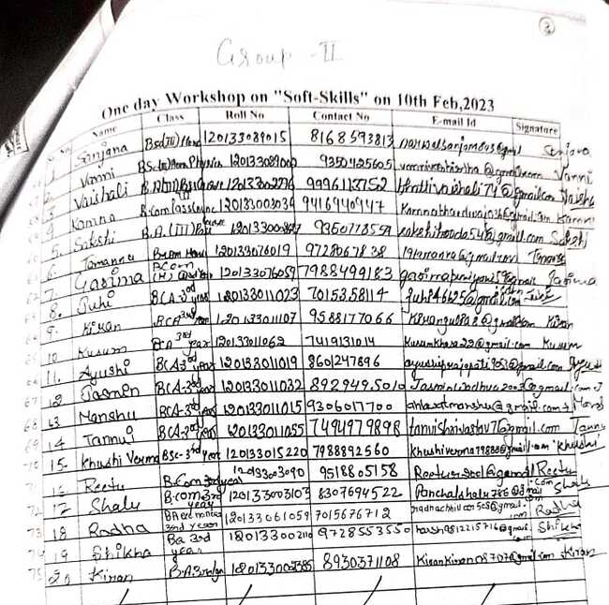
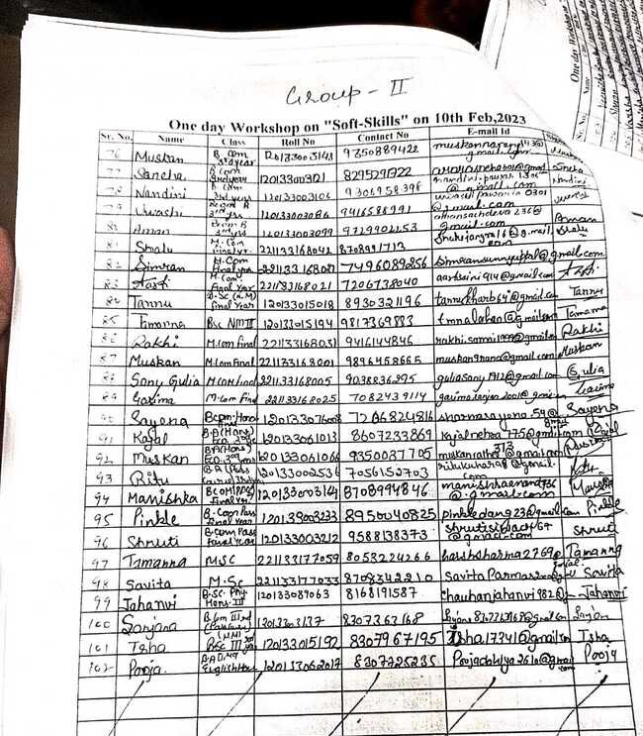

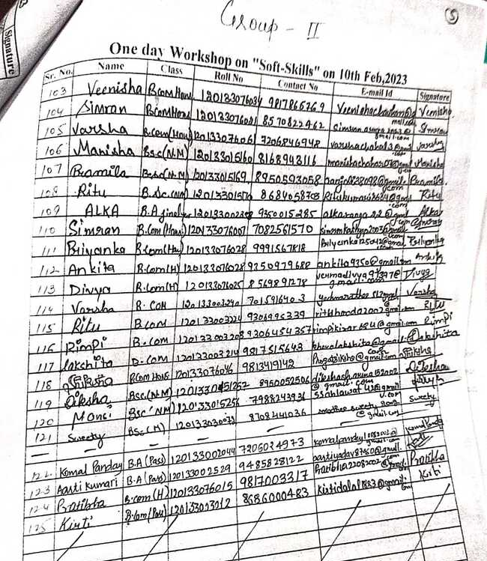

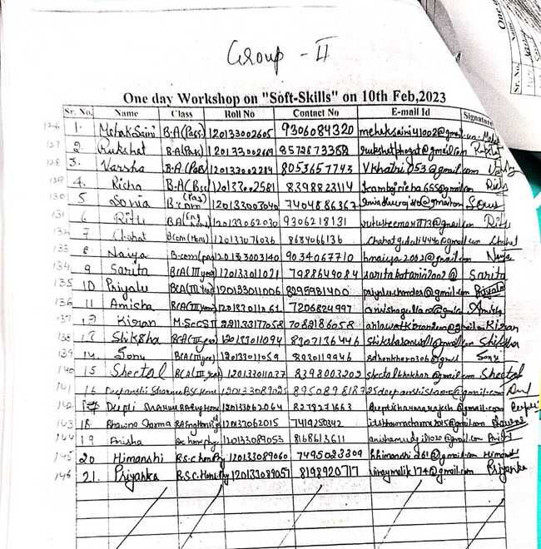

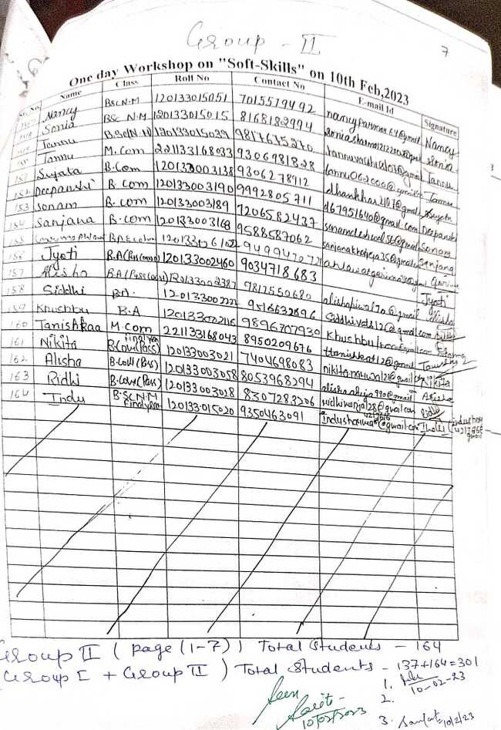ACTIVITY 3:
Rohtak Division Job Fair sponsored by DGHE held at Pt. NRS Govt College, Rohtak on 14-02-2023 in which 225 final year students of UG/PG participated. 15 Companies conducted interviews for different streams of students and finally 37 students got offer letter in this event.

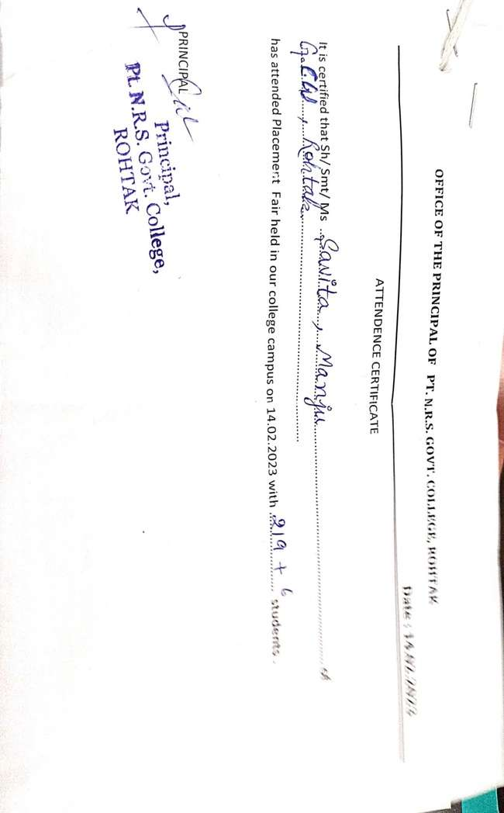
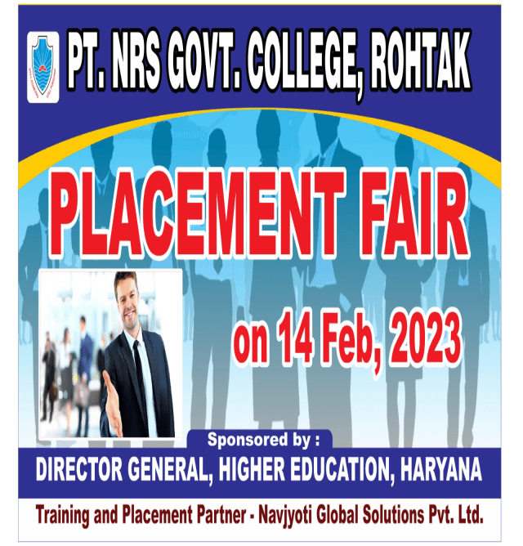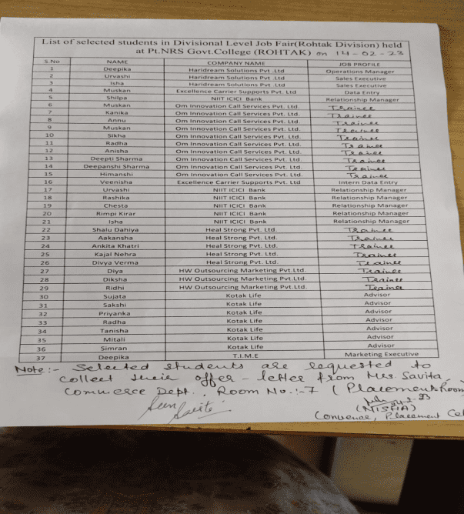

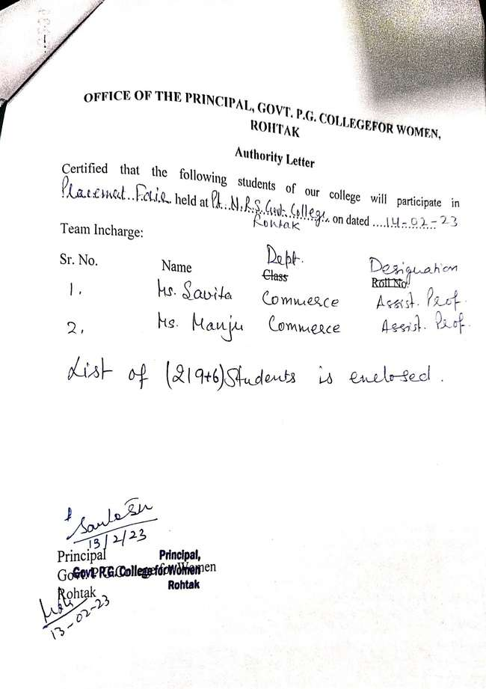

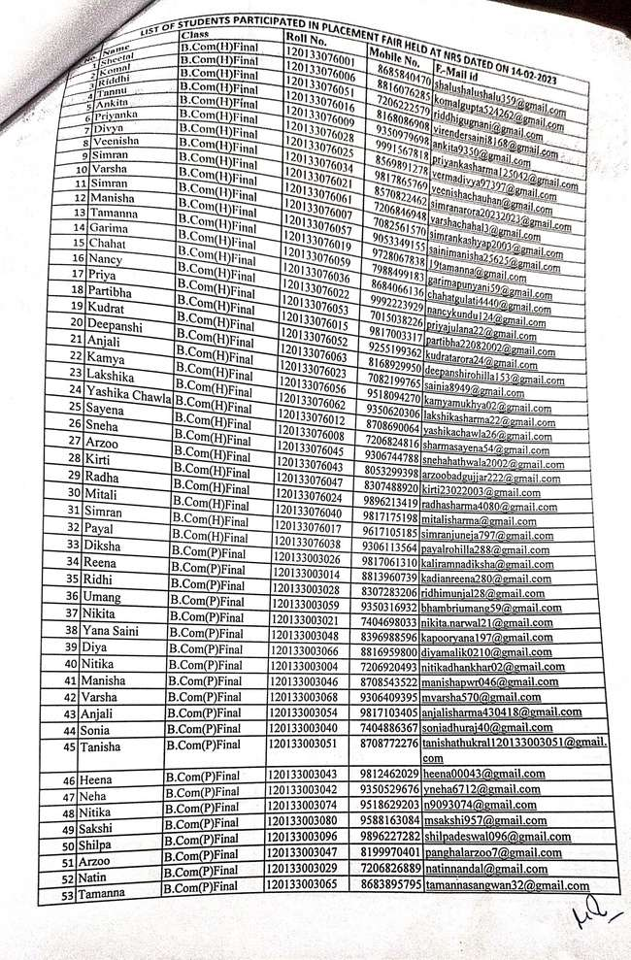

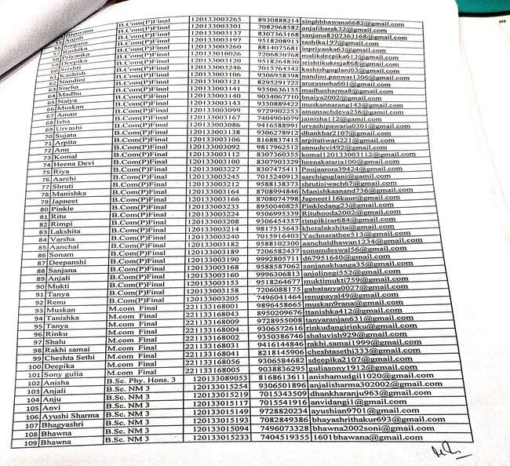

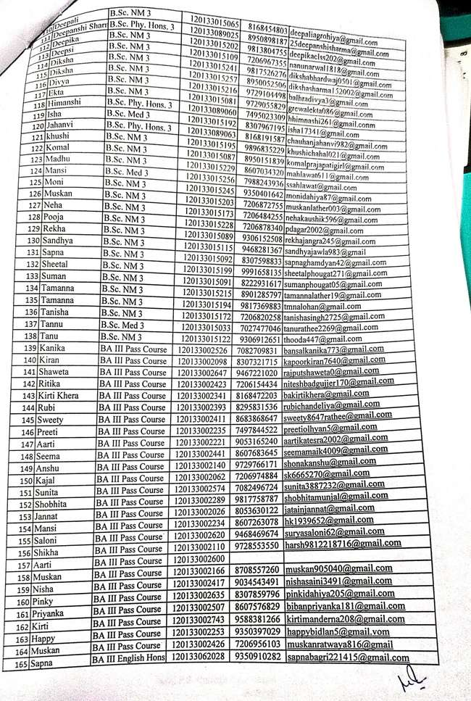

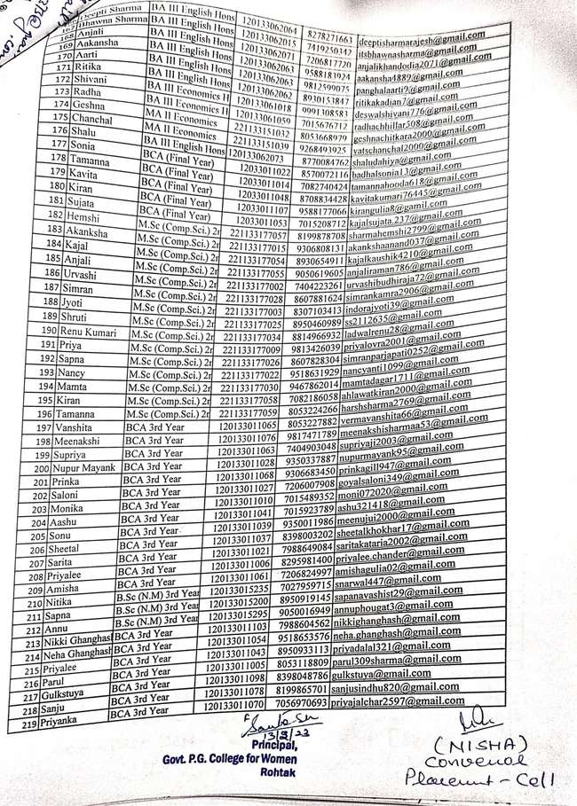

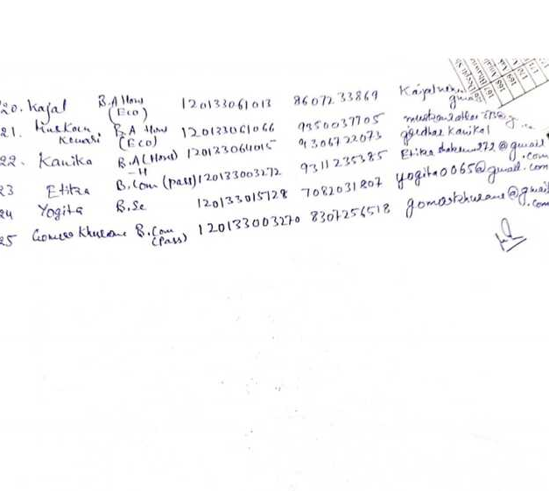

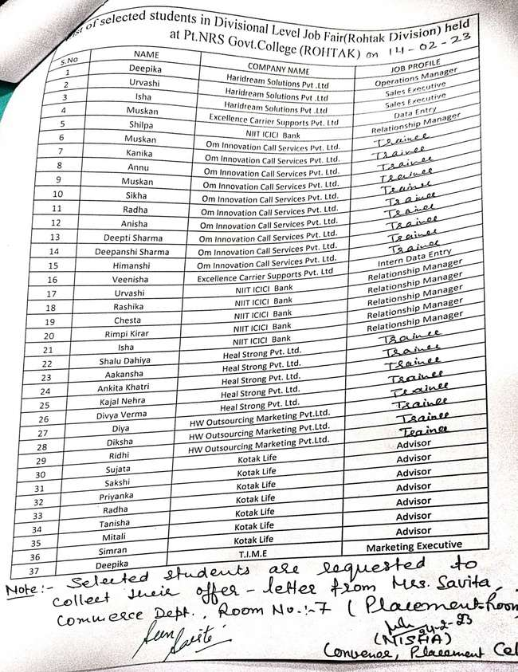

ACTIVITY 4:
Two lectures were organized to guide the students about their career opportunities in administrative services and IT sectors on 01-03-2023. First lecture titled “ Administrative services: IAS/HCS” delivered by Mr. Ankit from Bhavishya Academy, Rohtak and second one was delivered by Dr. Pooja Mittal, Assistant Professor, Dept. Of Computer Science, MDU, Rohtak titled “ Current Trends and Opportunities in IT Sector.” 137 students of various streams attended these lectures.

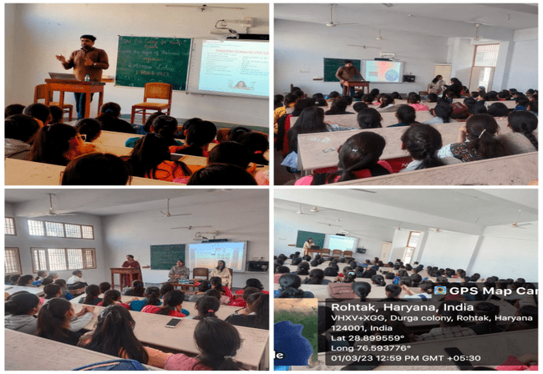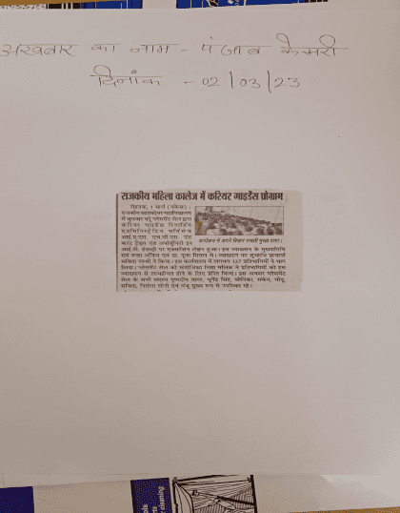

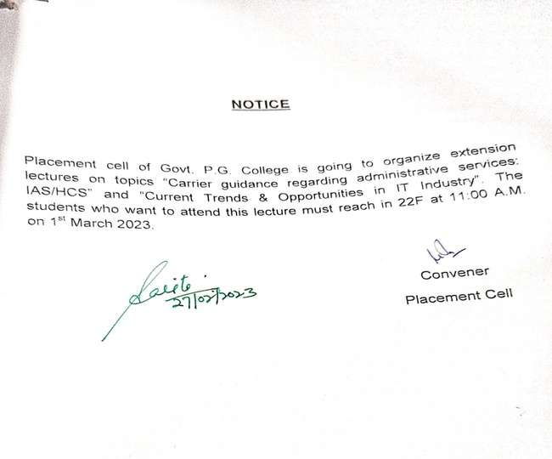

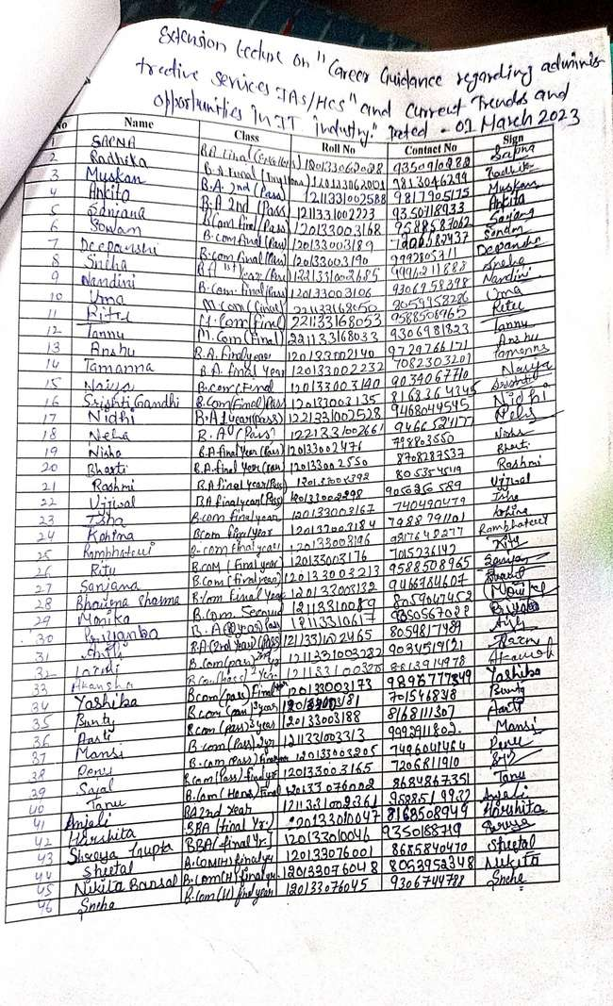

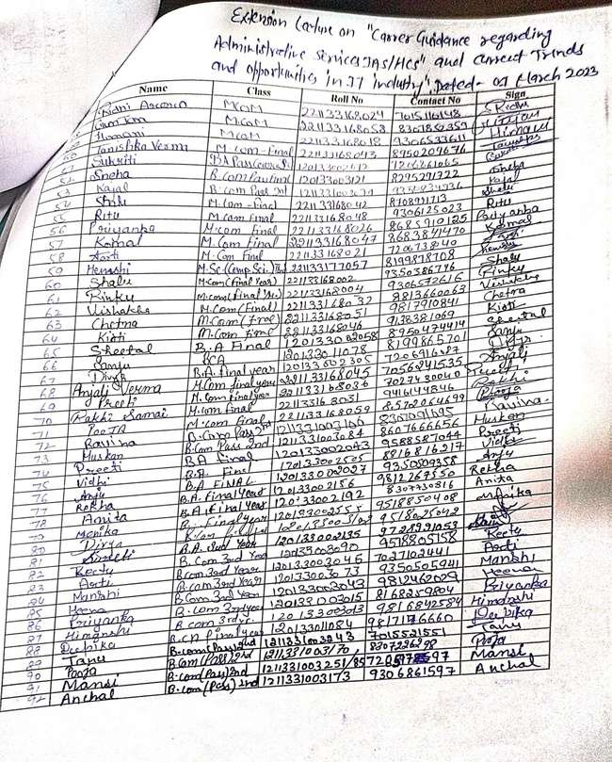

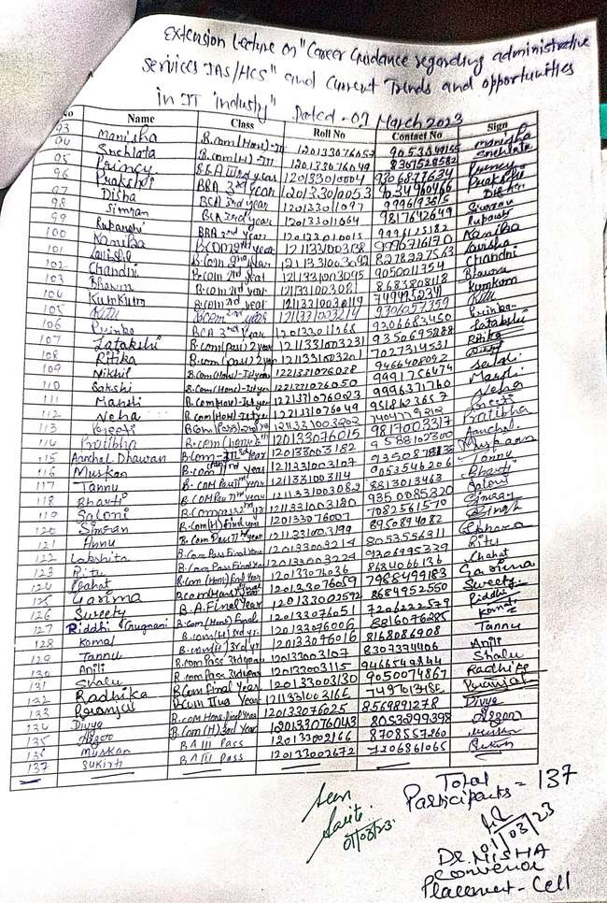

ACTIVITY 5:
A campus placement drive was organized for the students of computer science on 31-03-2023. Code Quotient Software company conducted a written exam for first level and call for interview for next level on the basis of written results 87 students of Computer science department participated in the drive.

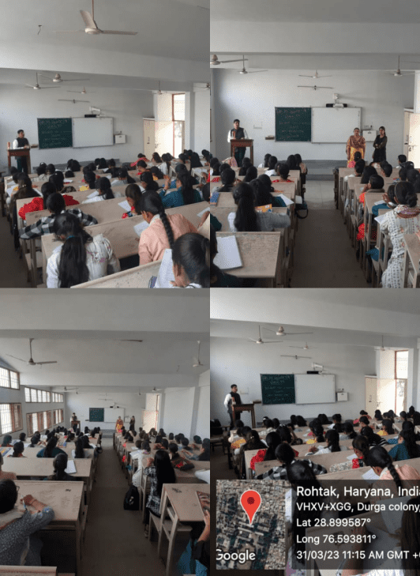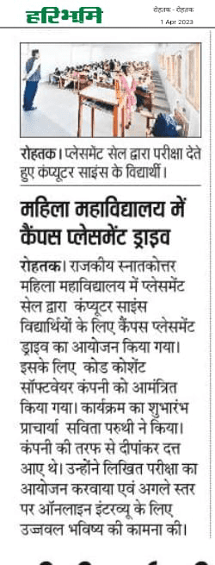

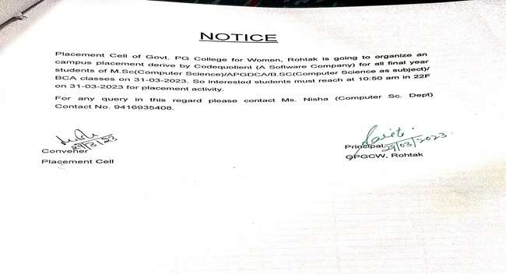

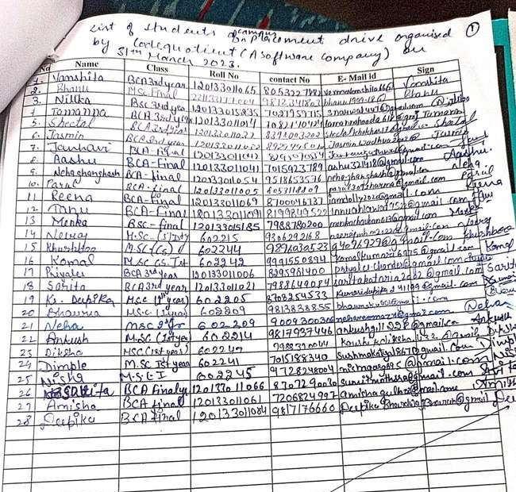

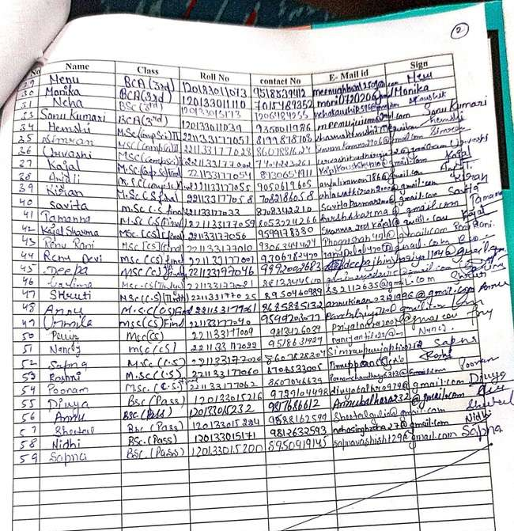

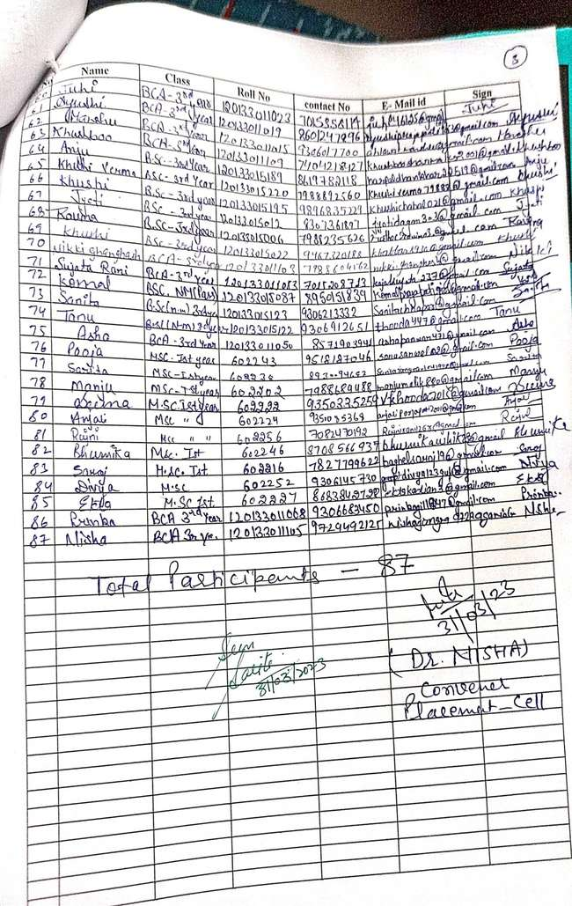

ACTIVITY 6:
A workshop was organised to aware and guide students on “Career Development” by "Sunstone LEAP" for all final year students of all UG classes on 06-04-2023. 60 students of final years from different streams attend this lecture.

