Internal Quality Assurance Cell (IQAC)

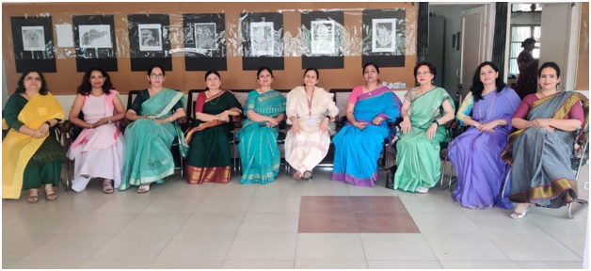

To promote measures for the institutional functioning towards quality enhancement through internalization of quality and institutionalization of best practices, Govt. College for Women, Rohtak established IQAC in the year 2011 in compliance with ideology of the governing body of the higher educational institutions: The NAAC.As the quality enhancement is a continuous process, the IQAC works towards the realization of goals of quality enhancement. It plays a vital role in development of a system of conscious, consistent and catalytic improvement in the holistic performance of the institution in all its academic and administrative efforts. IQAC ushers quality in assessment and accreditation by taking up latest initiatives and planning new strategies and deploying these towards the attainment of the higher objectives/goals of the institution for excellence. It also helps the institution in channelizing its efforts towards promoting the comprehensive academic and administrative excellence.

NAAC Certificate
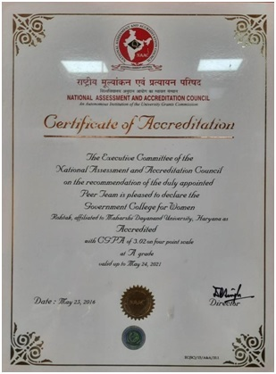
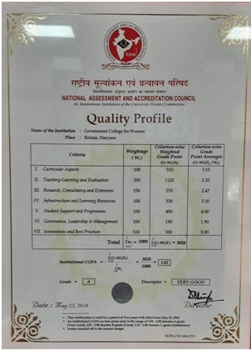

Vision
Setting quality benchmarks with consistent work for excellence.

Mission
To promote measures for institutional functioning towards quality enhancement through internalization of quality cultural and institutionalization of best practices as well as to act as a catalytic agent in the institution by bringing heightened level of focus in institutional functioning.

Objectives

The primacy of this cell is
- To evolve a system for diligent and meticulous action to enhance the academic and administrative performance of the institution
- To promote a cultural of quality through innovative techno-abled practices
- To provide a learner-centric environment for the principal stakeholders and to assist them to confront the multi-dimensional demands and challenges of the industry
- To implement and sustain quality systems which will ensure compliance with relevant regulations and standards
- To motivate and facilitate quality measures in improving teaching quality through Upgrading initiatives such as professional development opportunities and programs
- To empower the faculty and administration staff by sending them for training programs and FDPs
- To provide adequate and supportive facilities to enhance student learning experience in the campus
- To provide recorded mechanisms for feedback from the stakeholders to continually strive to incorporate changes in keeping with the changing scenario
- To develop, implement, monitor benchmarks and high standards in all activities of the college

Strategies
The Internal Quality Assurance Cell shall evolve mechanisms and procedures for
- Organizing meetings with external experts and heads of departments.
- Approving proposals put forth by Committees/cells/units/departments.
- Addressing grievances of students as and when needed.
- Collecting student’s feedback, faculty feedback, alumni feedback.
- Encouraging faculty to attend seminars/conferences/workshops/symposia/FDPs.
- Putting proposals before the principal for improvement of facilities and infrastructure.
- Monitoring the mentor-mentee groups.

Benefits
IQAC will facilitate and contribute towards its chief objectives and its endeavour is to ensure and assure robust cultural of quality to a heightened level of clarity and focus on institutional functioning towards quality enhancement and facilitate internalization of quality culture.
- There is effective coordination between the committees/cells/department heads and college programs.
- A sound base is provided for decision making to improve institutional functioning.
- The process of development is catalysed in the institution.
- Better environment for internal communication is provided.
- Enhancement and integration among the various activities of the institution are encouraged.

FUNCTIONS
- Setting quality benchmarks with consistent work for various academic and administrative activities of the institution.
- Creating parameters to reach academic as well as non-academic learning goals.
- Creating a student centric teaching-learning environment.
- Enabling faculty to efficiently use Hi-tech tools for innovation in education.
- Collection and analysis of feedback of students, faculty and Alumni for the best practices.
- Organizing various workshops &seminars for quality education environment.
- Documenting all the activities in chronological order and keeping an eye on improvements.
- Preparation and maintenance of institutional database through MIS for the purpose of maintaining and enhancing the institutional quality.
- Preparation and submission of the Annual Quality Assurance Report (AQAR) as per guidelines and parameters of NAAC.

ROLE OF THE COORDINATOR
IQAC coordinator is like the captain of the ship. Coordinator has the responsible approach towards the work processes and most importantly works on the goal of achieving NAAC accreditation.

Operational Features of the IQAC
IQAC ensures clarity of the work processes. Its continuous assessment pattern makes it possible to create an internalization of quality education culture in the institution. It ensures a better collaboration between various departments of the college and eradicates the communication gap with frequent evaluation and feedbacks. IQAC allows the faculty to properly create authentic documentations and keep their records for future reference in the NAAC assessment process.

Monitoring Mechanism
The IQAC will conduct audits both internal and external to accomplish its quality enhancement initiatives.
Documentation of the records will be the prime focus of the IQAC and will be communicated to all concerned in bringing about positive changes. The IQAC will form a nexus between the Management, Principal, faculty and student body to achieve tasks set every year.
Regular documentation and SPP of each committee/cell/club and following it stringently will provide ample scope for annual submission of the AQAR to NAAC.
The IQAC will also put in place a feedback system, which will in turn benefit each of the stakeholders.
The IQAC shall also create its exclusive space on its institutional website and regularly upload its activities and host its annual report .

IQAC Composition of the institution is tabled below
SlNo. | Member | Name of Member | Designation
1 | Chair Person | Mrs. Poonam Bhanwala | Principal
2 | Convener | Mrs. Seema Jain | HOD Zoology
3 | Advisor | Mrs. Savita Pruthi | HOD Chemistry
4 | Member | Dr. Santosh Hooda | Faculty, Dept. of Zoology
5 | Member | Dr. Meenu Nain | Faculty, Dept. of History
6 | Member | Dr. Savita Thakran | HOD English
7 | Member | Mrs. Sudesh | HOD Computer
8 | Member | Dr. Jyoti | Faculty, Dept. of Geography
9 | Member | Dr. Kiran Sharma | Faculty, Dept. of English
10 | Member | Dr. Pushp Deep Dagar | Faculty, Dept. of Commerce
11 | Member | Dr. Sushila | HOD Commerce
12 | Member | Dr. Renu | Faculty, Dept. of Botany
13 | Alumni Member | Dr. Manju | Retd. Asso. Prof. Psychology
14 | Student Member | Ms. Aanchal | B.Sc II (Phy. Hons)
15 | External Member | Mr. Parmod Gouri | Social Achivist
16 | Industry Representative | Mr. Mahipal Jain | MD Supertech Industries

