GOVERNMENT PG COLLEGE FOR WOMEN, ROHTAK

SUPPORTING DOCUMENT FOR 2.3.2

USE OF ICT FOR EFFECTIVE TEACHING AND LEARNING
(2021-2022)

AVAILABLE ICT FACILITIES IN GPGCW COLLEGE, ROHTAK

Number of Teachers using ICT | ICT  Resources  available | Number of Projectors in College | Number of Smart Classrooms | E-resources  Techniques
220 | Wi-Fi Enabled Campus; ICT Enabled Smart Classrooms having projectors, interactive boards; Automated College library having accessibility to e-resources vide SOUL software. | Total: 14 (Fourteen) | 10 (Ten) | Wi-Fi Enabled Campus; ICT Enabled Classrooms having projectors, interactive boards; College library having accessibility to e-resources vide SOUL
(PPT, E-learning resources, Sharing and delivering E- contents, Web references, others (audio/visual, documents etc.)

GOOGLE FORM ANALYSIS OF INDIVIDUAL TEACHERS USING VARIOUS METHODS FOR THE STUDENT LEARNING EXPERIENCE
- Video lecture Link/Links to students:

- Hindi Department
https://youtu.be/MAwlusWBygk
https://youtu.be/Orl1r5kxJsA
https://youtu.be/RbH_ZZSpV_s
https://youtu.be/5S0A_muEM6I
https://youtu.be/q4XitgIKMIQ
https://youtu.be/JLsftwlWoiI
https://youtu.be/t2Qu063-swQ
https://youtu.be/eejuBl5K-QM
https://youtu.be/3v7HhdUHTnI
https://youtu.be/6sGiwHP9wU0
https://youtu.be/ABwYASJc3Ac
https://youtu.be/S8BoGD6XrRQ
https://youtu.be/226m5SG3P5k
https://youtu.be/2KiXNI-SbTM
https://youtu.be/JJ3rRlxcin4
https://youtu.be/8Xin2rKeOYM
https://youtu.be/SN2pdMX6od0
https://youtu.be/M41HIK8AmGI
https://youtu.be/P9cb3-FVqQo
https://youtu.be/537dGrLTv9M
https://youtu.be/ACgYpY17QRA
https://youtu.be/jM0gpxHAtCc
https://youtu.be/CRyM58XEeXM
https://youtu.be/PrdHVtTtKIs
https://youtu.be/THgCUt69HzQ
https://youtu.be/GFJA-yS3IYY
https://youtu.be/xBL1UpcxdSU
https://youtu.be/boXVWH4zEYQ
https://youtu.be/zWOAt-PwPHg
https://youtu.be/HzBj3FkcTJc
https://youtu.be/Ax6AmUVnnpM
https://youtu.be/D74TV8adyTw
https://youtu.be/CbdH9DuK89k
https://youtu.be/e2SF2H8Zu84
https://youtu.be/MVWjXenu0-c
https://youtu.be/_rQO92E5LHI
https://youtu.be/-U6aMyVS4tI
https://youtu.be/tLxvQb3gW08
https://youtu.be/lEWKVsQ1dHw
https://youtu.be/hWcsbCkHjUs
https://youtu.be/0FKflr7n3aU
https://youtu.be/TJUm1H-adHY
https://youtu.be/0RW3PYcKcSg
https://youtu.be/H99wDbDzxKo
https://youtu.be/Kb5ULgGOmuA
https://youtu.be/4ePPS8vjQlI

- Chemistry Department

Faculty | Video lecture Link
Dr. Anita (HOD) | https://youtu.be/0uwLYsJ75Do
Dr. Sonika | https://youtu.be/9nm2cQwE--g

- Zoology

Faculty | Video lecture Link
Babli | https://drive.google.com/file/d/1TslxDwWLbPR9wWZvH0smhyG8BvhFcnC_/view?usp=drivesdk
Radha Rathee | https://youtube.com/@Radharathee

- Maths

Faculty | Video lecture Link
Babita | https://youtu.be/2IuXXyjQUqI  https://youtu.be/d2a0pX-C5To
Sarita | https://youtu.be/rQVag5NlGiI  https://youtu.be/CVwtmrggx2Q
Neeraj | https://youtu.be/AjJjY6CbixE  https://youtu.be/1VdHtgBaLtk
Savita Deswal | https://youtu.be/0_UwriUNA8  https://youtu.be/U_t2cx7e_aI
Kusum | https://youtu.be/2b-3xs3zUsI  https://youtu.be/BEIRqinU6eU
Ridam | https://youtu.be/N4-bKleosH0  https://youtu.be/4JA9d65219E
Shalini Nagpal | https://youtu.be/7vO0uc3ekxE.  https://youtu.be/rJ_vEs4TE-I

- Computer Science

Faculty | Video lecture Link
Rohini Sharma | https://www.youtube.com/watch?v=4jmsHaJ7xEA  https://www.youtube.com/watch?v=eIrMbAQSU34&t=7s

WHATSAPP GROUPS TO SHARE NOTES AND OTHER VALUABLE INFORMATION WITH STUDENTS
- Botany Department
(HOD): Mrs. Veena Sachdeva
https://chat.whatsapp.com/IUX3Cmq5oN54ATIn2OEfi3
- Hindi Department
(HOD)
https://chat.whatsapp.com/K6gcOe17BpkKe3ZmHitpHq
https://chat.whatsapp.com/KSJ7J75yC3dISFS6jF2ibt
https://chat.whatsapp.com/KkKNTjtyJHWIb8G3Hqc5p1

- Home Science Department
(HOD) : Ritu Hooda
https://chat.whatsapp.com/GfXXbVqXp1U92a3aSySqSV
https://chat.whatsapp.com/Iskvw6akJmtBZ6bPchtcxK
https://chat.whatsapp.com/E3dXv4aj7ZyG6oZ5Ic6LDP
https://chat.whatsapp.com/GhssNkCGpnU5877vsmNZvL

Others
https://chat.whatsapp.com/KOhfjoOtprkKxzuPH1uFvg
https://chat.whatsapp.com/ISSVCG9lCz52BJyBrcI5Wm
https://chat.whatsapp.com/DKUfcZIy7P9GF5sjXqFoWw
https://chat.whatsapp.com/DFzbHsbcXScCA725Xco1tK
https://chat.whatsapp.com/BC1uIHQhikw14qGyxoDsrn
https://chat.whatsapp.com/GhssNkCGpnU5877vsmNZvL

- Chemistry Department

Faculty | WhatsApp Link
(HOD) Dr. Anita | https://chat.whatsapp.com/BC39GtpeWYX6SCvd2C5rbU
Dr. Sonika | https://chat.whatsapp.com/HHFstPio64lDKIiTIUY6Qx  https://chat.whatsapp.com/EvJk4nPRO5F23kt0FhljIC  https://chat.whatsapp.com/C1mhWp3zXecBPVkqid2E9T

- Geography Department
https://chat.whatsapp.com/LQ6jZR445ZpDGbE2nziUBq
- Zoology Department

Faculty | WhatsApp Link
Manju Chikara | (B.Sc.Final year )  https://chat.whatsapp.com/JnrCbKYlipc319EqnuDPsU
Mamta passi | https://chat.whatsapp.com/HZOJTE5801lBNYr5PKVgt6
Anu Bhargava | https://chat.whatsapp.com/HZOJTE5801lBNYr5PKVgt6

- Maths

Faculty | WhatsApp Link
Babita | https://chat.whatsapp.com/BQXNjbne6lPG5eU9sX4YH3  https://chat.whatsapp.com/DLUuvy5pHtiJWrx2UcraLk  https://chat.whatsapp.com/DUwF6XC8x9wJQJb4LyjxhL  https://chat.whatsapp.com/GtHeNrREvkN4a4ZF7MgwpN
Sarita | https://chat.whatsapp.com/IYnuBBwCq6MGUbOw7DJAYp  https://chat.whatsapp.com/GtHeNrREvkN4a4ZF7MgwpN
Neeraj | https://chat.whatsapp.com/HxD6M3ubGwA6HJN16WENN3
Savita Deswal | https://chat.whatsapp.com/HxD6M3ubGwA6HJN16WENN3  https://chat.whatsapp.com/GaHnw1cY1QN8mSkOAEC7Iz
Kususm | https://chat.whatsapp.com/G2xzVIiOdiv1niW4XulWag  https://chat.whatsapp.com/GaHnw1cY1QN8mSkOAEC7Iz  https://chat.whatsapp.com/GtHeNrREvkN4a4ZF7MgwpN
Ridam | https://chat.whatsapp.com/FginWPaNaXaL2ecT7rJrVj  https://chat.whatsapp.com/GtHeNrREvkN4a4ZF7MgwpN
Shalini Nagpal | https://chat.whatsapp.com/IYnuBBwCq6MGUbOw7DJAYp.  https://chat.whatsapp.com/G2xzVIiOdiv1niW4XulWag

- Computer Science

Faculty | WhatsApp Link
Dr. Nisha Malik | https://chat.whatsapp.com/JAipNoJL0yDKQ6ETdqHmUd  https://chat.whatsapp.com/BFA36NfPquN4w87XWPmtuD
Rohini Sharma | https://chat.whatsapp.com/FsWXF5IRXLt4w8qi7IXcLu  https://chat.whatsapp.com/DbJo8nJrqLW6zSKT5VvquE  https://chat.whatsapp.com/IbrSH2pvtGeJa905uswbvW

- Physics Department
Class | Faculty | WhatsApp group link
B.Sc. Physics Hons. 1st | Ms. Sanket, Ms. Renu, Ms. Pooja,  Mr. Sonu | https://chat.whatsapp.com/L0AFzBpNnemE5Er6PYoZVH
B.Sc. Physics Hons. 2nd | Ms. Sanket,  Mr. Pardeep,  Ms. Pooja, Ms. Anju | https://chat.whatsapp.com/HWSWgDATNGgJqPLXnPVa7X
B.Sc. Physics Hons. 3rd | Ms. Neha,  Ms. Sanehaa,  Mr. Sonu,  Mr. Vikas | https://chat.whatsapp.com/BYkPNFIypTyK0tWkODdMTu
B.Sc. Non-Medical 1st | Ms. Manju, Ms. Neeraj, Ms. Ekta,  Ms. Renu | Section- A+B  https://chat.whatsapp.com/KVnhhkD09lEC3QCMusqW0E  Section- C-  https://chat.whatsapp.com/HxvFb1Fw3Tz6TUJmZUyUrZ
B.Sc. Non-Medical 2nd | Ms. Manju, Ms. Neeraj, Mr. Vikas  Ms. Ekta | Section- A+B  https://chat.whatsapp.com/HQ9WUbDQTKDFf0o4n6bt4W  Section- C  https://chat.whatsapp.com/EP1U2tQxuGPKkjgEoJRIc5
B.Sc. Non-Medical 3rd | Mr. Pardeep,  Ms. Sanehaa,  Ms. Anju | Section- A  https://chat.whatsapp.com/DWQMdlWpSfACQdgT30eaZo  Section- B+C  https://chat.whatsapp.com/I60JWeTIOjR3km6f4PxJDh

LEARNING MANAGEMENT SYSTEM

The college has implemented the LMS (Learning Management System) which is an online system or software used to plan, execute, and assess a specific learning process.

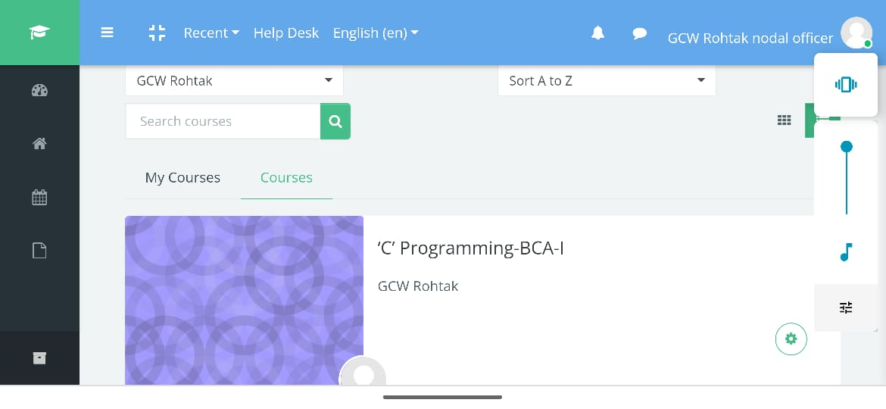

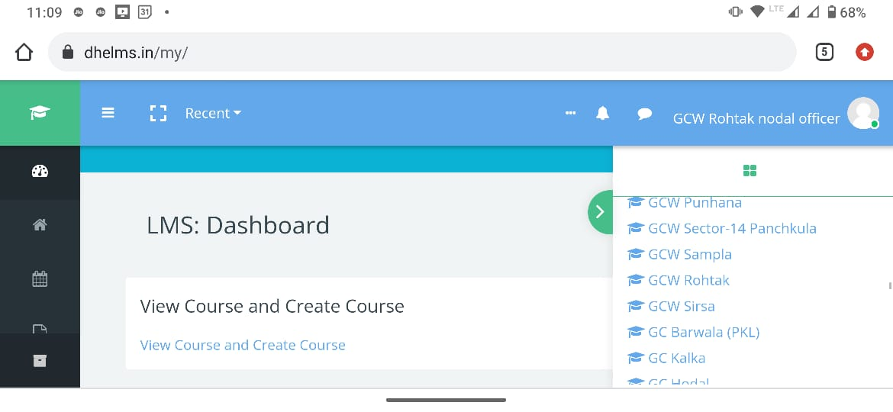

Use of LMS by faculty members of the College

Higher education (Basant Sir)

Geography (Bindu Hooda)

SHIKSHA SETU APP

The Haryana government has launched a mobile application to provide students with information on attendance, fee, online admission, and scholarships of all government colleges in the state. Proof of App used in our college.

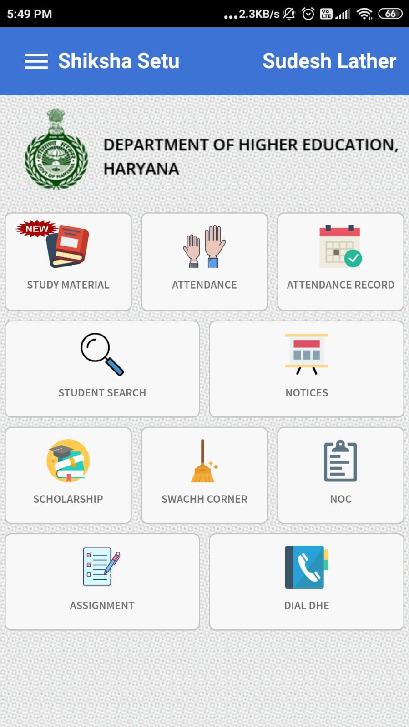

WEBINAR/ SEMINAR / ONLINE EVENTS ORGANIZED BY THE COLLEGE FOR STUDENTS

Hindi Department

अंत: महाविद्यालय ऑनलाइन भाषण प्रतियोगिता :

14-09-2021

अंतर महाविद्यालय ऑनलाइन कविता पाठ प्रतियोगिता:

05/10/2021

अंत: महाविद्यालय ऑनलाइन कविता पाठ प्रतियोगिता :

26/11/2021

अंत: महाविद्यालय ऑनलाइन भाषण एवं कविता पाठ प्रतियोगिता : 04/12/2021

PLATFORMS USED BY TEACHERS FOR ONLINE CLASSES, NOTE SHARING ETC.

Google Classroom
- Zoology
Babli
https://classroom.google.com/c/MzE4MDc2MTIxMTU3/p/MzMwMzcyODg5NzE0/details
- Maths
Babita
https://classroom.google.com/c/NDA5NDY2Mjk4ODk3?cjc=lx7ohf2
https://classroom.google.com/c/NDA5NDc0NDAzODI5?cjc=iyvjs25
https://classroom.google.com/c/NDA5NDcxNTcyNzE2?cjc=udhars2

Neeraj
https://classroom.google.com/c/NDU3MzQ0MDM4Nzg4?cjc=idef7ox
https://classroom.google.com/c/NDU3MzQzMDc5NTc4?cjc=vhliw3b
https://classroom.google.com/c/NDU3MzQ0NzE1NDgz?cjc=67toqce

COMPUTER BASED LABS

Physics Lab

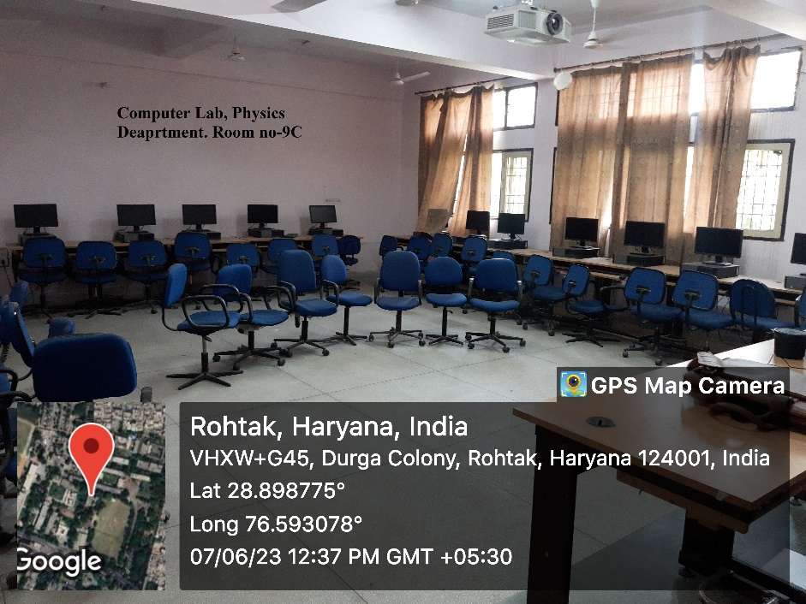

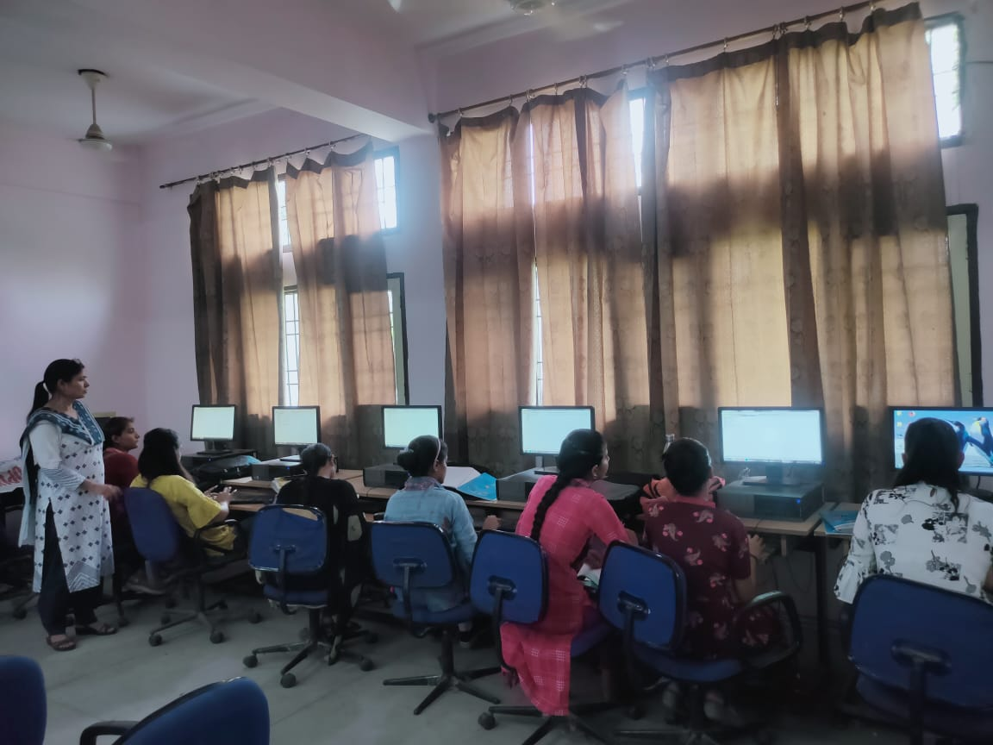

Computer Science Department Lab

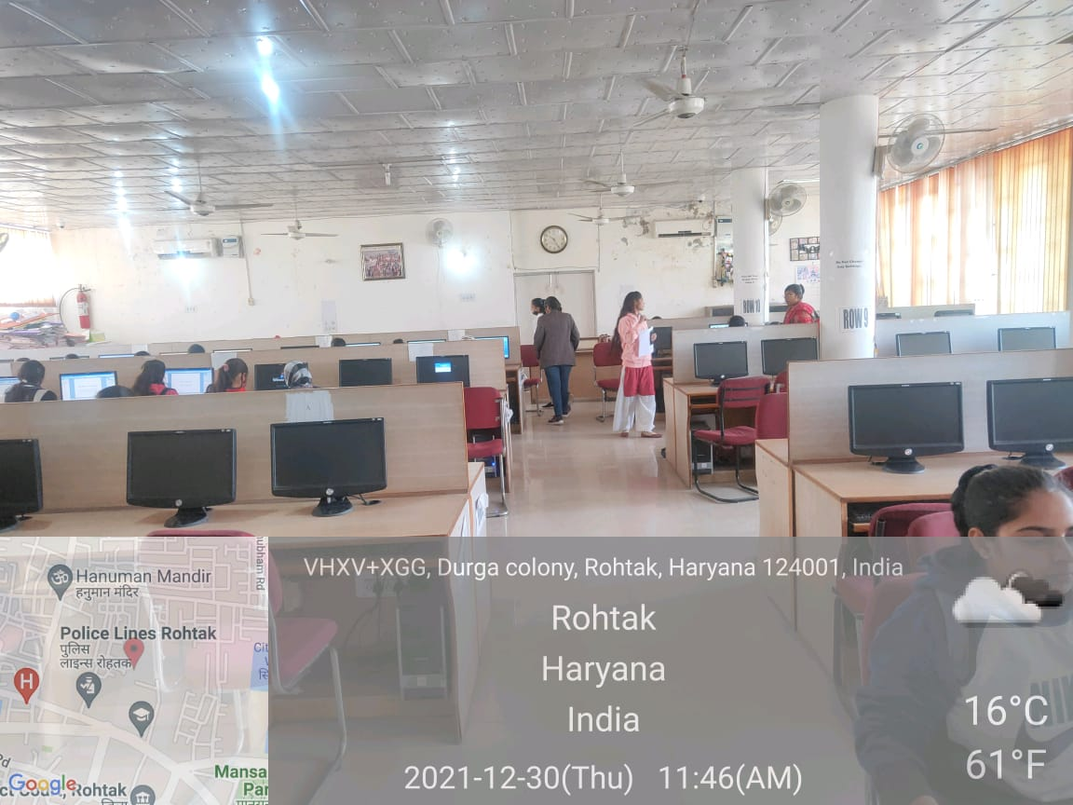

Geography Department Lab

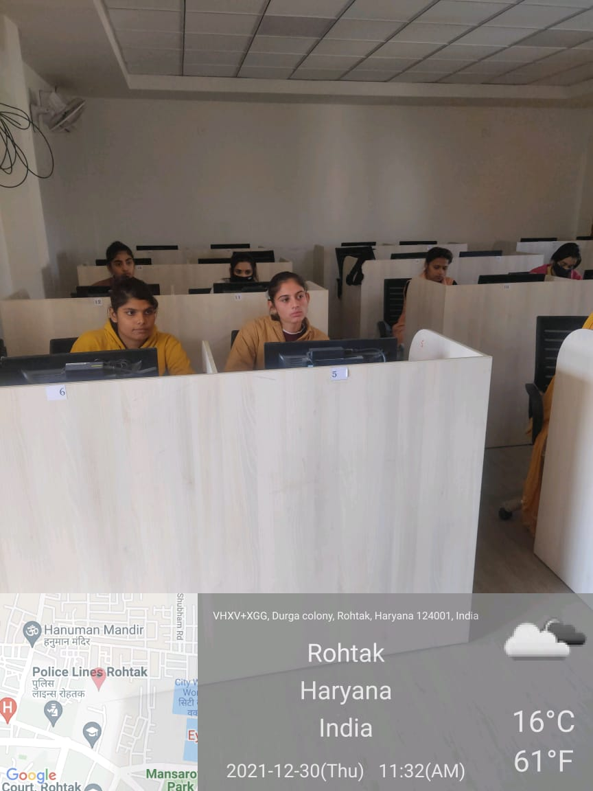

English Department Lab
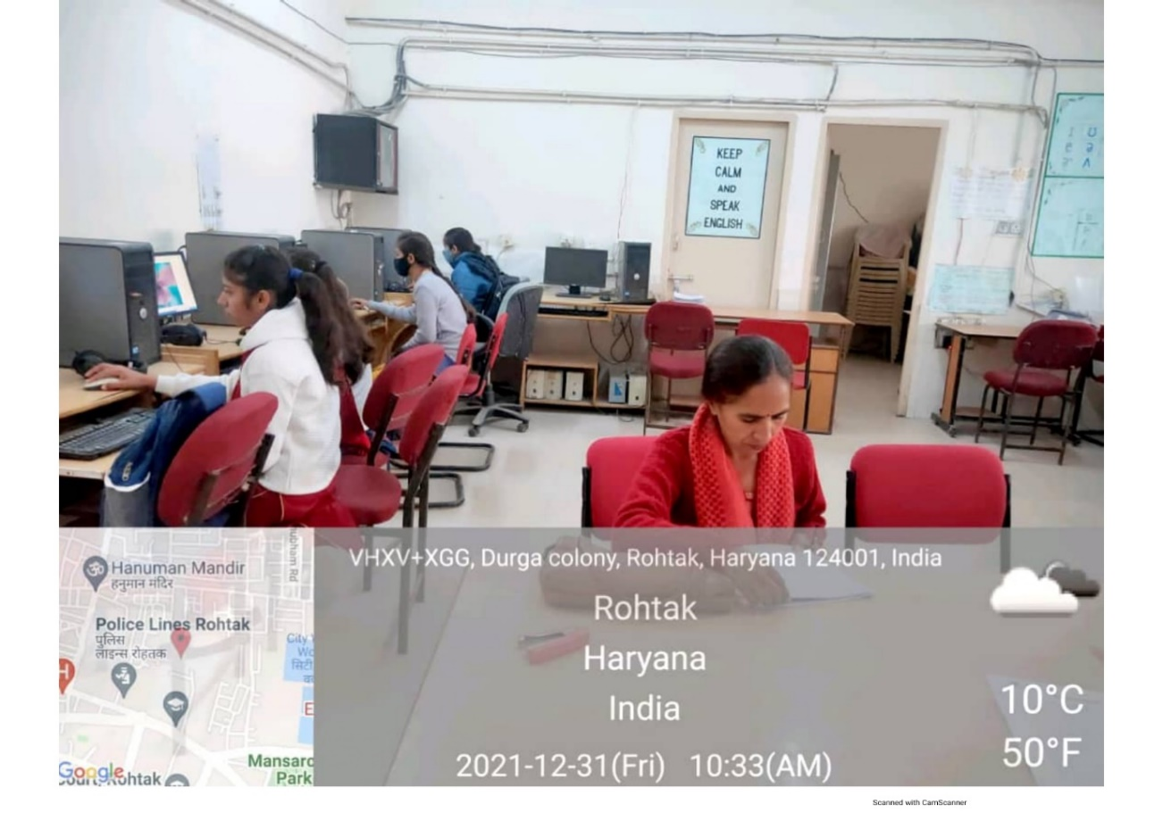
Maths Department Lab
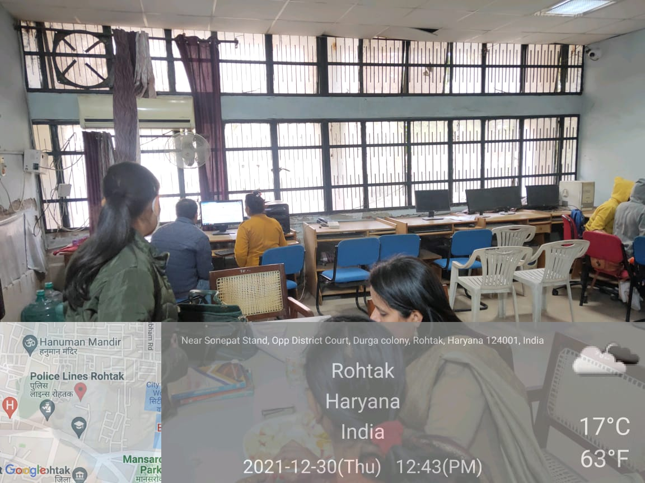

Commerce Department Lab

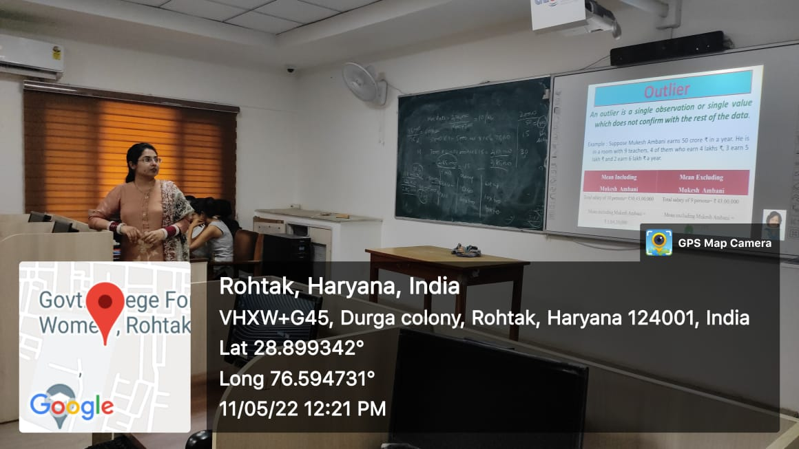

FOLDERS OF E-NOTES SHARED WITH STUDENTS

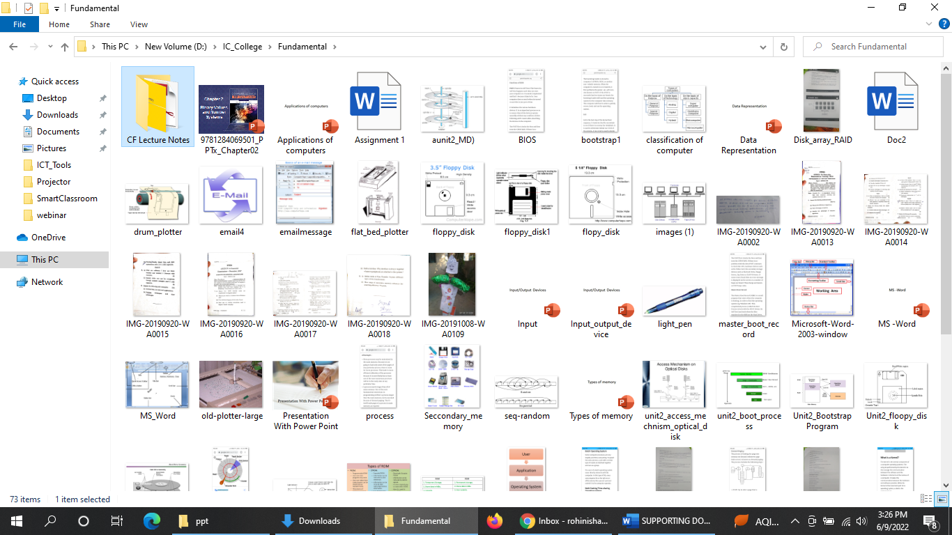

POWER POINT PRESENTATION DETAILS WITH PROOF

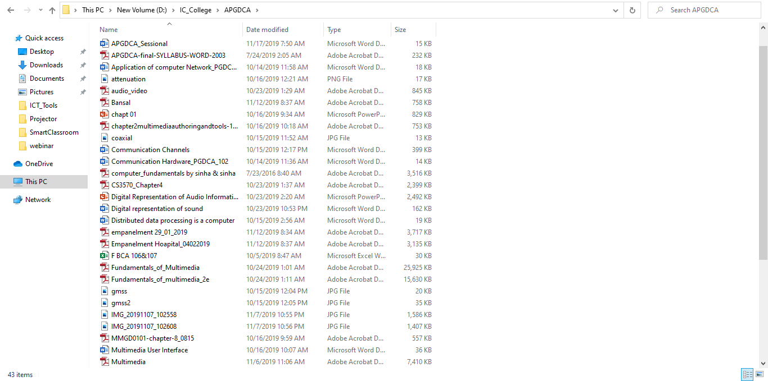

RECORDED VIDEO LECTURES WITH PROOF

https://drive.google.com/drive/folders/1OfMFYSs2PXNRfbtoyDofY1MI1310u6fwM4mHoC3rukzLSbCSTgxXD1OVBpqooPJkoM1xyKII

https://drive.google.com/drive/folders/1OfMFYSs2PXNRfbtoyDofY1MI1310u6fwM4mHoC3rukzLSbCSTgxXD1OVBpqooPJkoM1xyKII

https://drive.google.com/drive/folders/1OfMFYSs2PXNRfbtoyDofY1MI1310u6fwM4mHoC3rukzLSbCSTgxXD1OVBpqooPJkoM1xyKII

https://www.youtube.com/watch?v=aomaLNxtlrA

https://www.youtube.com/watch?v=cK3gdbR-nEM

https://www.youtube.com/watch?v=0BTnOGlJrrU

https://www.youtube.com/watch?v=1FtaTx5LiY0

https://www.youtube.com/watch?v=C_VXsIzTlL4&t=6s

https://www.youtube.com/channel/UCPJNcyaob4eUEMxtpJW8lqA

PROJECTOR FACILITY
In a learning world increasingly dominated by individual devices, the projector remains central to education ---Simon Fry

Computer Science Department Lab (56B-II)
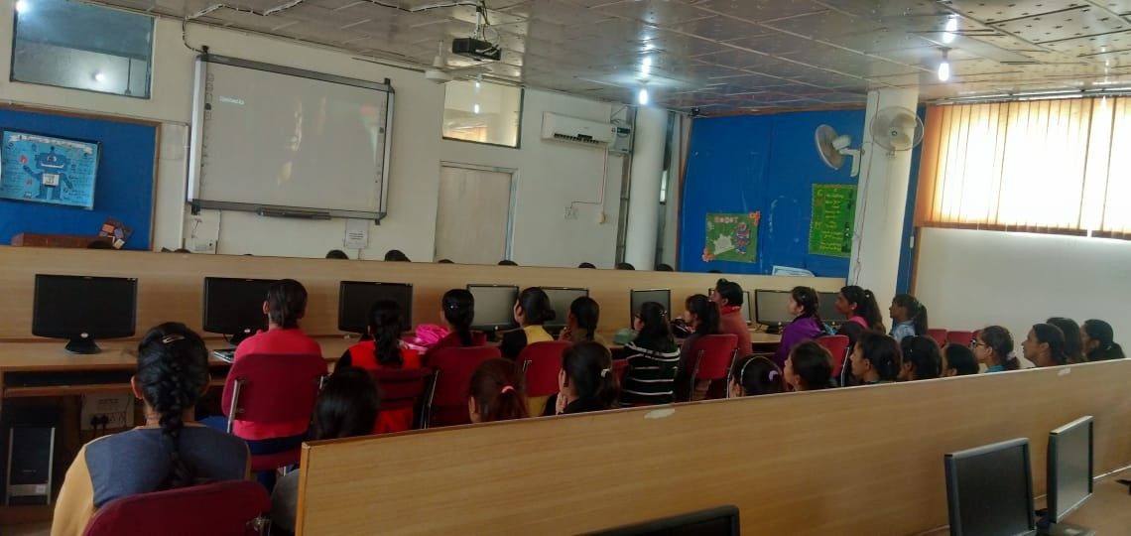

Commerce Department (Room No. 1)
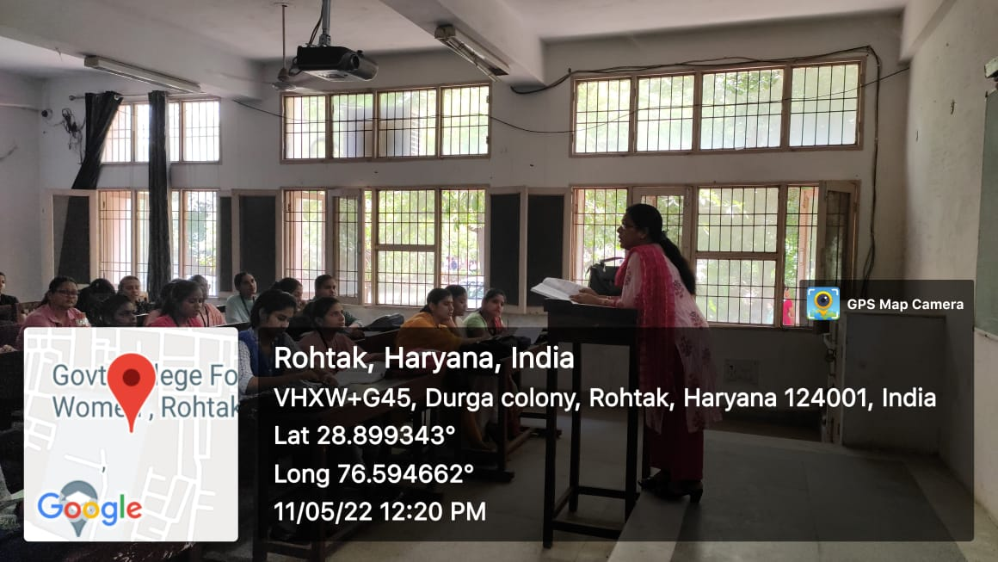

Physics Department ( Room No. 9C)
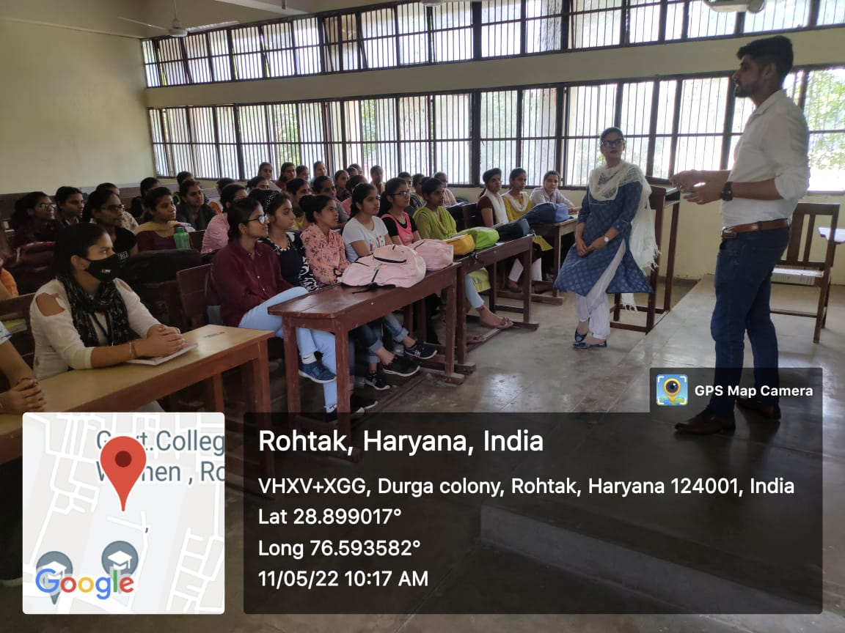
EDUSAT Room
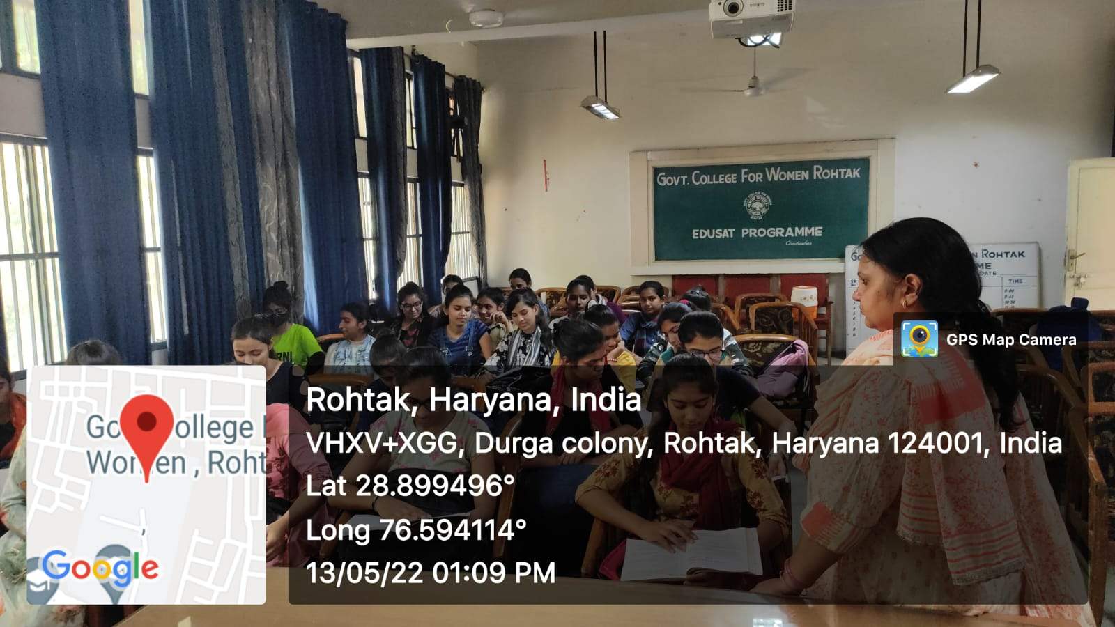

AUTOMATED LIBRARY SYSTEMS HAVING ACCESS TO E-RESOURCES
The record of books in the library is maintained through SOUL software. It is used to maintain a catalogue of books. The library also provides access to free Journals, books and other reading material through https://www.britishcouncil.in/ (N-list, British council of India, national digital library of India).

Details of Book Transaction

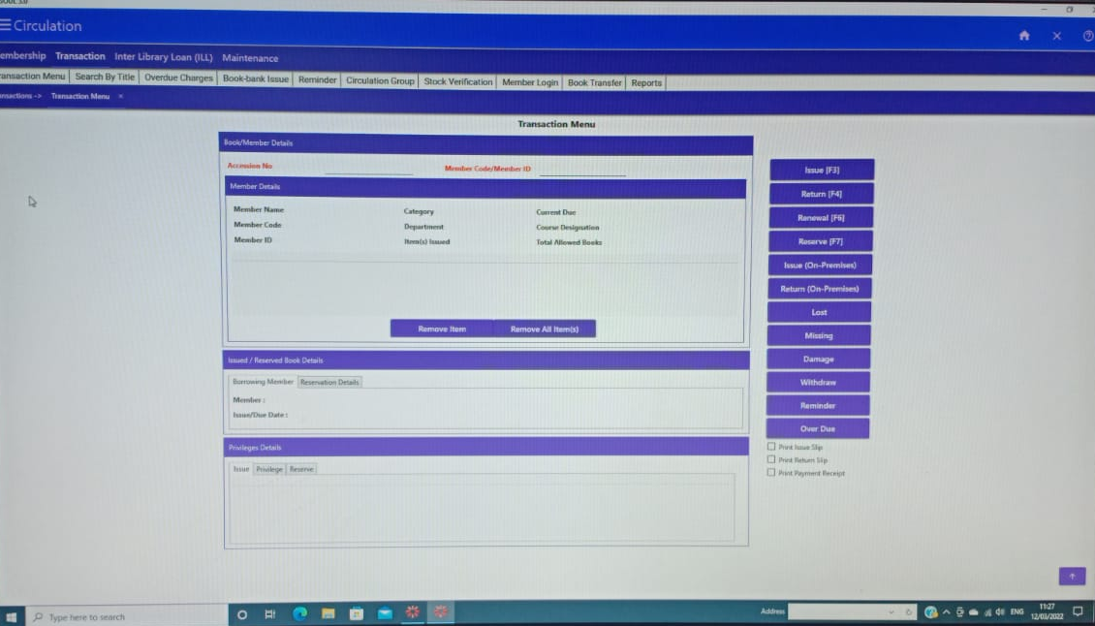

Catalogue of Books

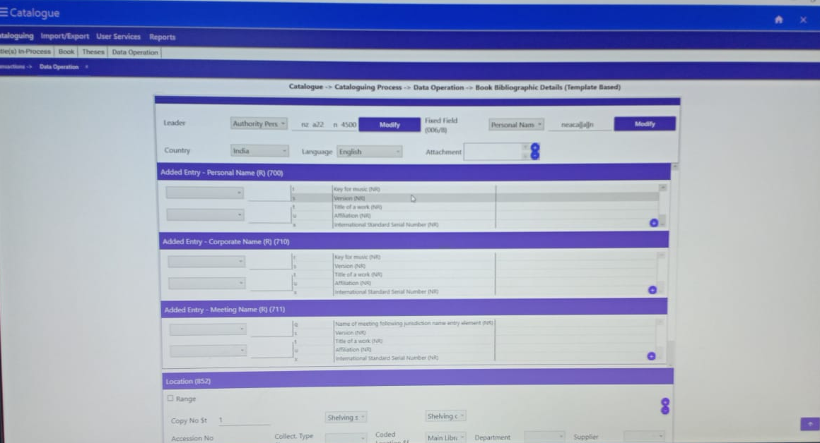

Book Search using OPAC

SOUL Software
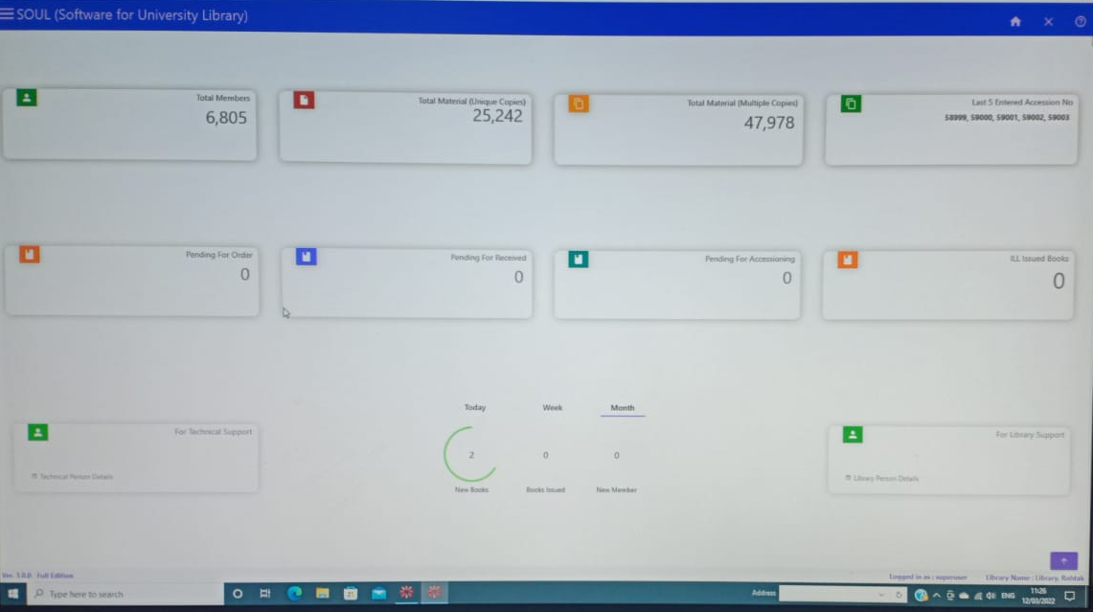

SMART CLASSROOMS
A smart classroom is a technologically advanced learning environment that improves digital teaching and learning. Digital displays, tabs, whiteboards, assistive listening devices, and other audio/visual components are integrated into the classroom, making lectures easier, more engaging, and more interactive. There are total ten smart classrooms available in GPGCW, Rohtak.
Chemistry Department (Room No. 2C)

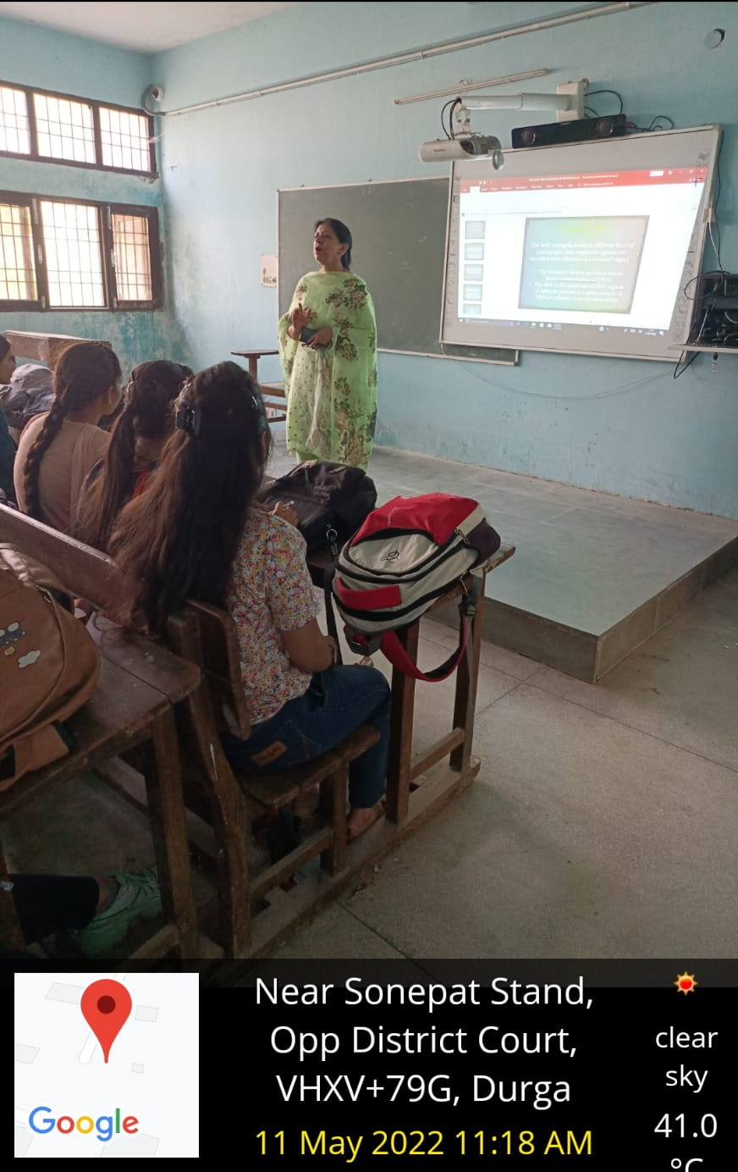

Commerce Department (Room No. 5)
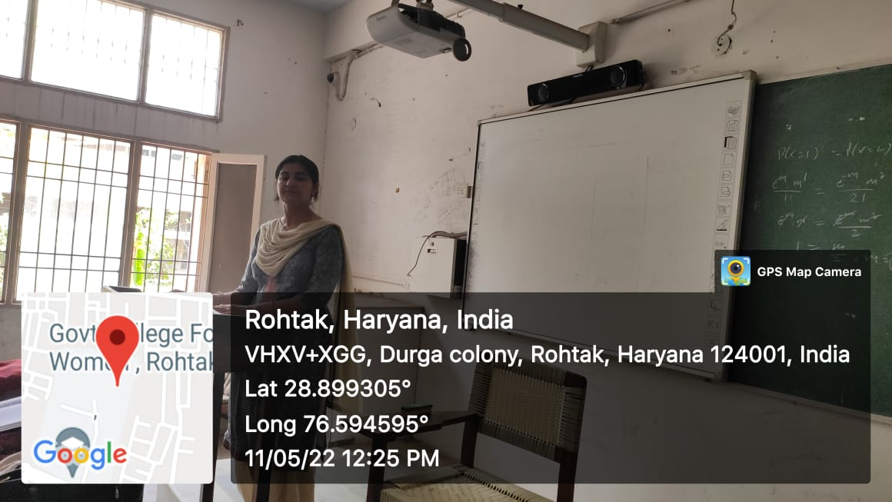

Zoology Department (Room No. 12 C)
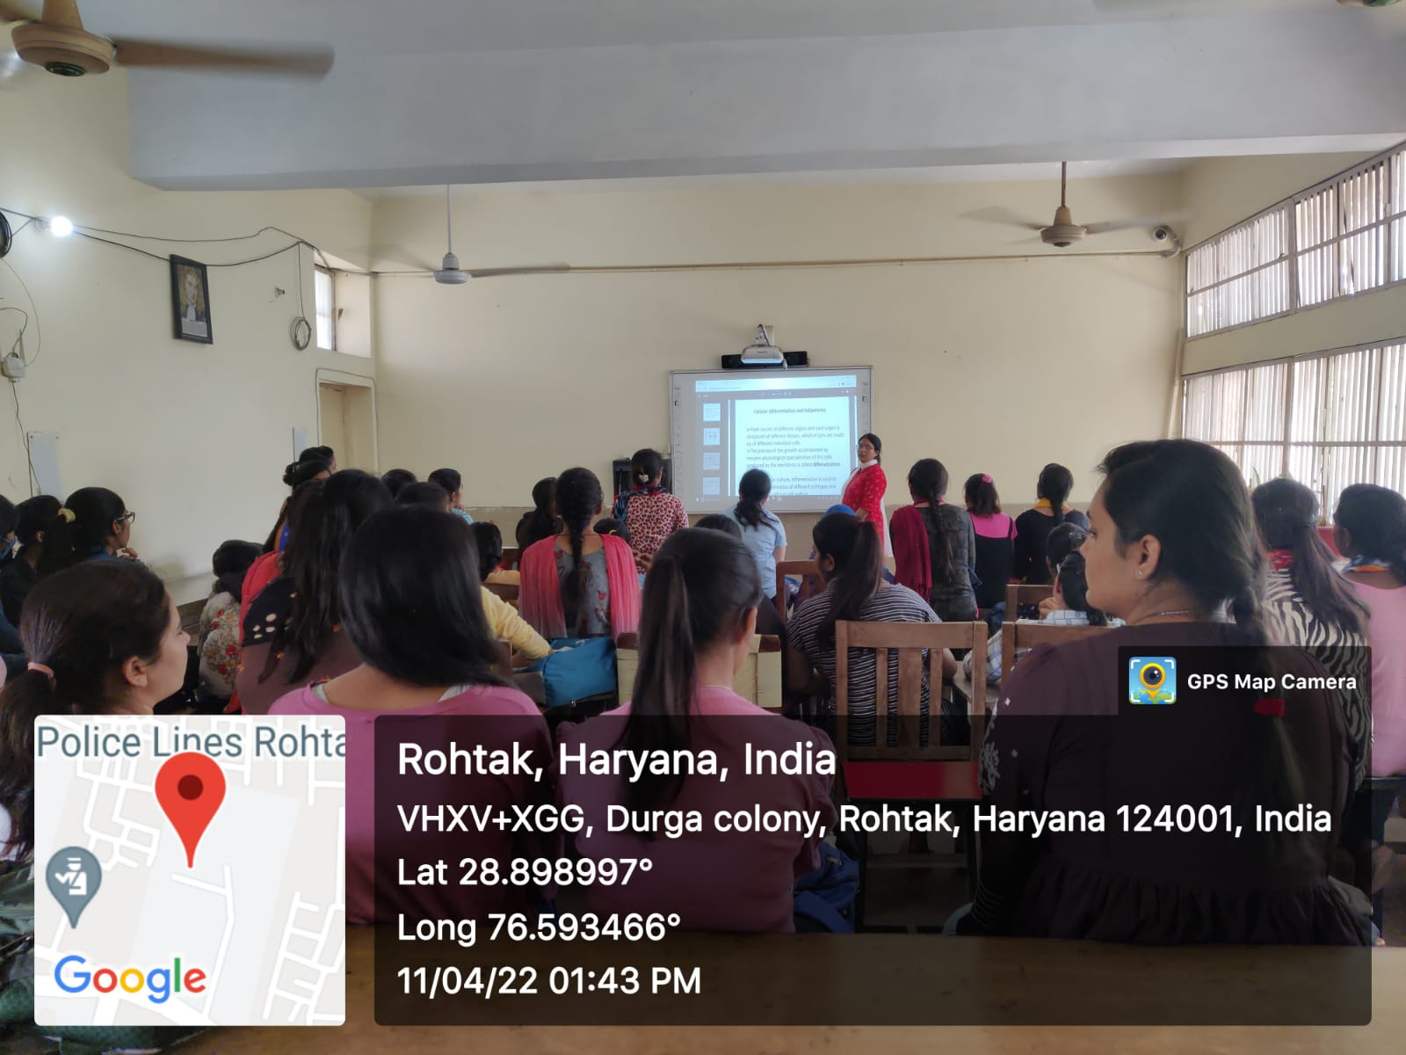

Computer Science Department (Room No. 22F)
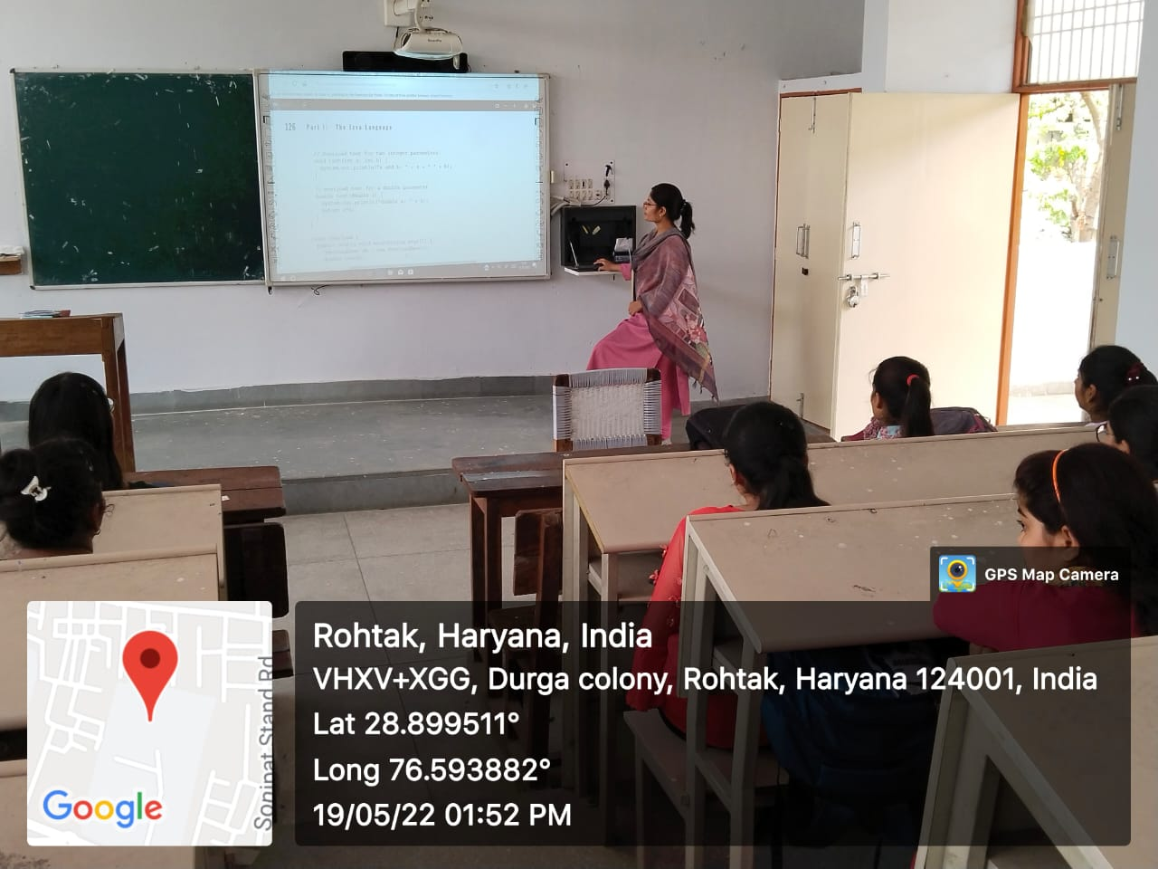
English Department (Room No. 5 A)
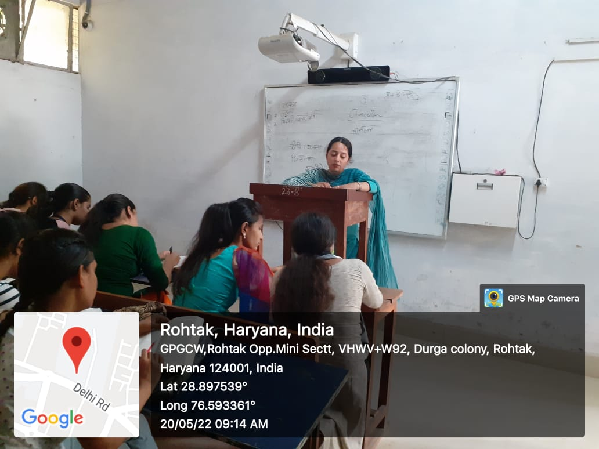

Botany Department (Room No. 51 B)

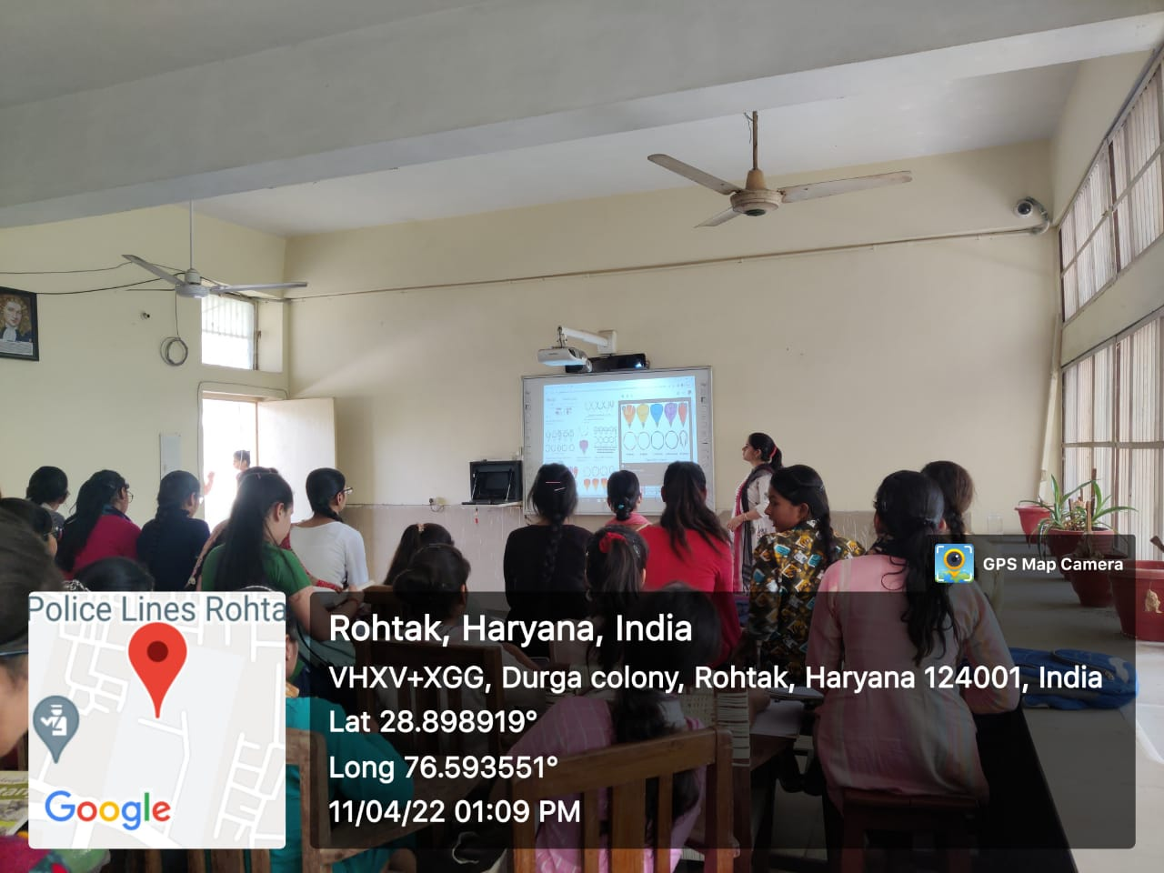

Maths Department (Room No. 2 F)
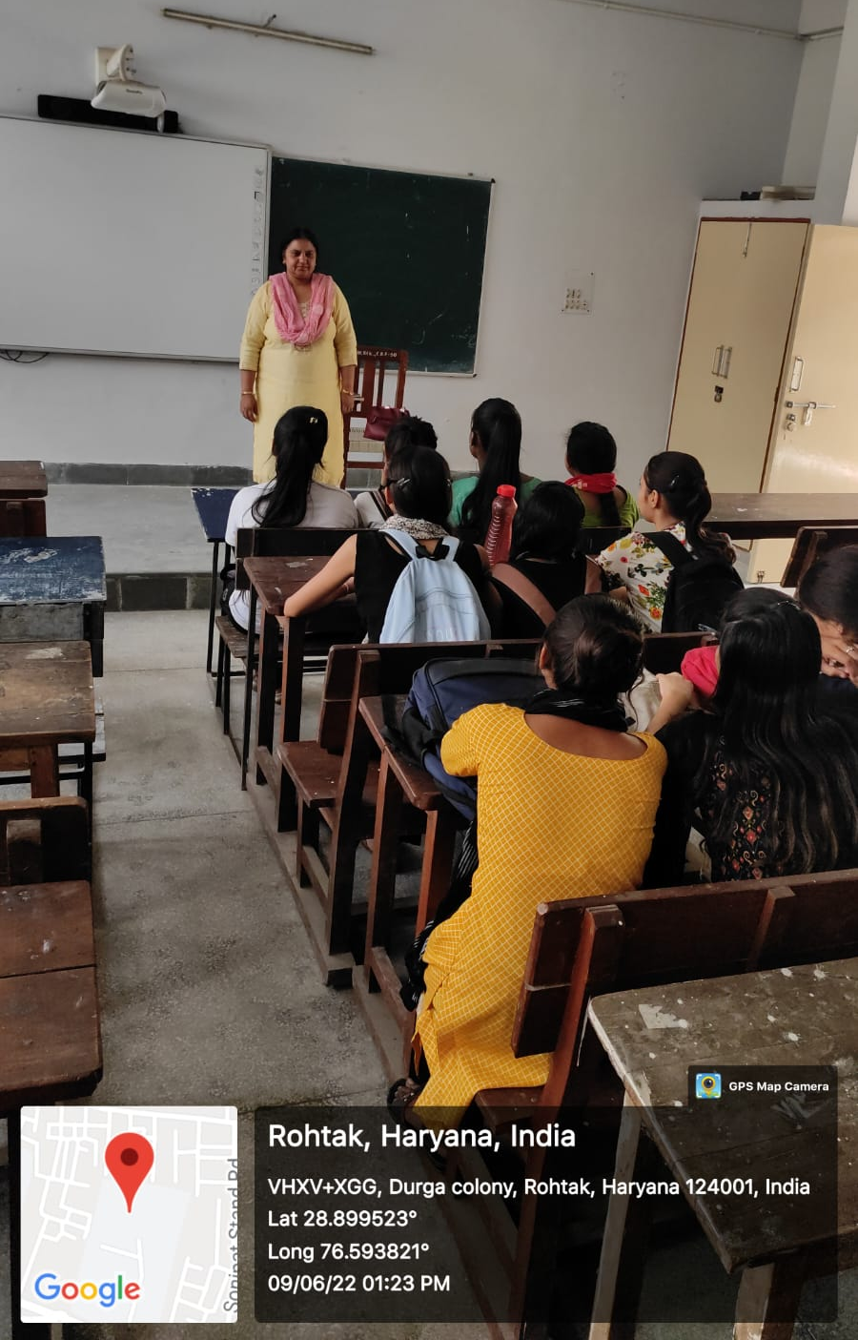

Physics Department (Room No. 32 B)

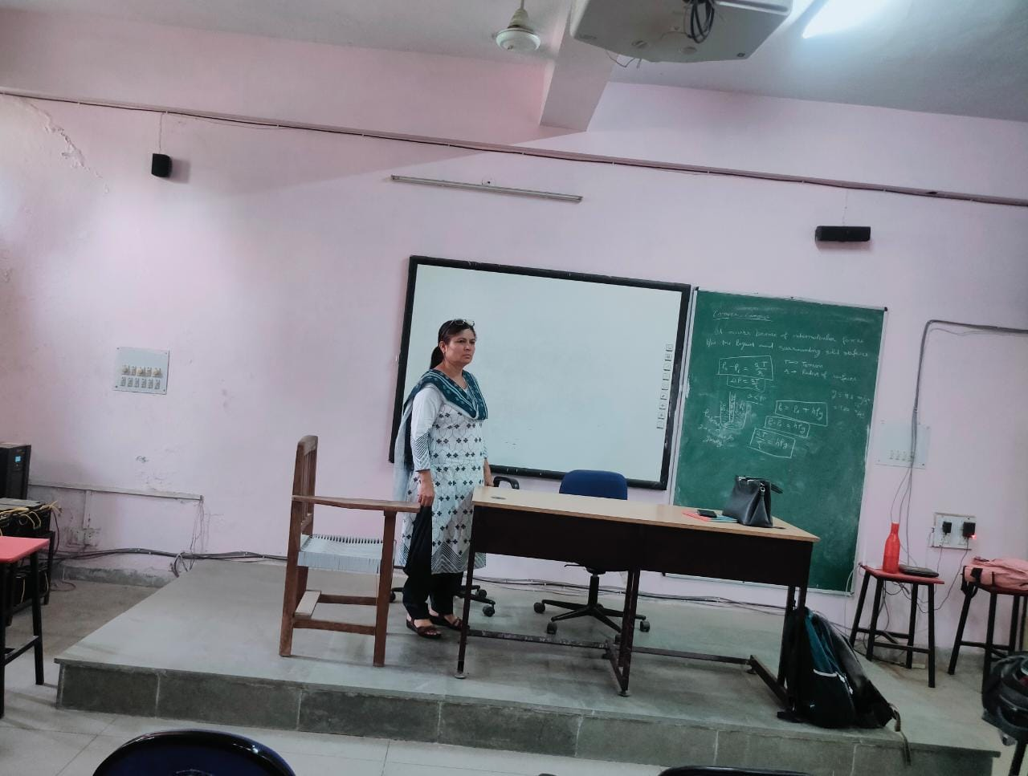

Geography Department (Room No. 31F)
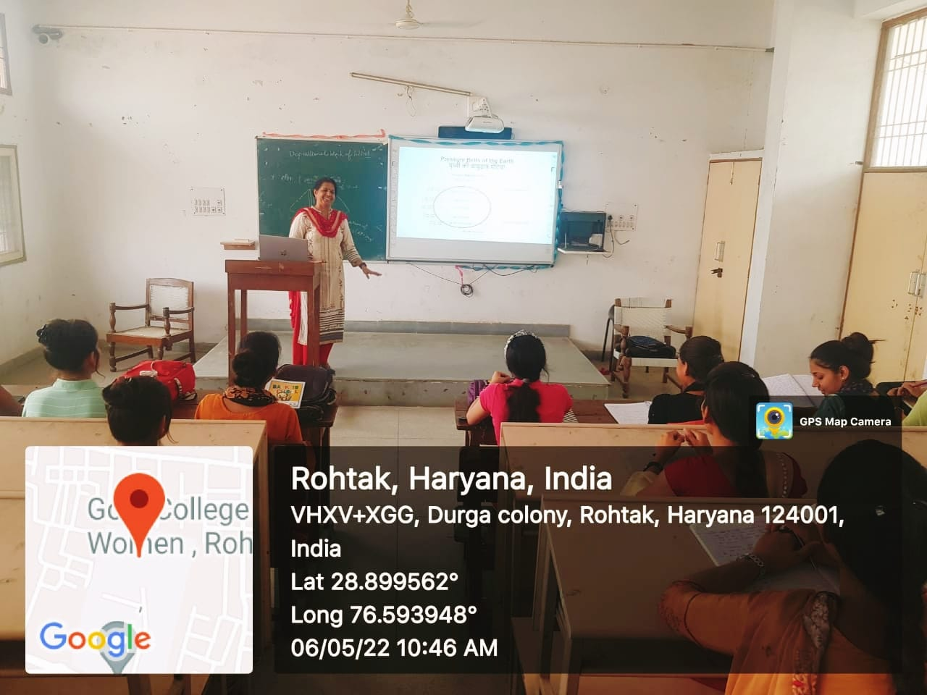

Psychology Department (Room No. 8A)
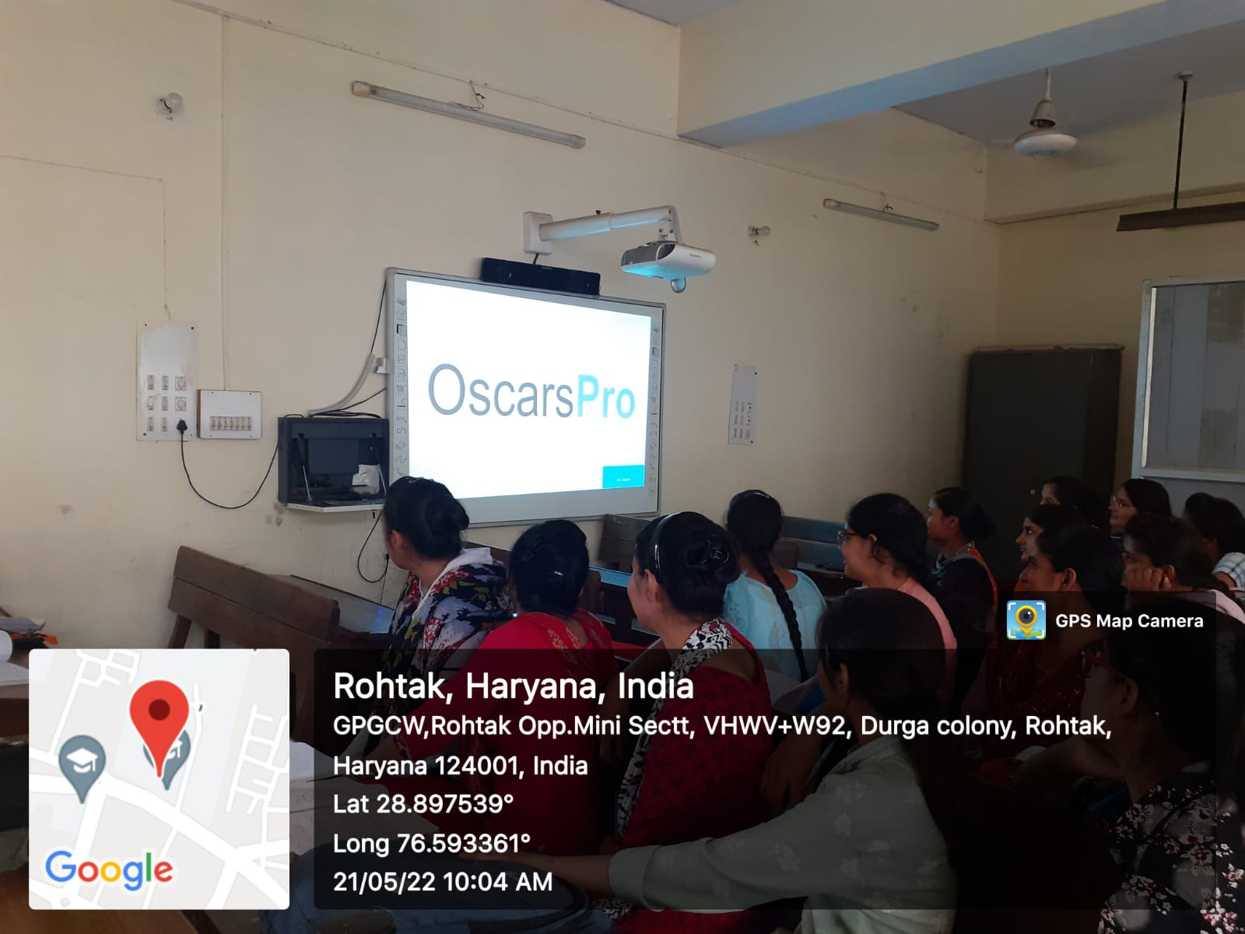

LCD Facility
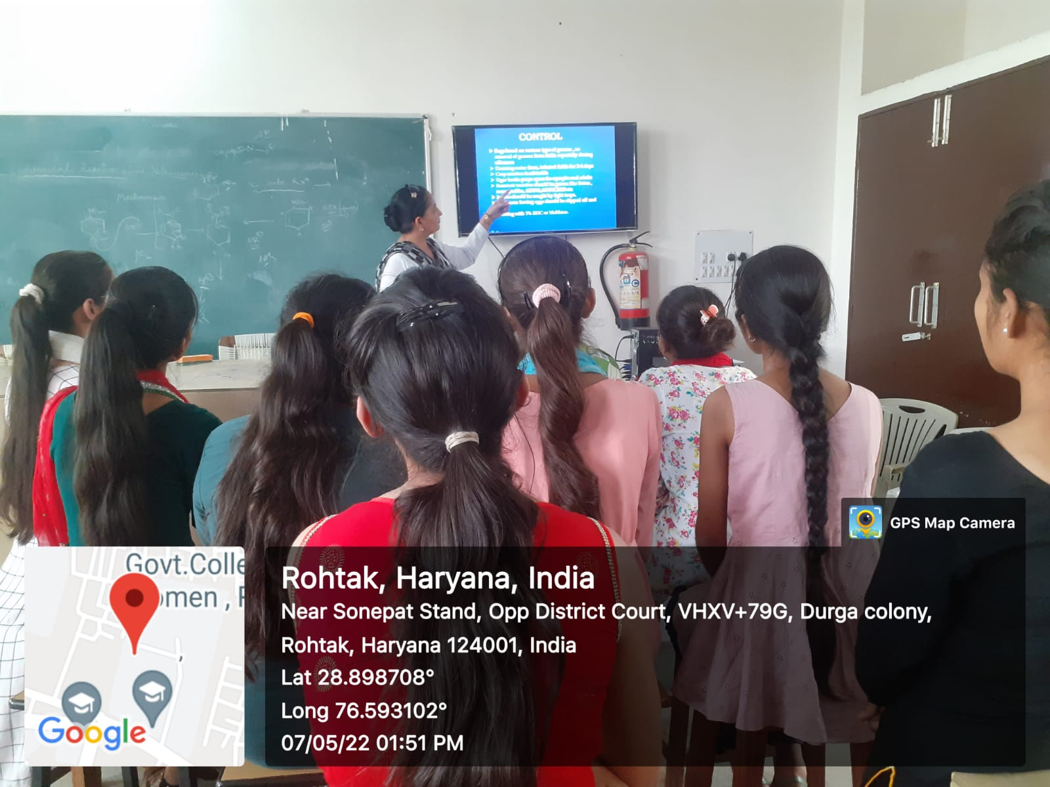
Lecture Presentation Through LCD in Zoology Department
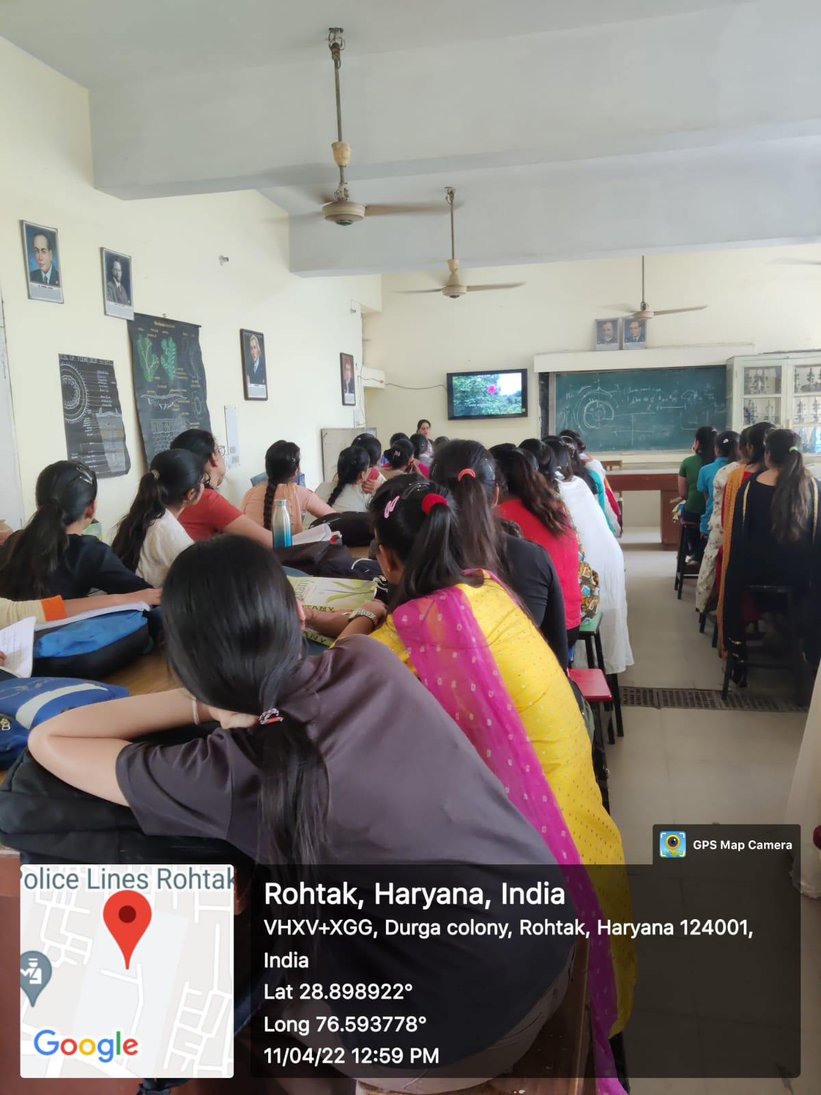
Lecture Presentation Through LCD in Botany Department

ONLINE STUDY MATERIAL BY DEPARTMENT OF HIGHER EDUCATION, HARYANA
http://epgp.inflibnet.ac.in/Home/
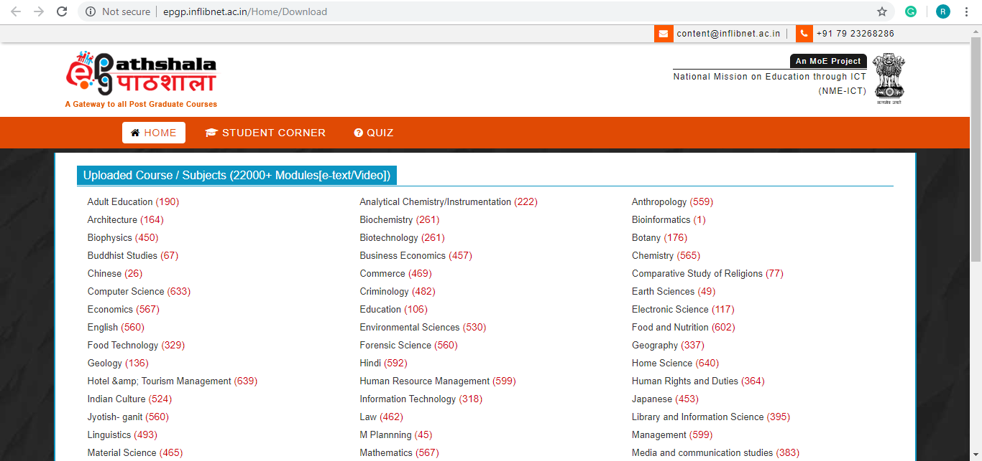

STUDY @HOME
The “Study @Home” facility provided by the DHE, Haryana, enables students to get the online study material just by clicking on the TV screen with the name of the course of students’ choice. https://www.highereduhry.ac.in/StudyHome

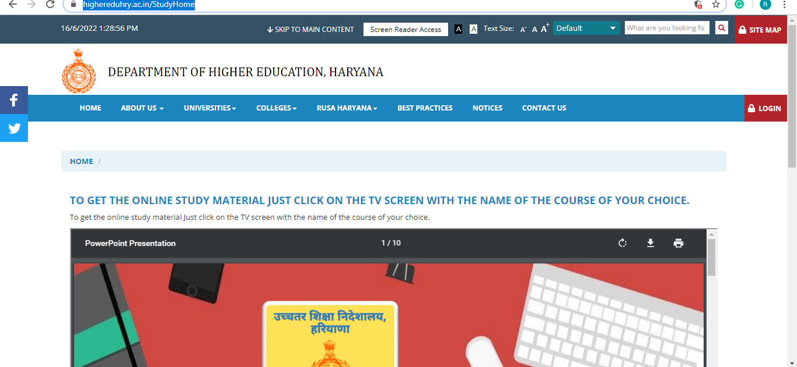

DIGIGYAN- An Initiative of DHE, Haryana
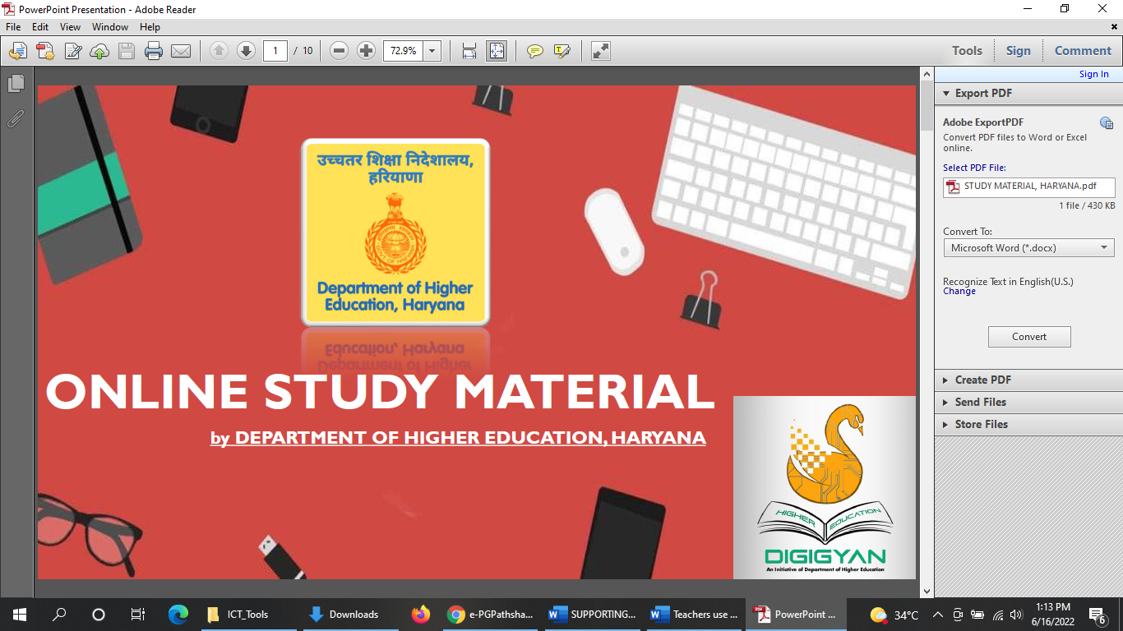

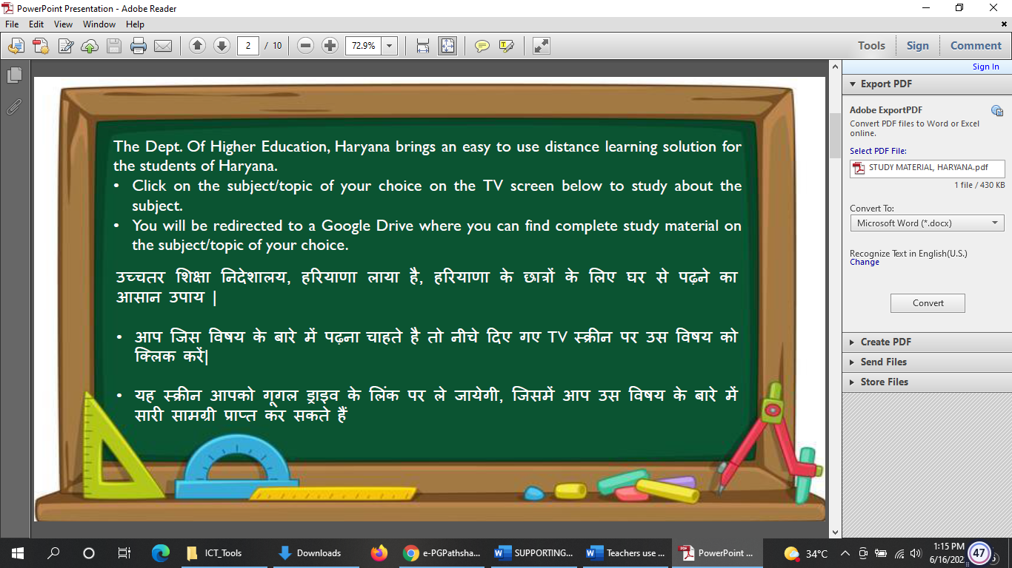

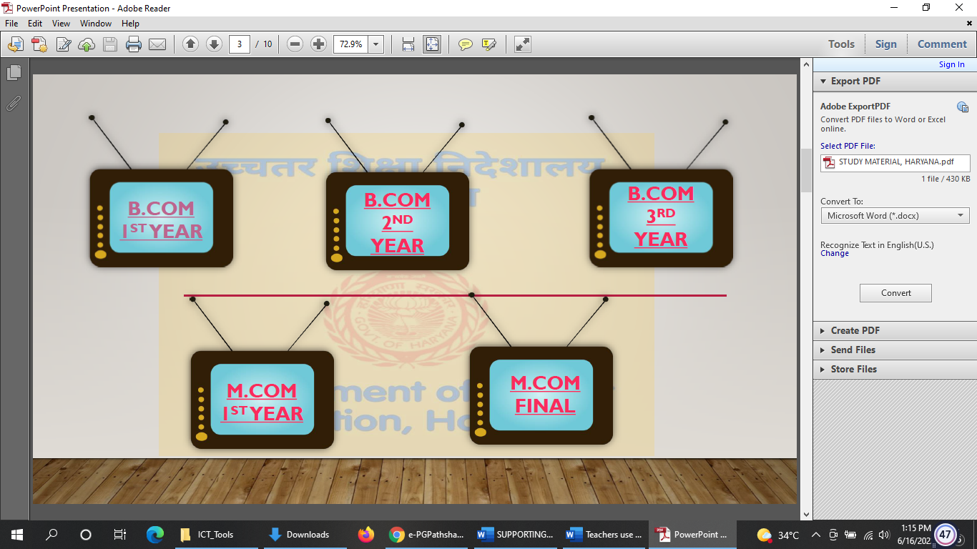

SWAYAM PRABHA, MINISTRY OF HUMAN RESOURCES DEVELOPMENT, INDIA

SWAYAM Prabha is an initiative of the Ministry of Human Resources Development to provide 32 High Quality Educational Channels through DTH (Direct to Home) across the length and breadth of the country on 24X7 basis. It has curriculum-based course content covering diverse disciplines. This is primarily aimed at making quality learning resources accessible to remote areas where internet availability is still a challenge. The faculty members of our college encourage students to learn from this medium. https://www.swayamprabha.gov.in/

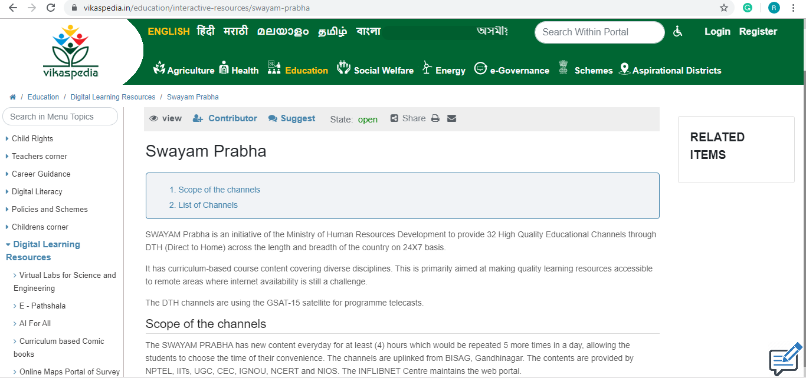

DRISHTIKON
The DGHE has initiated the “Drishtikon,” a digital magazine that provides information about different schemes of DGHE for the welfare of the students.
https://www.highereduhry.ac.in/drishtikon
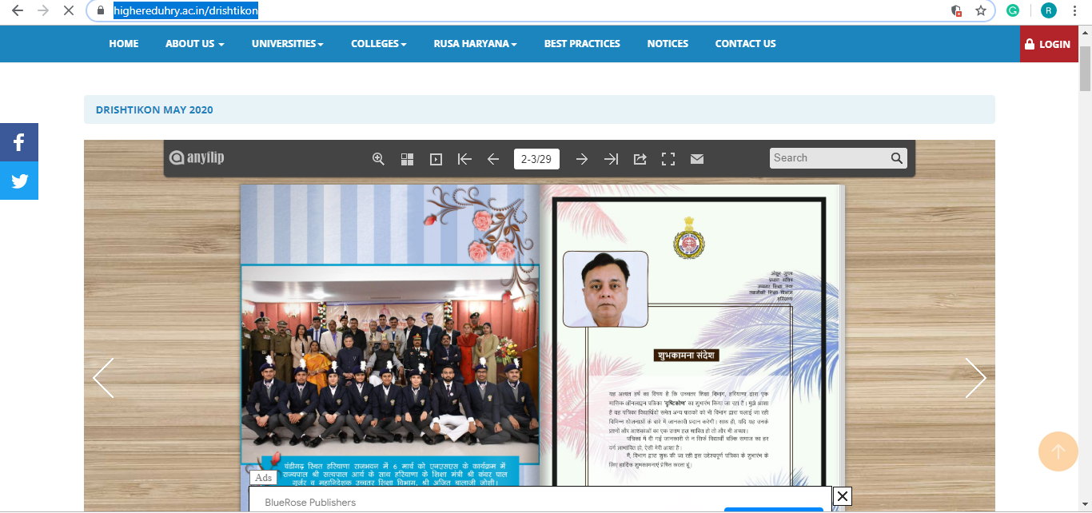
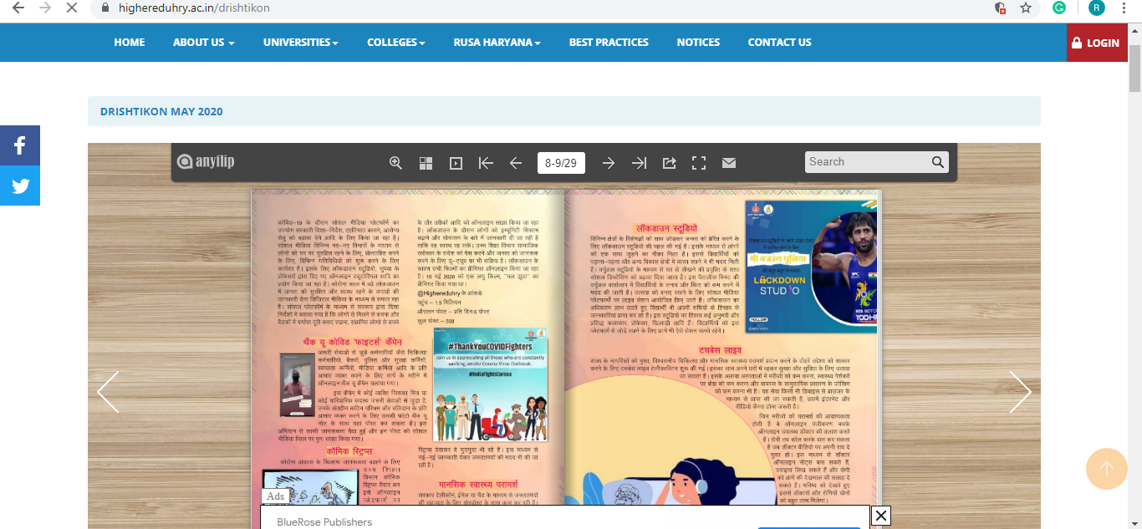

DRISHTI
The DHE, Haryana, has devised a DRISHTI program (Digital Revolution in Information Studies in Haryana for Transformation and Innovation) to boost digital and E-learning in all colleges.
https://www.highereduhry.ac.in/BestPractices

