SUPPORTING DOCUMENT FOR 2.3.1

The College has been constantly working towards a shift from a teaching culture to a learning culture. The institution provides a thought-provoking space, which facilitates the spark to learn, unlearn and re-learn. Taking into consideration the diversity of student’s educational hub that works towards the overall progress of the society by enabling the young minds of the nation to achieve their knowledge and language.

SCIENCE SOCIETY Science society of Government PG College for Women, Rohtak remained active throughout the year. The COVID-19 pandemic made the world realize things that were actually important for the survival of humankind. For instance, people learnt the importance of helping each other for the better functioning of society. As the world fights one of the biggest health challenges in human history, it has brought a sharp focus on the role of science in society. Our goal was to introduce science to everyone by emphasizing the importance of science in our daily lives.

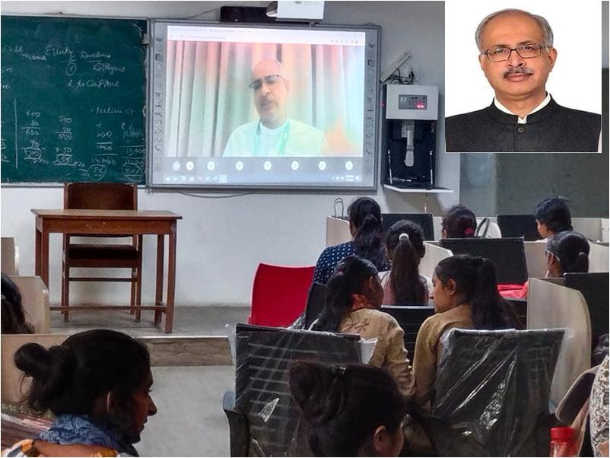

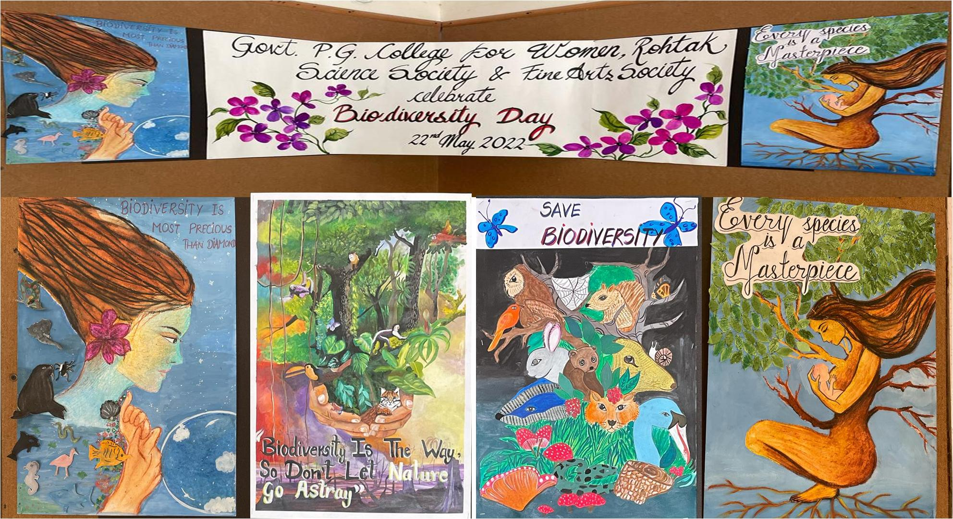

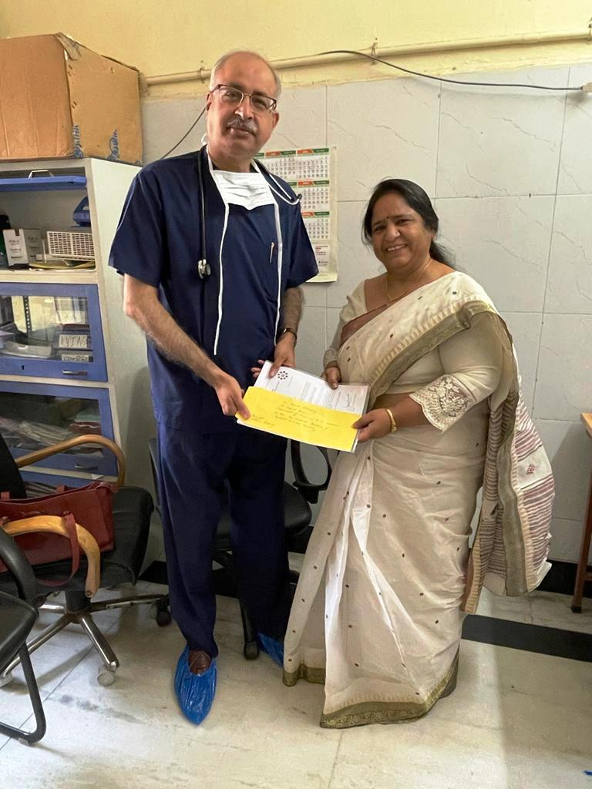

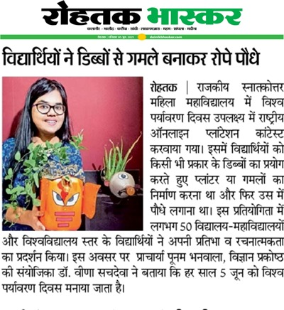

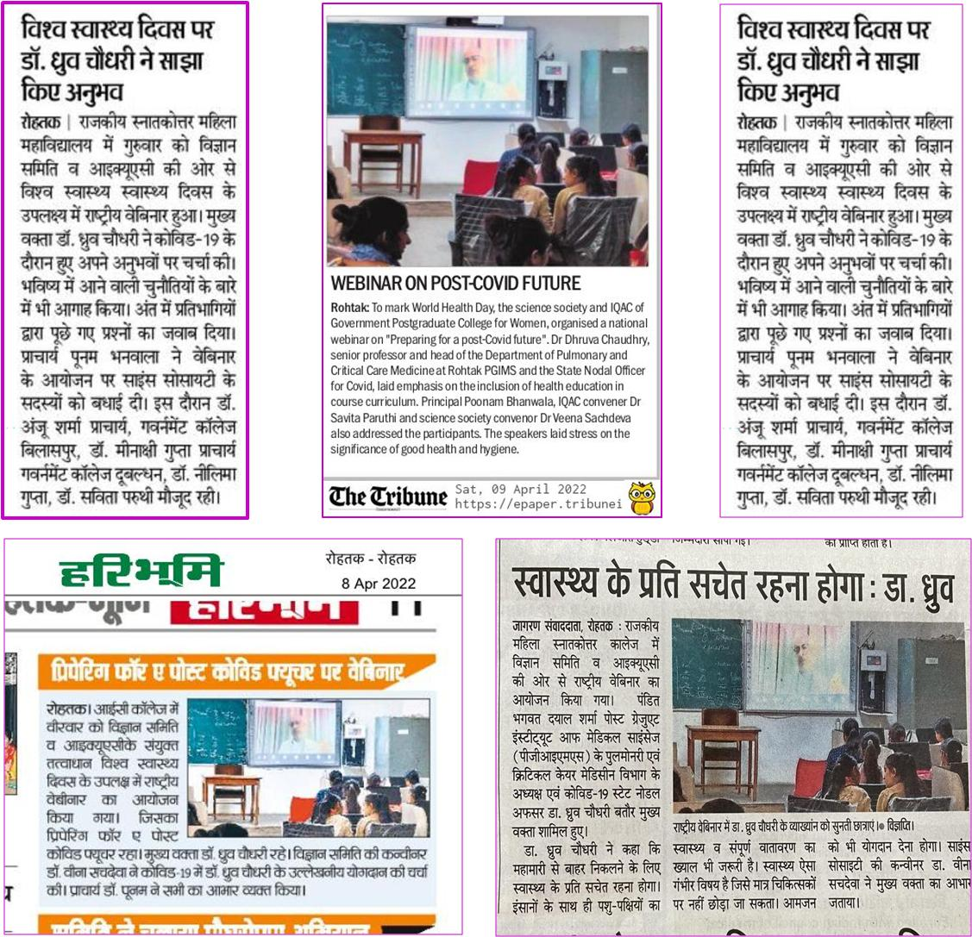

Women cell is involved in creating awareness and disseminating information and knowledge among the faculty and the students on the issues that are related to Gender discrimination. Every year the cell is committed to organize events/programmes to educate the faculty and students about the rights and responsibilities of fundamental and constitution of India by inviting the Guest speakers who have made names in their respective fields.
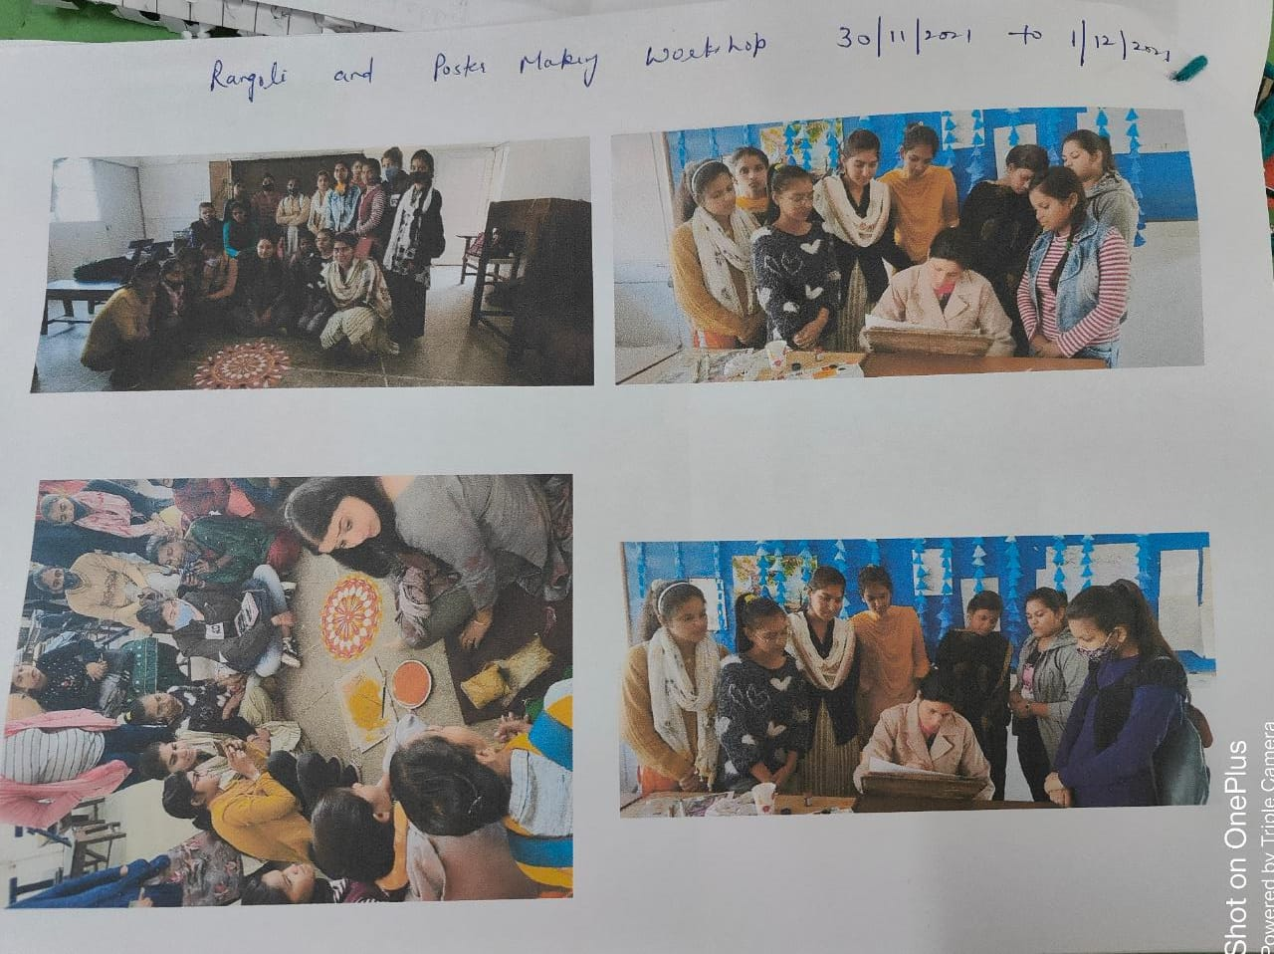
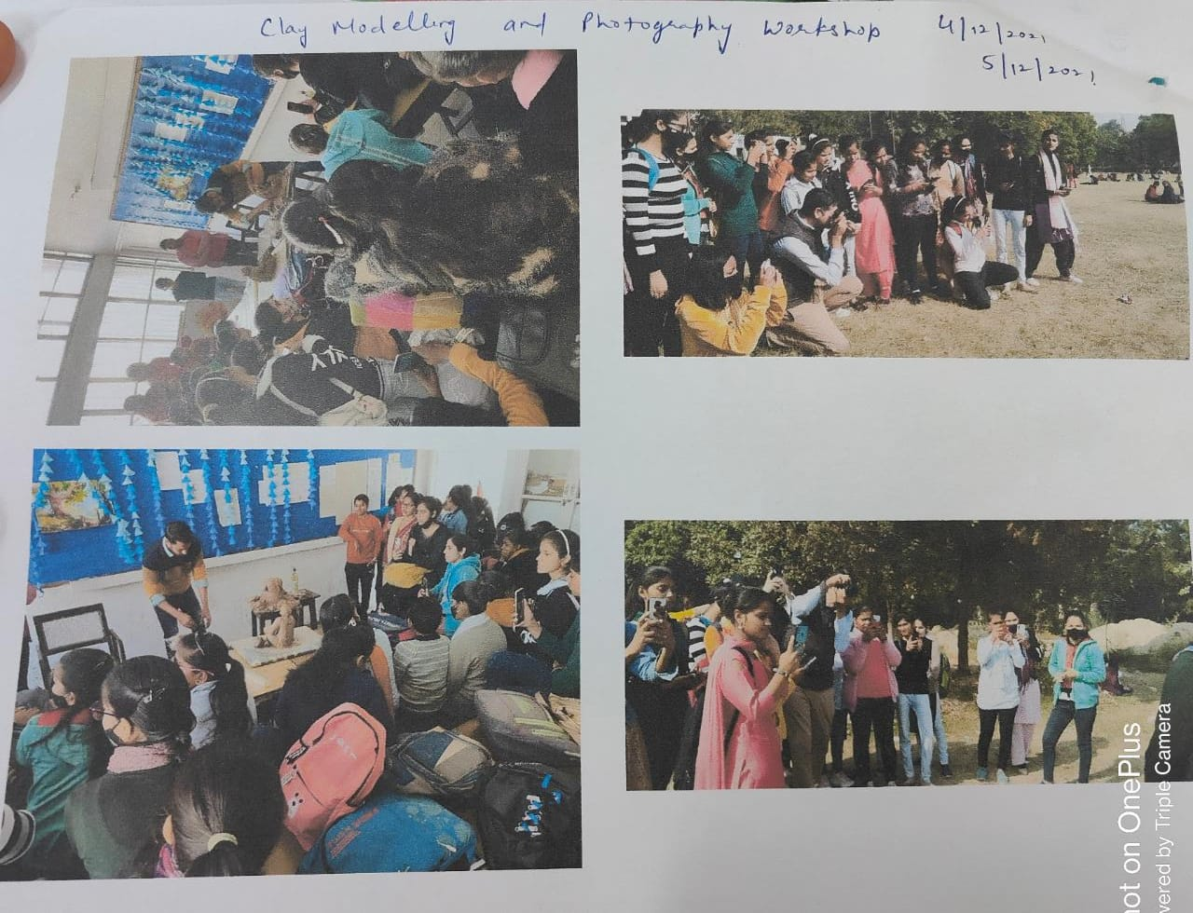

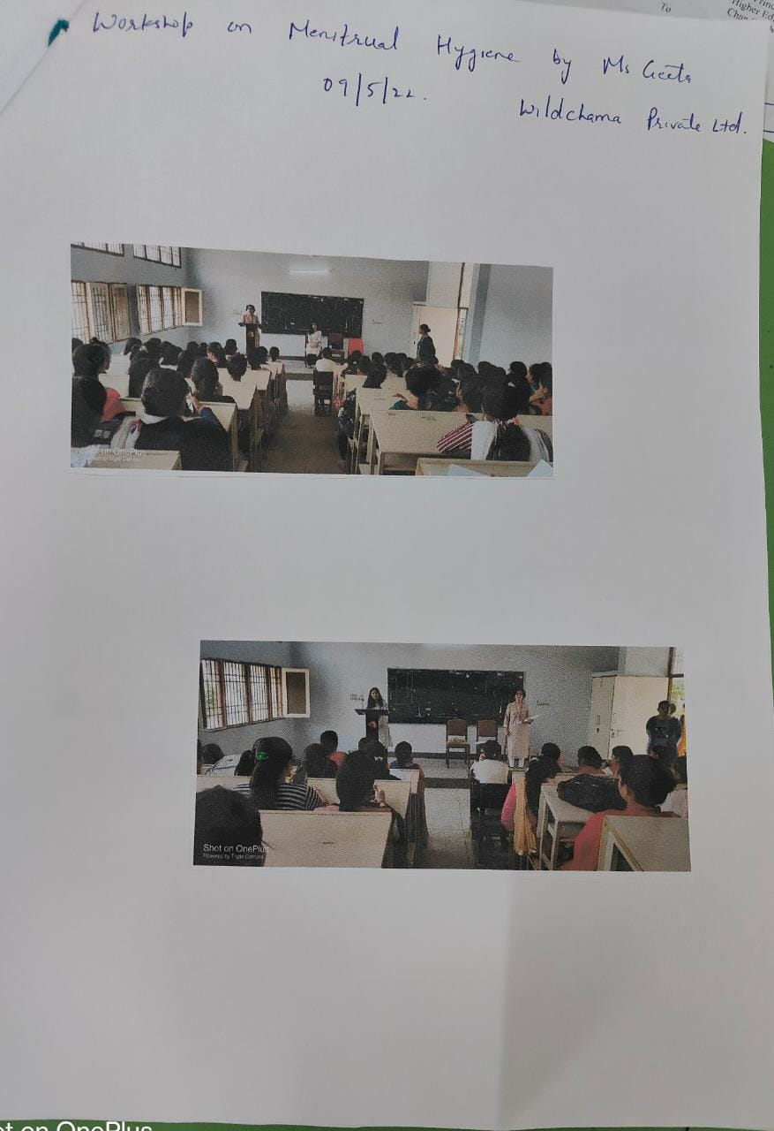

VARIOUS COMPETITIONS like power point presentation, quizzes, posters and web designing competitions etc. were organized for the students to enhance their abilities. Perhaps one of the most beneficial aspects of getting involved on campus is that it offers students the chance to develop and build skills. Such activities also provide opportunities to interact with peers and form new connections.
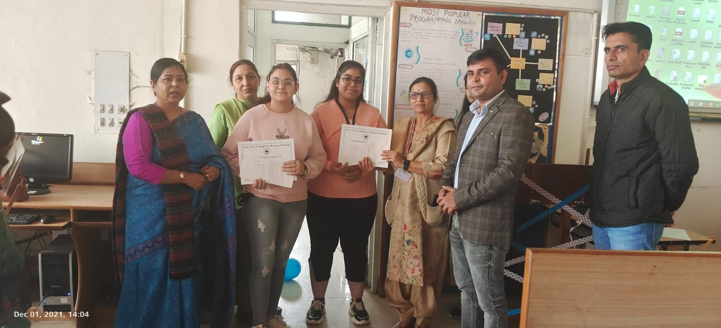
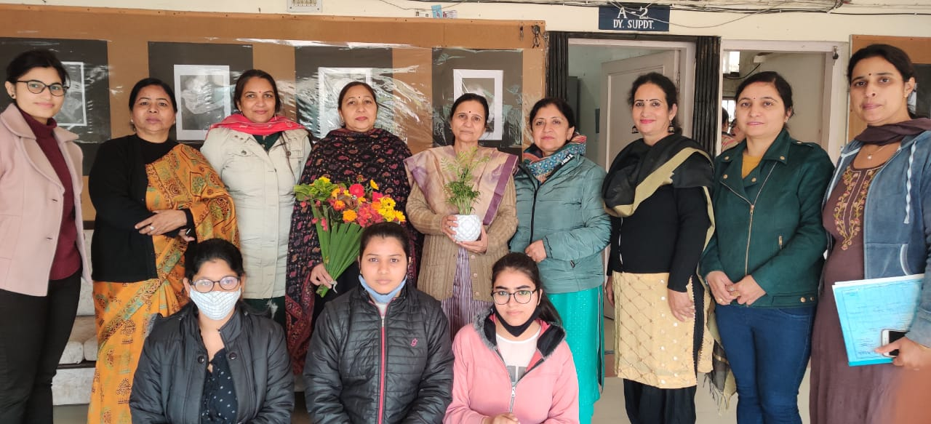
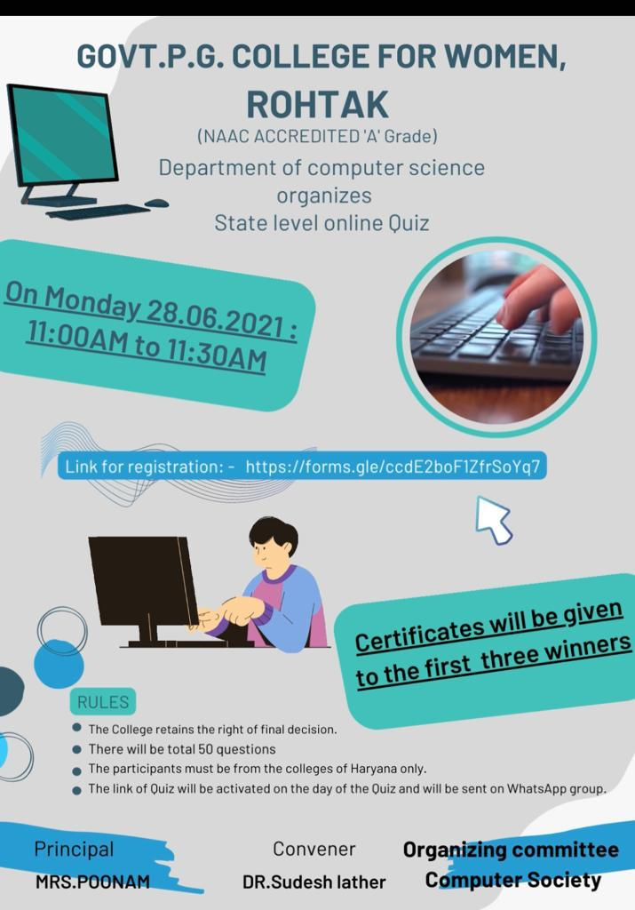

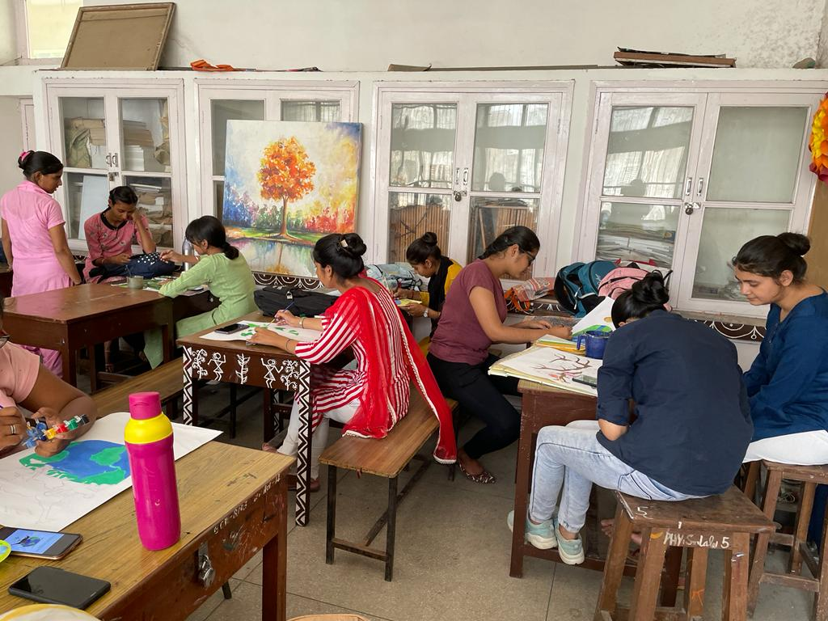

Our N.S.S. Units work hard to bridge the gulf between the educated and uneducated section of the community. In the process of hosting a variety of programmes and engaging in work with other welfare organisations, our students are empowered with organisations skills and get exposure to democratic leadership. At present, there are four units of N.S.S in our college.
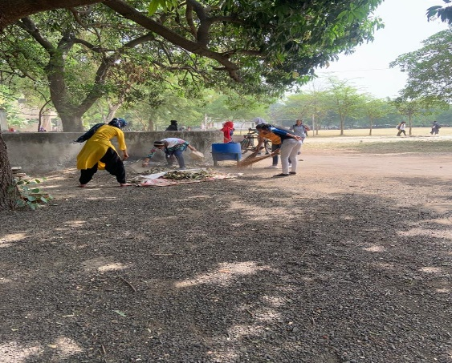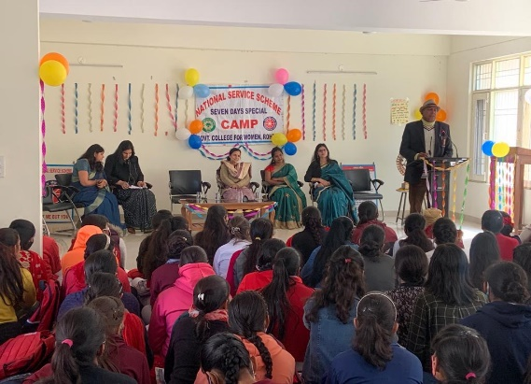
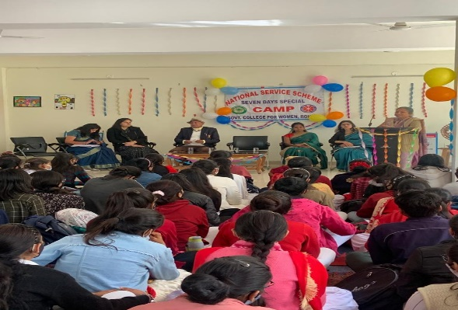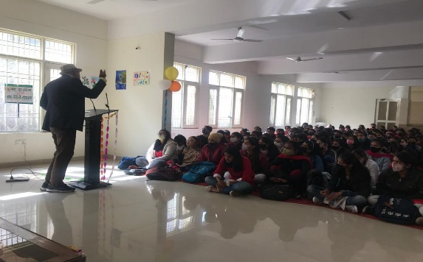
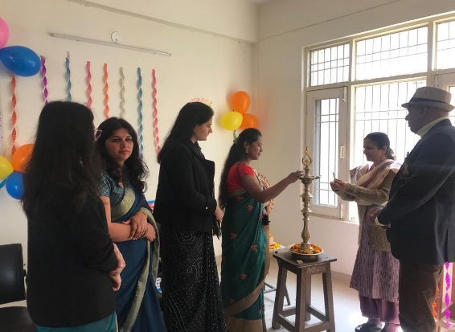

LIBRARY
The prime purpose of a library is to provide access to knowledge and information. To fulfil this mission, college library preserves a valuable record of culture. Then they pass down this to the coming generations. Therefore, they are an essential link between the past, present and future.
Students use library to study and work. They also use library resources to learn about personal interests. Sometimes, they get recreational media such as films and music.
Library helps the students to develop good reading and study habits. The college library provides information and services that are essential for learning and progress.
There are 66761 books, 18 newspapers, 34 magazines, 02 journals and 04 e-resources are present in college library. Reading room capacity is 100 and there is open access system for the students. Daily visiting register is also maintained.
