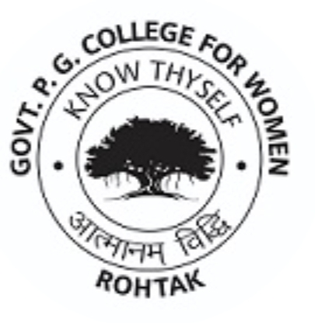

**Dr. Darshana Govt. P.G. College for Women, Rohtak**

**HES-I Rohtak 124001 (Haryana)**

**PRINCIPAL Ph. No. 01262- 251116, 271901**

**E mail: gcwrohtak@gmail.com**

**Website: gcwrohtak.com**

**SUPPORTING DOCUMENTS**

**6.3.1** The institution has effective welfare measures for teaching and non-teaching staff

|  |  |
| --- | --- |
| **S.No.** | **Link** |
| **1** | <http://www.finhry.gov.in/Portals/0/hcs-leave-rules-2016_1.pdf> |
| **2** | <http://www.finhry.gov.in/Portals/0/hcspensionenglishind.pdf> |
| **3** | <http://www.finhry.gov.in/Portals/0/hcs-gpf-rules-2016_1.pdf> |
| **4** | <http://www.finhry.gov.in/Portals/0/hcs-allowances-rules-2016.pdf> |