"Entrepreneurship Pakhwada" (21 August to 4 September 2025)

Extension lecture - 21 August,2025  **“India’s Start-up revolution: Opportunities and Challenges”**

The extension Lecture was delivered by Dr. Ritu, Assistant Professor in Commerce, GCW, Sampla, Rohtak. Fifty Seven (57) students were benefitted from this lecture.

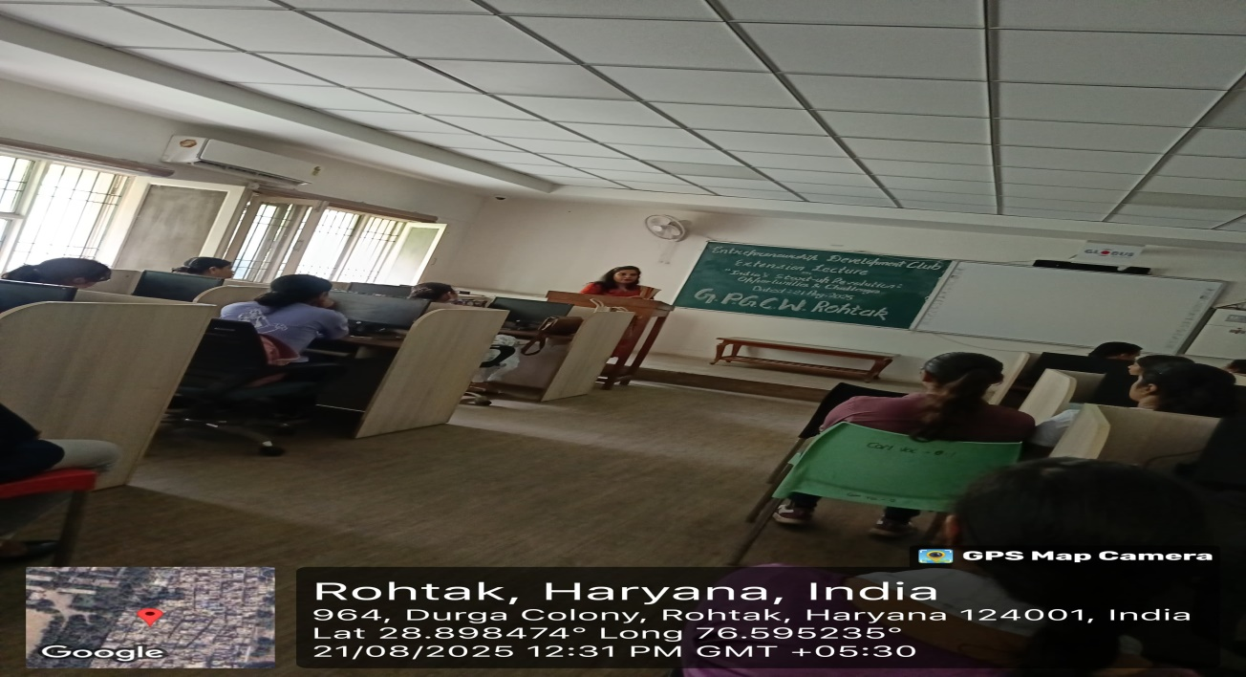

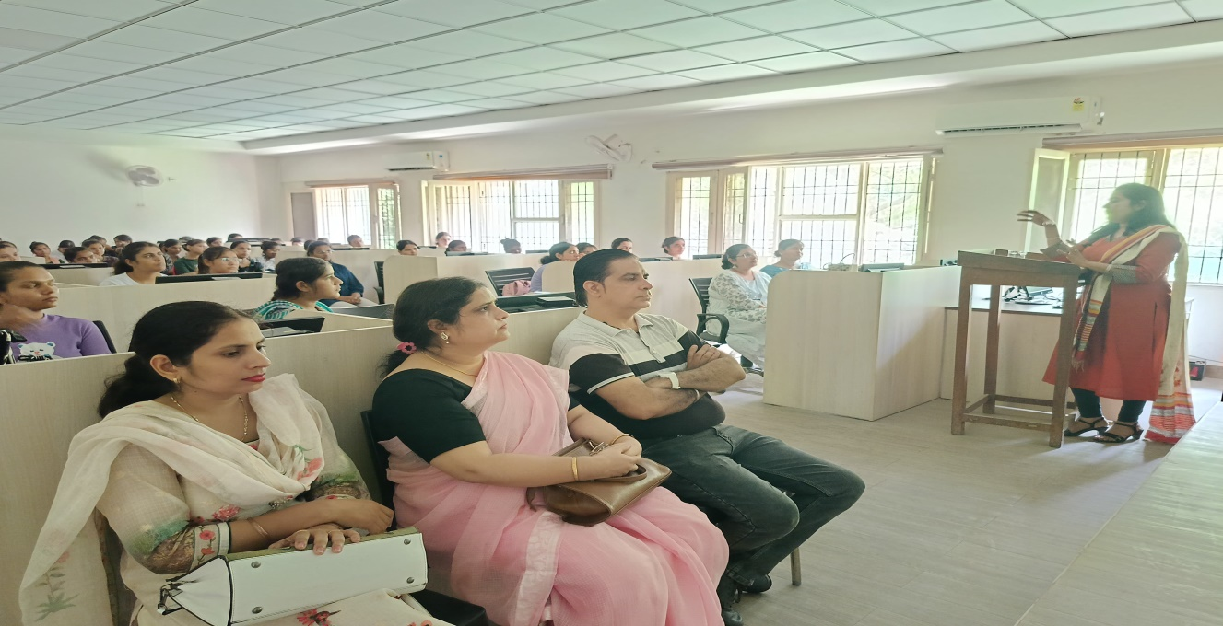

Under the theme of **“Entrepreneurship Pakhwada”** a Slogan Writing competition on the topic **“Entrepreneurship Development and Small Scale Business”** has been organized by the Entrepreneurship Development Club on 28 August, 2025. Twenty Three (23) students participated in this event.

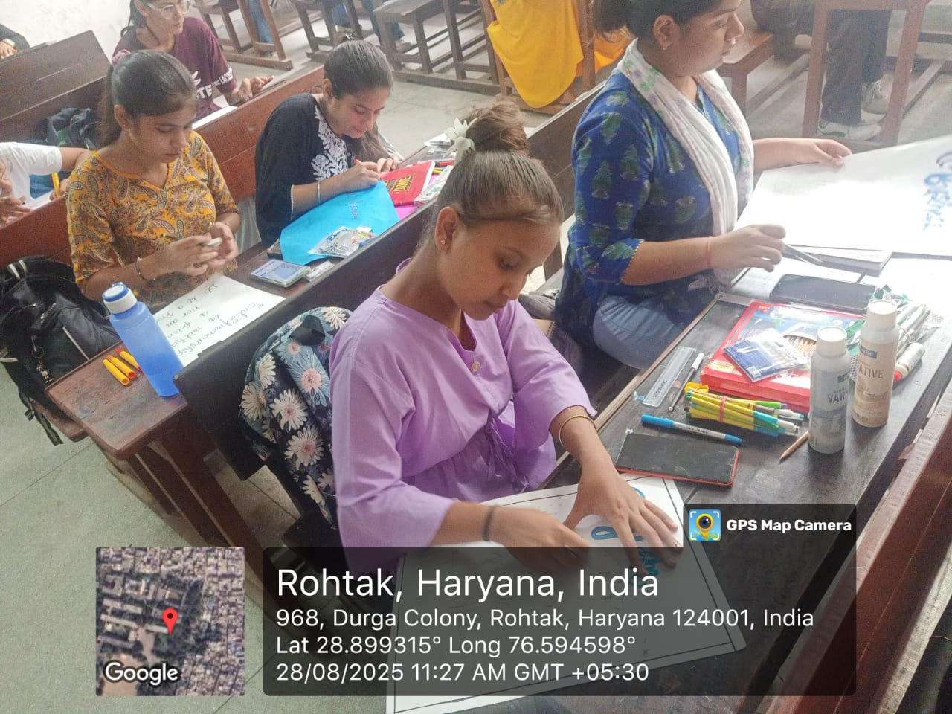

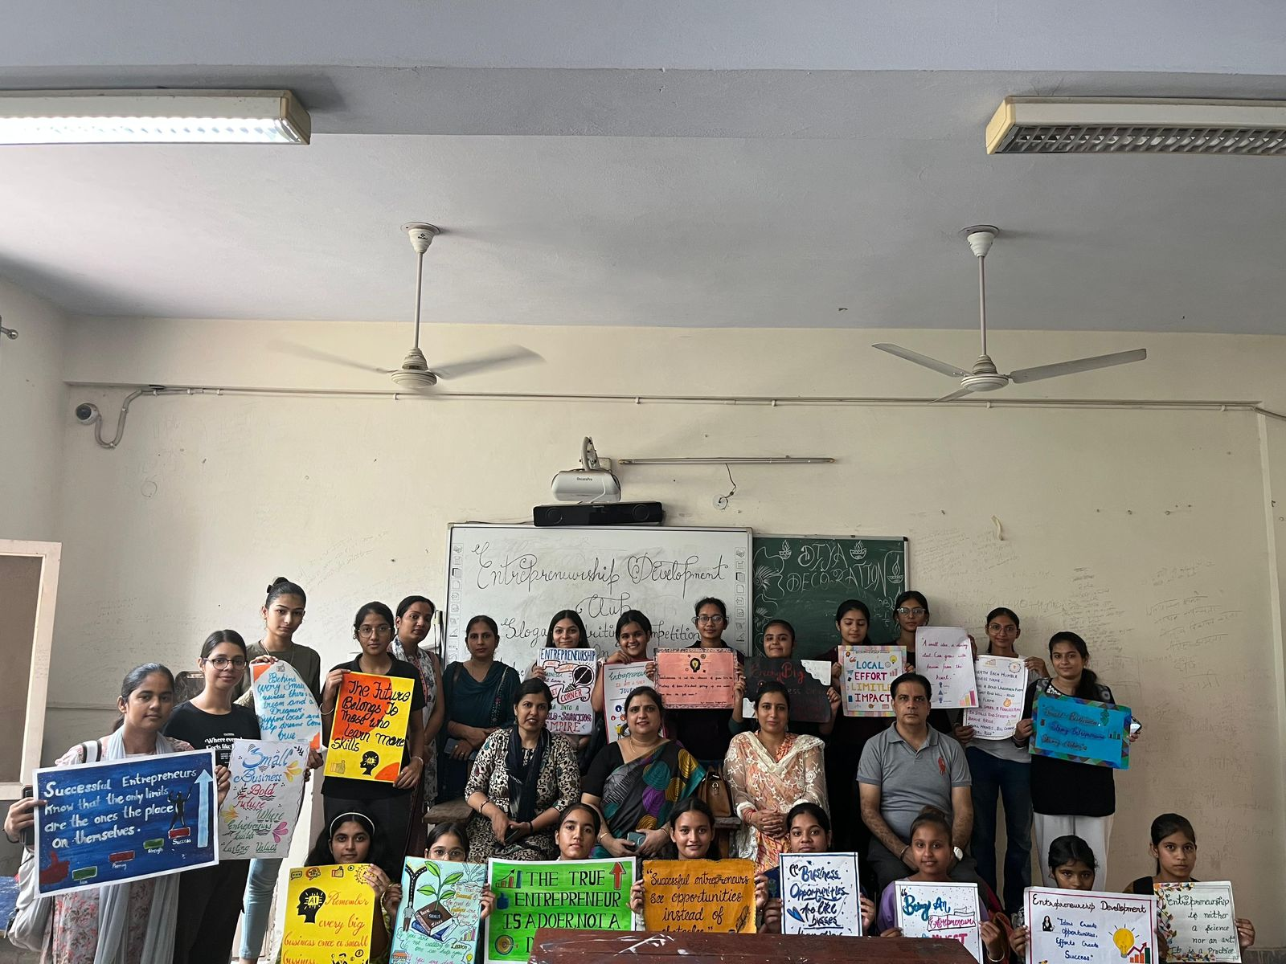

Under the theme of **“Entrepreneurship Pakhwada”** an extension lecture has been organised by Entrepreneurship Development Club on 12 September, 2025. The Lecture was delivered by Dr. Meera, Assistant Professor in Commerce, CBLU, Bhiwani. Fifty Nine (59) students were benefitted from this lecture.

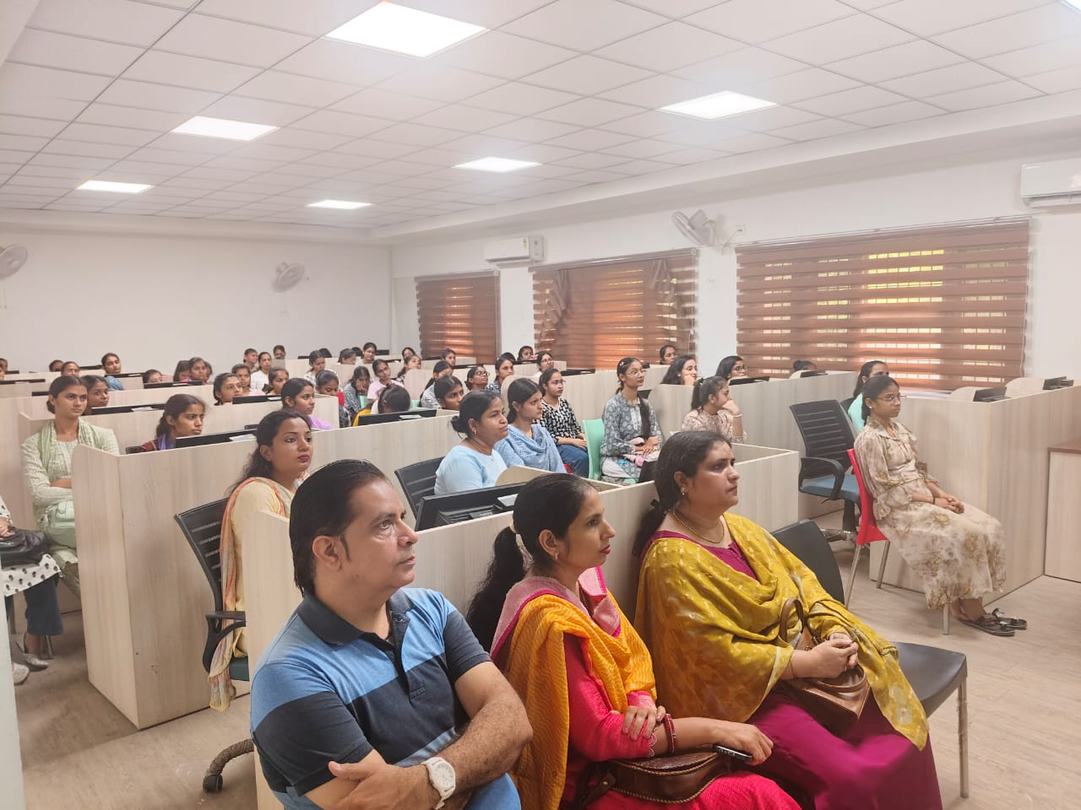

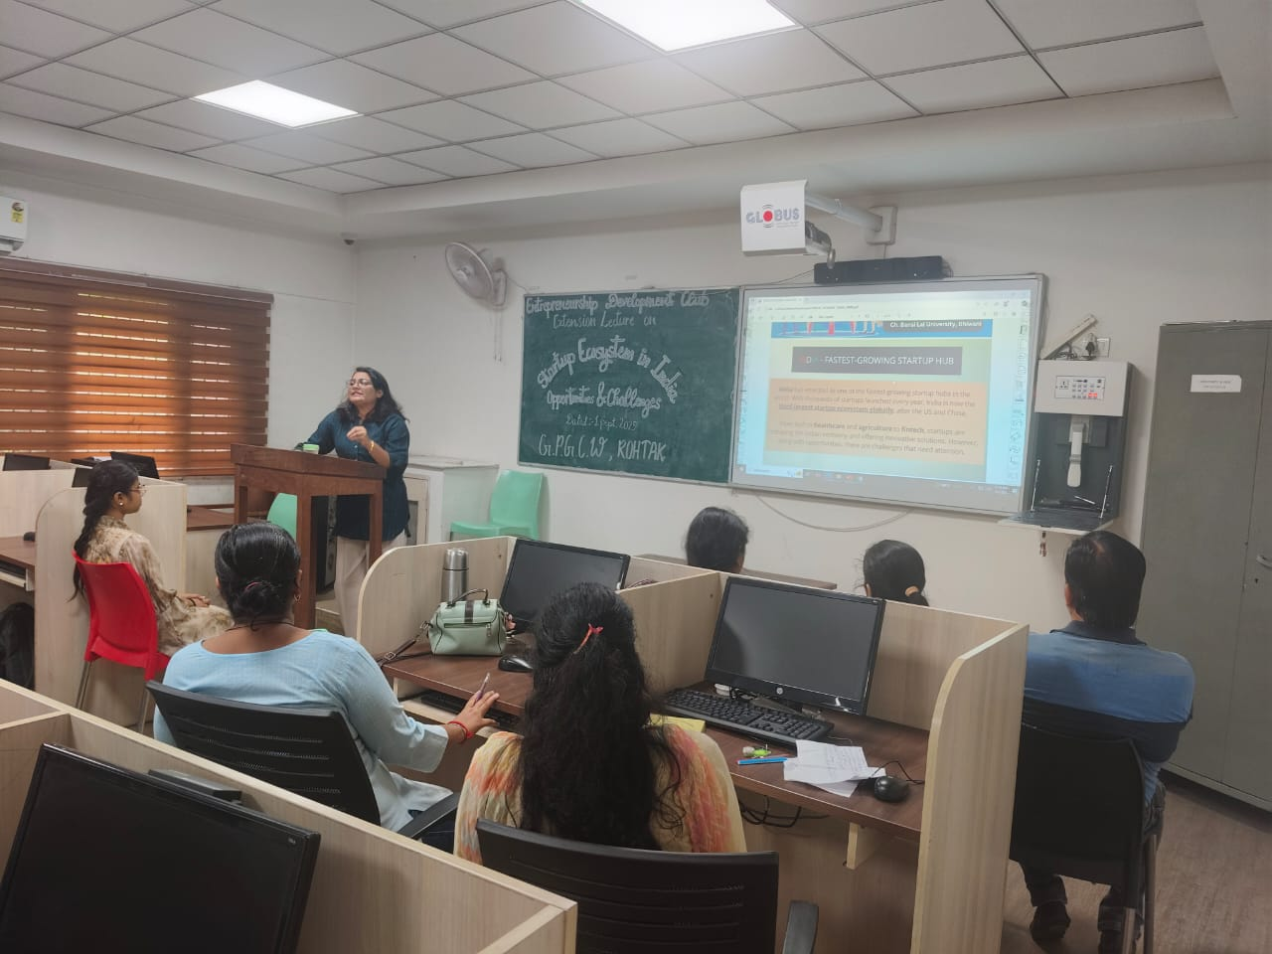

Objectives

The camp sought to:

1. Familiarize students with the fundamentals of entrepreneurship.

2. Provide insights into the journeys of startup founders and the challenges faced in building enterprises. 3. Emphasize the importance of leadership and personal branding in the entrepreneurial ecosystem.

4. Encourage students to think innovatively and develop problem-solving abilities.