**Home Science Society**

**(September 2025)**

**Date: 18/9/2025**

**Organization of Extension Lecture on Weight Management in Celebration of Nutrition Month at Government Post Graduate College for Women, Rohtak.**

The Home Science Department organized an extension lecture on weight management as part of the Nutrition Month celebrations. Departmental alumna Erwin Batra, a dietitian, delivered a comprehensive presentation on weight management. She empowered students with knowledge on maintaining a healthy weight by adopting mindful consumption habits, including reducing oil, salt, and sugar intake. Principal Dr. Shamsher Hooda commended Erwin Batra's efforts, highlighting the value of a balanced diet. This lecture was organized under the supervision of Ritu Hooda, Dr. Pankaj Sharma, Mrs. Monica, and Dr. Princy.

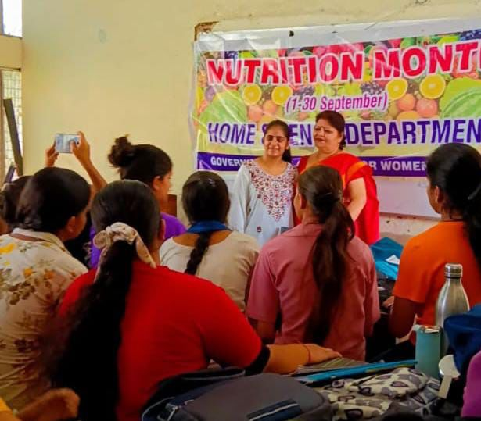

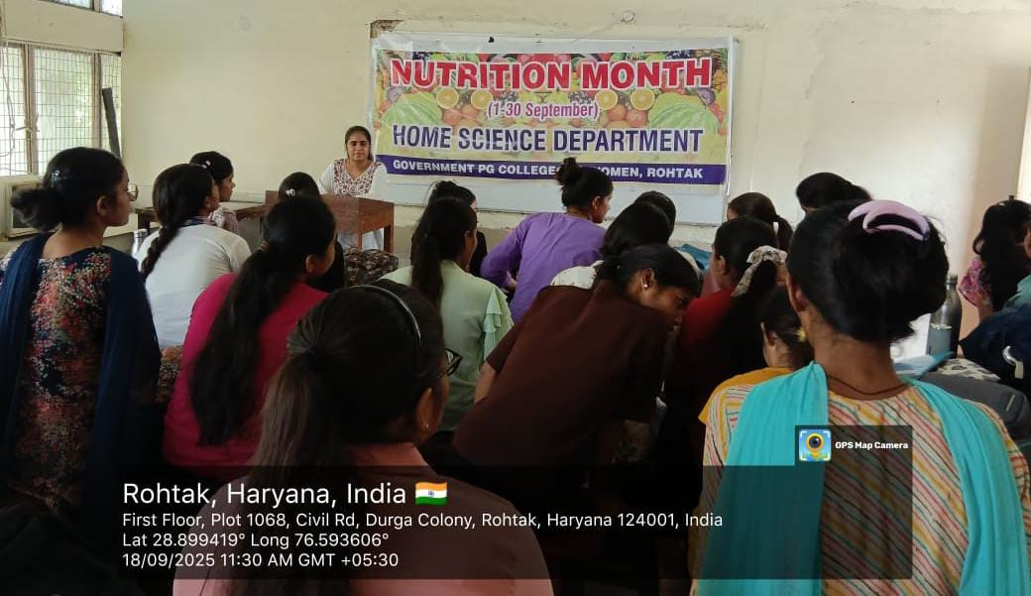

**Date: 19/9/2025**

**Extension Lecture on "Right Nutrition Healthy Life" Organized at Government Post graduate College for women. Rohtak.**

The Department of Home Science of Government Post graduate College for women Rohtak, organized an extension lecture on "Right Nutrition Healthy Life" as part of the Nutrition Month celebrations. In this lecture, departmental alumni Erwin Batra (Dietician) provided valuable insights on Infant and Young Child Feeding (IYCF) practices, emphasizing the importance of proper complementary feeding. She also highlighted the critical link between nutrition and education under the "Poshan Bhi Padhai Bhi" initiative, which is crucial for early childhood development. The students listened to the lecture with great interest and keenness. The event was attended by Mrs. Ritu Hooda (Head, Department of Home Science), and faculty members Dr. Pankaj Sharma, Mrs. Monika Narang, and Dr. Princy Katyal. Principal Dr. Shamsher Singh congratulated alumni Erwin Batra, wishing her a bright future, and felicitated her with an appreciation certificate.

