NSS Activity November 2025

On 14 November 2025, under the leadership of Principal Dr. Shamsher Hooda, all four units of NSS at Government P. G. College for Women, Rohtak organized “Vande Mataram @150”.

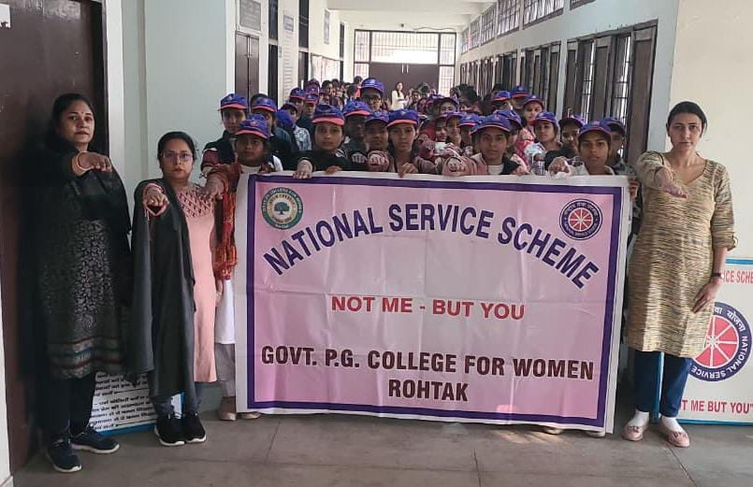
Under this event, NSS volunteers sang the Vande Mataram song and took a pledge to use Swadeshi (indigenous) products and languages. The volunteers also raised slogans of Vande Mataram and encouraged other students to adopt Swadeshi practices. On this occasion, all four NSS Programme Officers—Dr. Suman Rani, Dr. Pooja Chahal, Mrs. Harsh, and Dr. Neeraj Kadyan—were present.

