PLACEMENT REPORT

Placement cell organized various activities for the welfare of the students during the whole year.
2025-26

Sr. No. | Name of Program | Date | No. of Students | Name of Agencies/Consultant
1 | One Day Workshop on Job Offers in LIC | 06-08-2025 | 73 | Life Insurance Corporation
2 | Workshop on Design, AI and Digital Marketing | 13-10-2025 | 63 | Digital Riscup Institute, Rohtak
3 | Campus Placement Drive | 28-10-2025 | 61 | NIIT, Gurugram
4 | Two Days workshop on Personality Development | 13-11-2025 to 14-11-2025 | 92 | RBS Institute, Rohtak
5 | Rohtak division Job fair | 29-01-2026 | 88 | Pt. NRS Govt. College, Rohtak
6 | Extension Lecture on Career Opportunities in AI | 06-02-2026 | 81 | Amity University, Gurugram
7 | One Day Workshop on Placement and Career Opportunities | 24-02-2026 | 120 | OM Sterling Global University, Hissar
8 | One Day Workshop on fundamentals of AI | 17-04-2026 | 71 | Medha Foundation

ACTIVITY 1:
One day workshop on “Job Offers in LIC” was organised in our college for final year students of UG/PG on 06-08-2025. A development officer from LIC explained various aspects of job including commission structure and other benefits available. A total of 73 students from UG and PG final year attended the workshop and benefited from the session.

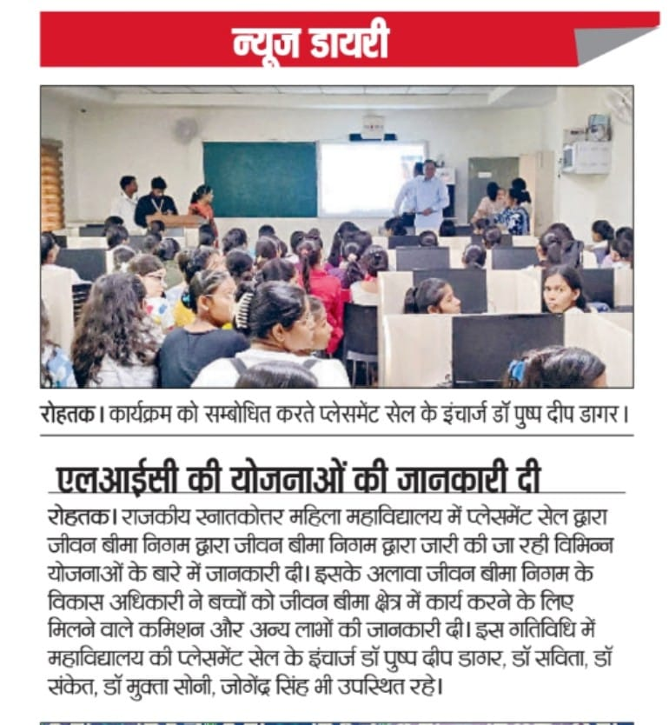

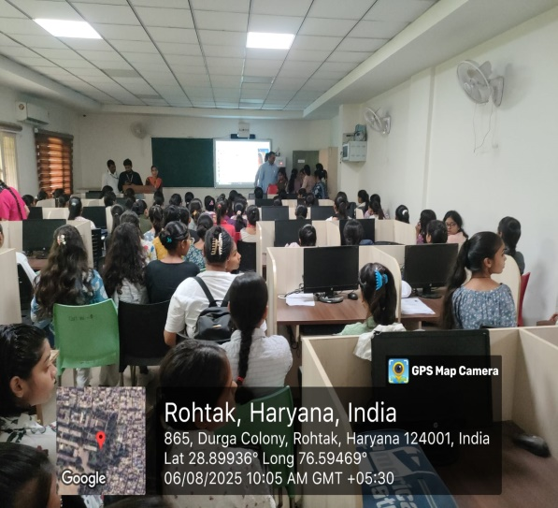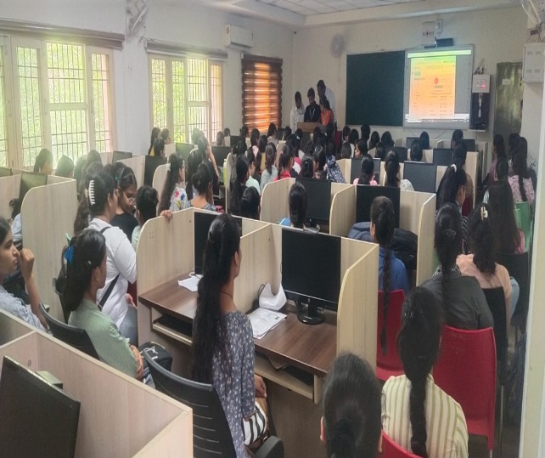

ACTIVITY 2:
On 13th October 2025 a workshop on ‘Design, AI and Digital Marketing” was conducted for BA/ BSc/B.Com and BBA students by Digital Riscup Institute. 63 students participated in this event and get the idea to ensure future using web designing and graphics designing integrated with AI.

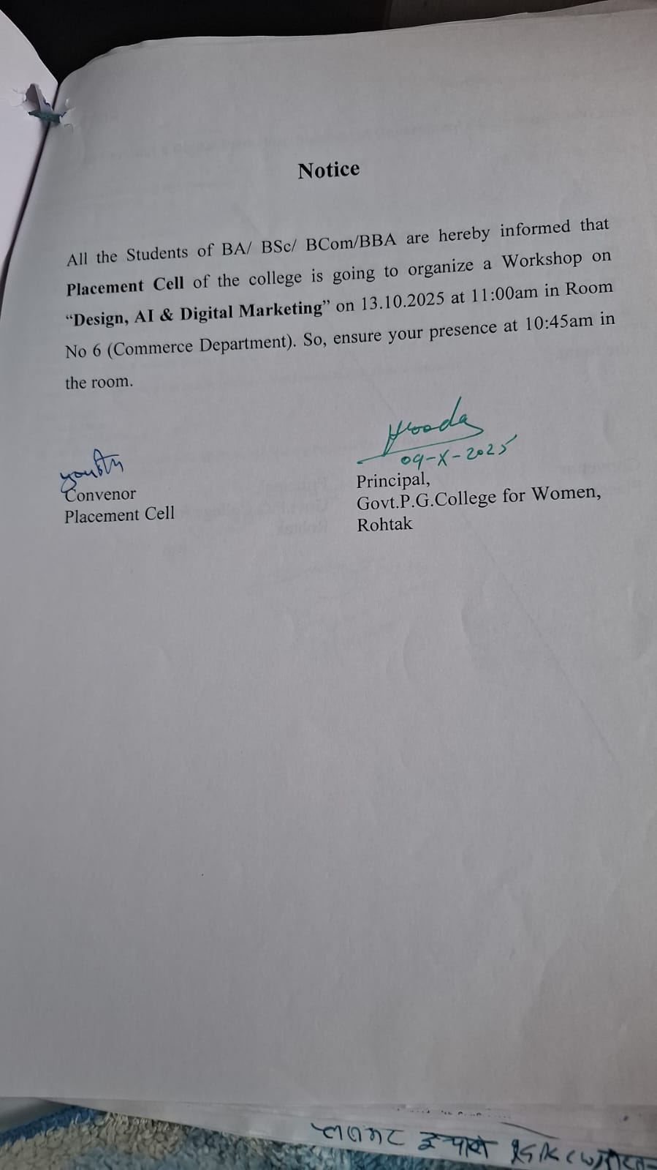

ACTIVITY 3:
A placement drive was organised on 28-10-2025 by Placement Cell in collaboration with NIIT Gurugram for the post of Assistant Manager in Axis Bank. A total of 61 students participated in drive out of which 19 students were passed out or from other colleges. Team of NIIT conducted an interactive session and around 20 students qualified in the first round. These students were shortlisted for the next stage of selection process.

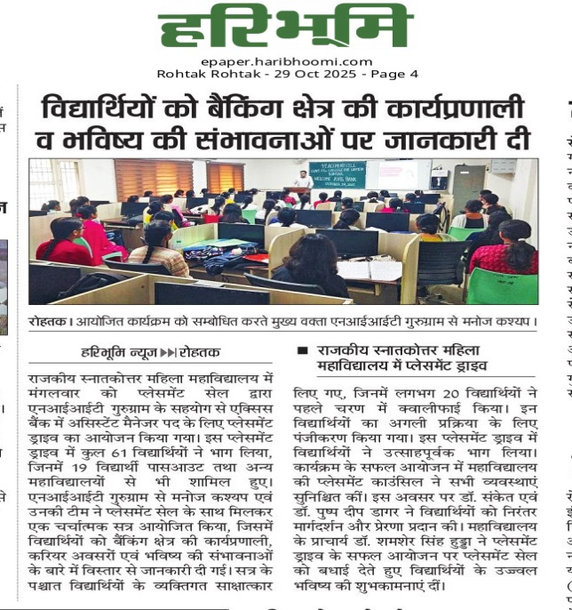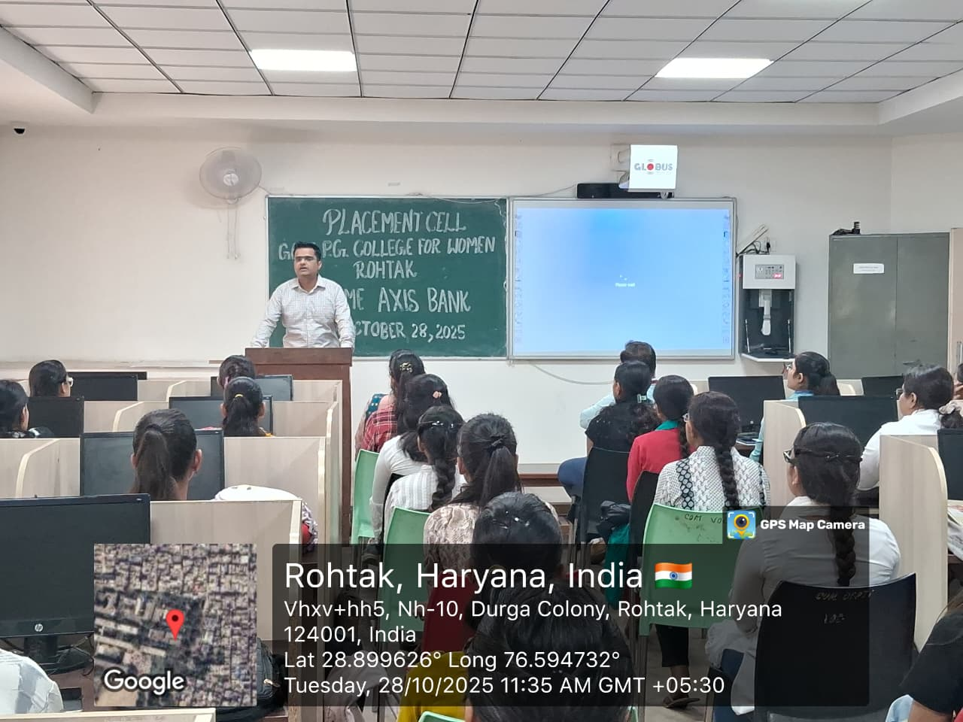

ACTIVITY 4:
Two day workshop was organised by placement cell on 13-14 Nov.2025 for the final year students of UG/PG students on Personality Development. On first day of workshop, Mr. Dinesh Madan from RBS Institute briefly covered dressing sense, behaviour, body language etc, aspects of personality. On second day Ms. Suchetra covered different modules of mock interview and various interview skills. A total of 92 students benefitted from the workshop.

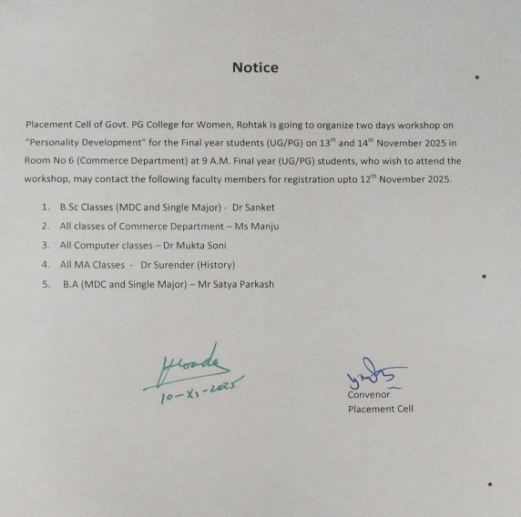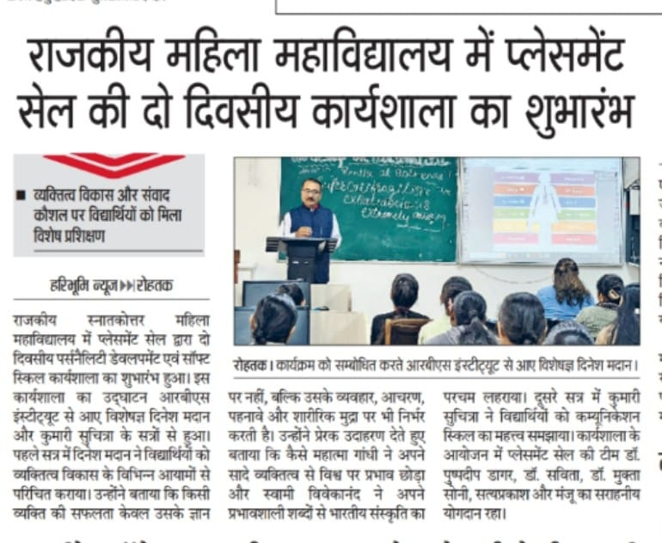

ACTIVITY 5:
On 29th Jan.2026, 88 students of final year of our college participated in Division Level Placement Fair held at Pt. Neki Ram Sharma Government College, Rohtak sponsored by DGHE, Haryana. Nearly 15 companies of various field for different streams of students come to this fair.

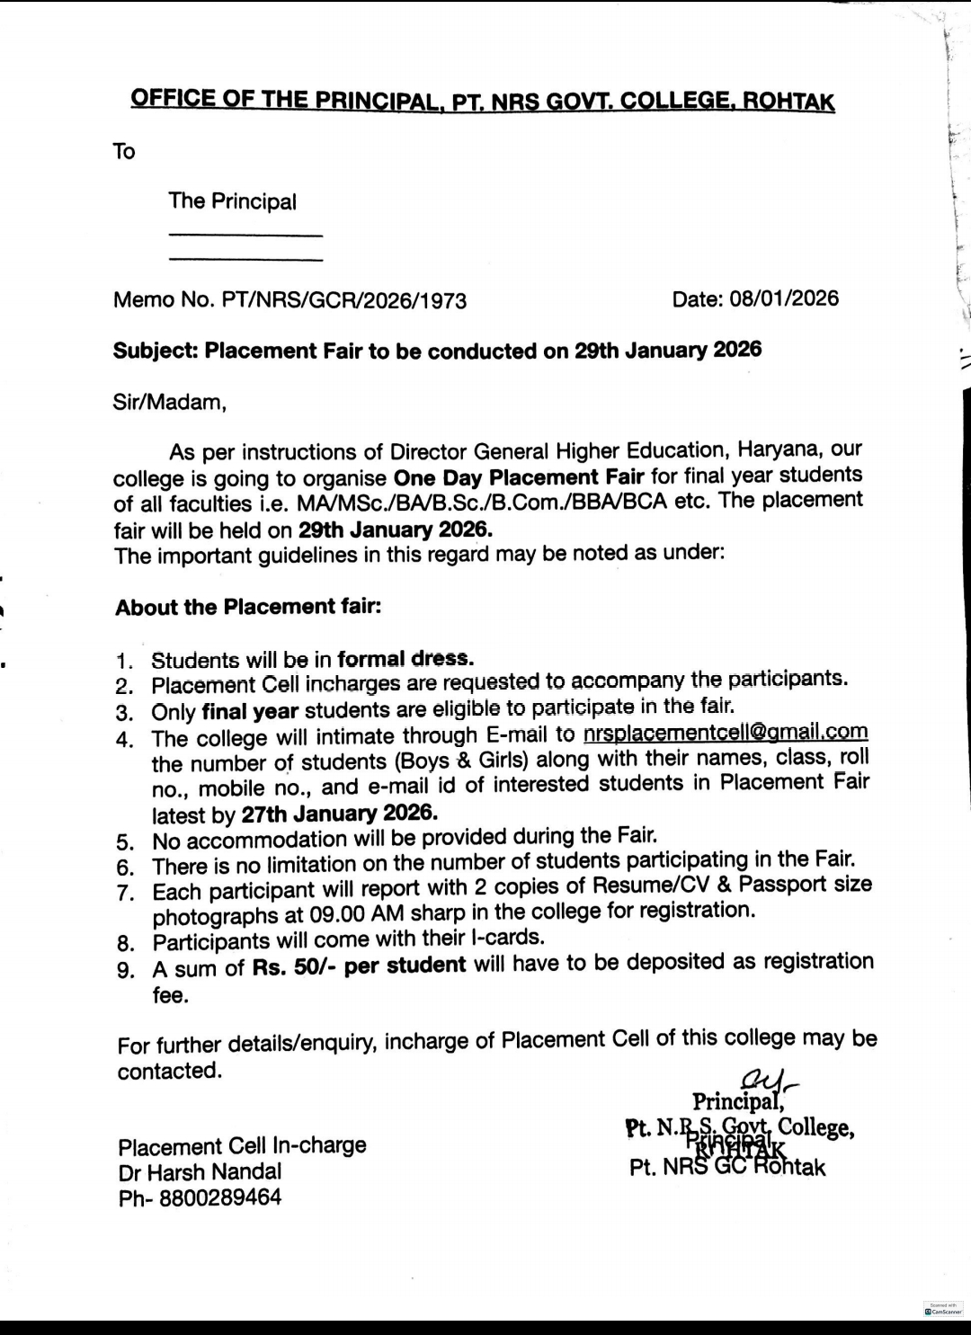

ACTIVITY 6:
An extension lecture was organised for the students of UG and PG classes on “Career opportunities in AI” dated on 06-02-2026. Mr. Deepak and His associates give valuable tips regarding career opportunities available in the area of AI so that students feel confident and performed well during job. A total of 81 students get knowledge about different aspects of AI.

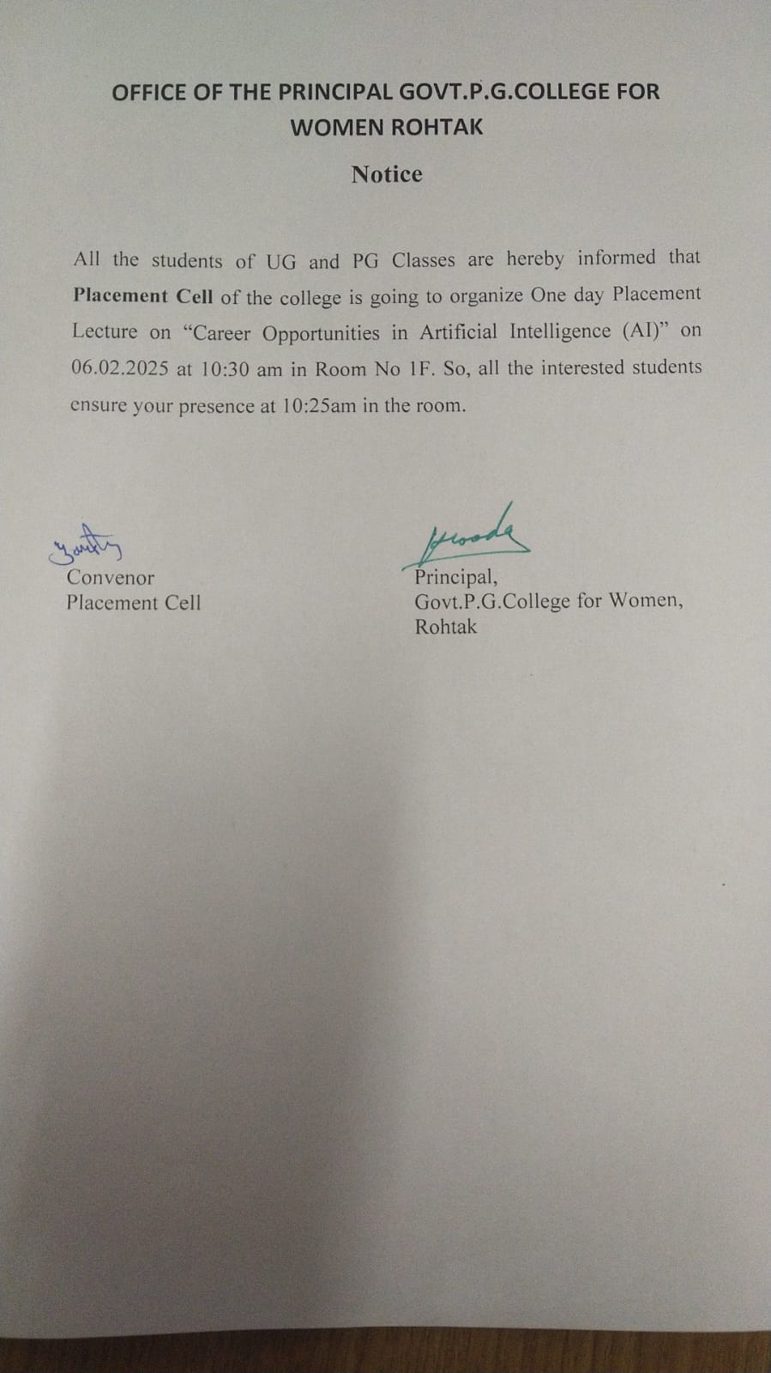

ACTIVITY 7:
One day workshop was conducted by Placement Cell titled “Placement and Career Opportunities” on 24-02-2026. Mr. Sachin and his associates from Om Sterling Global University, Hisar explained mainly on the topics of Personality Development, Resume Writing etc. in a very interactive way. A total of 120 students participated in this workshop.

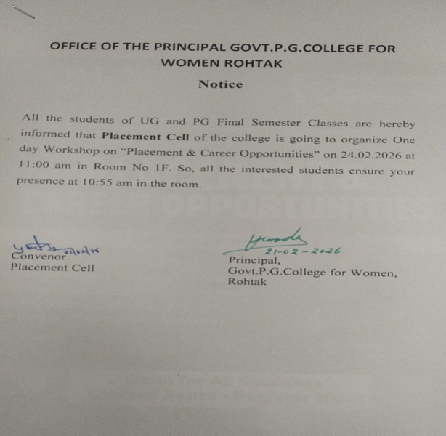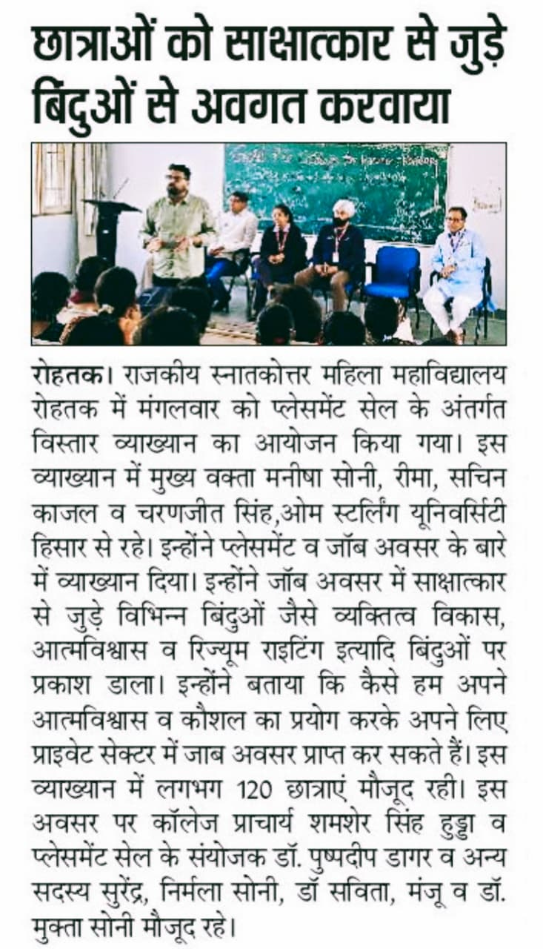

ACTIVITY 8:
On April 17, 2026 a one day workshop was organised by Placement Cell with collaboration of Medha Foundation on “Fundamentals of AI” for UG and PG classes. They explained fundamentals of AI and how to use AI for job opportunities. They also explained about various platforms for job opportunities. 71 students attended this workshop.

